Translation Memory:

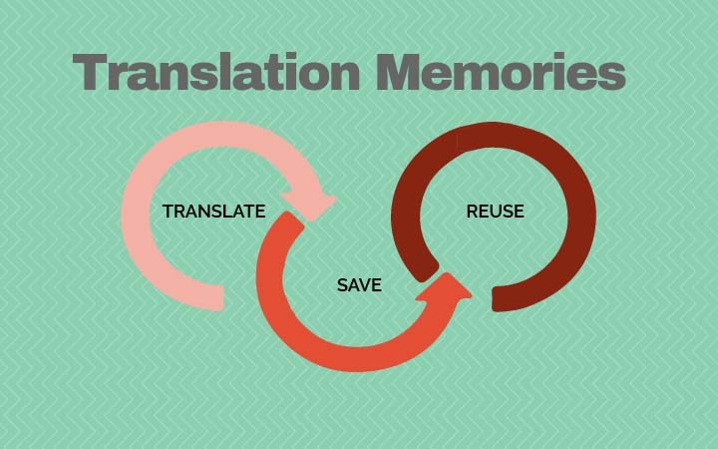

It is the most important advantage of CAT tools. It is created automatically once the translator begins his work. So, TM is considered an accurate tool of translation due to human intervention in the whole process.
The translator cannot use the same TM for each language combination. For example: English/Arabic TM cannot be used during the translation from Arabic into English document. So, He should create a TM for English into Arabic and another one from Arabic into English and so on.
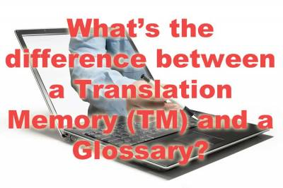
The translator deals with different types of texts. Basically, the translator creates his own glossary (TM). So, if he is used to translate legal documents, so his glossary contains legal terms. It does not mean he is not able to translate other types of texts. The TM suggests always the legal terms from the previous translations. In this case, different TM should be created according to each type (legal, medical ...).
Previous translations can be used in creating TM. It is called documents Alignment. Connecting source texts with the target texts to create TM.

CAT tools programs:
- SDL Trados
- Memo Q
- Word Fast
- Smartcat
- OmegaT.

