**University of M’sila Department of English**

**Master One Classes TEFL Courses / lecturer: Berkani**

**LESSON TEN :LEARNING OBJECTIVES**

Take a moment and think about a course or a training session that you have attended in the past or that you currently teaching. Identify one skill that you think would be essential to know or do by the end of this learning period. If you are able to do this, then you are beginning to construct a learning objective.

**1.Definition of learning objectives**

Learning objectives are statements that describe significant and essential learning that learners have achieved and can reliably demonstrate at the end of a course or program. In other words, learning objectives identify what the learner will know and be able to do by the end of a course or a program.

Spady (1994), an educational researcher who spearheaded the development of objectives-based education, suggests that the ability to demonstrate learning is the key point. This demonstration of learning involves a performance of some kind in order to show significant learning, or learning that matters. He claims that significant content is essential, but that content alone is insufficient as an objective. Rather, knowledge of content must be manifested through a demonstration process of some kind**.** Learning objectives refer to observable and measurable knowledge, skills, and attitudes**.**

Objectives, unlike goal statements, are detailed descriptions of **what students will be able to do** by the end of a learning activity.

* They are related to intended outcomes, rather than the process for achieving those outcomes.
* They are specific and measurable, rather than broad and intangible.
* They are concerned with students, not teachers.

3. **Guidelines for Writing Course Learning Objectives**

Learning objectives written at the course level should:

* state clear expectations - learners know what they have to do to demonstrate that they have achieved the learning objectives
* represent culminating performances of learning and achievement; ( meaning the highest stage of development, or exit, end performance)
* describe performances that are significant, essential, and verifiable (i.e., performances can be verified or observed in some way and that they represent more than one small aspect of behaviour; this also means that the performance is considered to be essential for success in the course) ;
* preferably state only ONE performance per objective
* refer to learning that is transferable; (meaning that the learning can readily be transferred from a class to a work place environment, or from one workplace environment to another, etc.)
* not dictate curriculum content (i.e., there could be a number of different ways to achieve the objective)
* reflect the overriding principles of equity and fairness and accommodate the needs of diverse learners
* represent the minimal acceptable level of performance that a student needs to demonstrate in order to be considered successful.

**4.Types of learning objectives**

Objectives for learning can be grouped into three major domains: cognitive, psychomotor, and affective. Benjamin S. Bloom and his associates developed a six-level taxonomy for cognitive domain from the lowest level *knowledge* to more complex intellectual levels *comprehension, application, analysis,* *synthesis*, and *evaluation*. A newer version of Bloom's Taxonomy puts *creating* as the most complex learning activity that can be performed to show one's learning mastery.

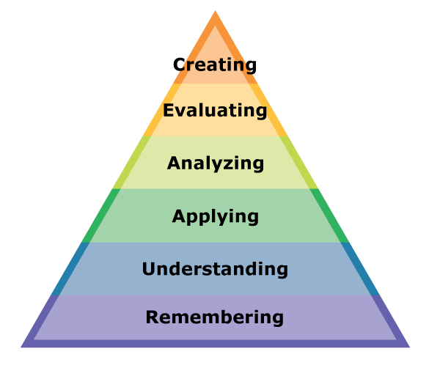

**4.1.Cognitive domain**

The domain that receives the most attention in instructional programs is the cognitive domain. It includes the objectives related to knowledge or information, naming, solving, predicting, and other intellectual aspects of learning.

* **Sample Verbs For Learning Objectives**

|  |  |  |  |  |  |
| --- | --- | --- | --- | --- | --- |
| **Knowledge** | **Comprehension** | **Application** | **Analysis** | **Synthesis** | **Evaluation** |
| Cite | Describe | Apply | Analyze | Arrange | Appraise |
| Define | Discuss | Assign | Appraise | Assemble | Assess |
| Give | Explain | Demonstrate | Calculate | Collect | Check |
| Label | Express | Dramatize | Categorize | Combine | Choose |
| List | Identify | Employ | Compare | Compose | Compare |
| Match | Locate | Illustrate | Contract | Conclude | Critique |
| Name | Recognize | Interpret | Criticize | Construct | Decide On/To |
| Recall | Report | Operate | Debate | Create | Discriminate |
| Record | Restate | Practice | Diagram | Design | Estimate |
| Relate | Review | Schedule | Differentiate | Determine | Evaluate |
| Select | Tell | Shop | Distinguish | Diagnose | Grade |
| State | Translate | Sketch | Examine | Differentiate | Inspect |
| Tell |  | Use | Experiment | Dissect | Judge |
| Underline |  |  | Inspect | Examine | Measure |

**4.2.Psychomotor domain**

The second category for grouping instructional objectives is psychomotor domain. It encompasses the skills that require the use and coordination of skeletal muscles. Psychomotor behaviors are easier to observe, describe, and measure than cognitive or affective behaviors.

* **Skills Verbs**

|  |  |  |  |  |  |
| --- | --- | --- | --- | --- | --- |
| Assemble | Diagram | Implement | Package | Refill | Sketch |
| Attach | Dictate | Inspect | Perform | Regulate | Sort |
| Balance | Direct | Instruct | Plant | Renovate | Splice |
| Build | Dismantle | Interview | Portion | Repair | Stratify |
| Bundle | Document | Lift | Position | Replace | Sterilize |
| Calibrate | Draw | Line | Prepare | Reproduce | Tape |
| Care For | Duplicate | Load/Reload | Press | Retrieve | Terminate |
| Clean | Edit | Locate | Process | Route | Transfer |
| Code | Execute | Log | Program | Save | Transplant |
| Collate | Fix | Make | Proofread | Search | Treat |
| Collect | Format | Manage | Propagate | Secure | Trim |
| Conduct | Gather | Measure | Prove | Select | Troubleshoot |
| Conserve | Grade | Mix | Provide | Separate | Verify |
| Construct | Grid | Mount | Prune | Sharpen | Wash |
| Control | Harvest | Operate | Raise | Simplify | Write |
| Design | Highlight | Organize | Recheck | Simulate |  |

**4.3.Affective domain**

The third category of affective domain encompasses attitudes, appreciations, values, and emotions – although highly important in education, the hardest to assess the student. The levels of affective domain form a continuum from simple awareness and acceptance to internalization, as attires become part of an individual’s practicing value system.

* **Attitudinal Verbs**

|  |  |  |  |  |
| --- | --- | --- | --- | --- |
| **Receiving** | **Responding** | **Valuing** | **Organizing** | **Characterizing** |
| Listen To | Reply | Attain | Organize | Believe |
| Perceive | Answer | Assume | Select | Practice |
| Be Alert To | Follow Along | Support | Judge | Continue To |
| Show Tolerance Of | Approve | Participate | Decide | Carry Out |
| Obey | Continue |  | Identify With |  |

**5.Effective learning objectives**

* Once you have written your objectives, ask yourself: “How will I evaluate the achievement of this learning objective?” and “How well do attendees have to do to demonstrate achievement (mastery) of the objective? (standard)
* Remember the acronym**, SMART**, when writing learning objectives: **S** – Specific, M – Measurable, **A** – Achievable, R – Relevant, T – Timely.
* Verbs to avoid when writing learning objectives include: Understand, enjoy, perceive, realize, know, be aware of.
* Instead try **SMART** verbs as : Demonstrate ,develop ,analyze, express ,evaluate, organize create ,write, plan ,apply ,produce, implement ,compile, incorporate ,construct