**CHAPTER III: RADIOACTIVITY AND NUCLEAR REACTIONS**

**III.1 MASS-ENERGY EQUIVALENCE:**

**III.1.1. Einstein's relationship :**

In 1905, when developing the theory of special relativity, Einstein postulated that mass is one of the forms of energy: A system at rest, of mass m has a mass energy: **E = m.c2** (mass-energy equivalence relation) with E : mass energy in joules (J), m : mass in kilograms (kg) , c : speed of light in a vacuum (c = 3.0.108 m.s-1 )

**Consequence:** If the system (at rest) exchanges energy with the external environment (by radiation or heat transfer, for example), its variation in energy ΔE and its variation in mass Δm are linked by the relationship: **ΔE = Δm . c2**

* If Δm < 0, then ΔE < 0, the system gives up energy to the external environment and its mass decreases.

* If Δm > 0 then ΔE > 0, the system receives energy from the external environment and its mass increases.

**III.1.2. Mass defect of the nucleus :**

Mass measurements have shown that the mass of the atomic nucleus is less than the sum of the masses of its protons mp and neutrons mn: **nucleus mass< Z.mp+ (A-Z).mn**

This difference is called the mass defect Δm: Δm = Z.mp + (A - Z).mn - m nucleus ( Δm > 0 )

**III.1.3. Binding and cohesive energy of nuclei**

**III.1.3.1. Binding energy (E):**

Energy required to form any nucleus from its nucleons (P+N). Nucleus formation is described by the following reaction:

**Z+N +E1< 0**

The formation of a nucleus generally requires negative energy.

**III.1.3.2. Cohesion energy (B):**

Energy required to destroy a nucleus into its constituents (N+P) according to the reaction:

+ **E2 Z+N**

This energy is positive and we can write: E2= -E1

**III.1.3.31. Cohesion energy per nucleon:**

The cohesion energy E2 is a function of the number of nucleons (A) in the nucleus, the greater the number, the greater the cohesion energy. To determine the stability of a nucleus, we calculate the ratio (cohesion energy)/(number of nucleons (A), i.e. E2/A). The greater the ratio E2/A, The more stable of the nucleus.

Exp : **73Li : E2/A=5,37 MeV, 168O: E2/A=7,72 MeV, 5626Fe :E2/A=8,55 MeV,**

**23592U: E2/A=7, 39 MeV**

**III.1.4. Aston graph :**

The Aston curve represents - El /A as a function of A (number of nucleons). The most stable nuclei, such as the iron nucleus (A between 20 and 195), are easily visualized at the bottom of the graph. Two different processes are possible for unstable nuclei: (light atoms: fusion and heavy atoms: fission).

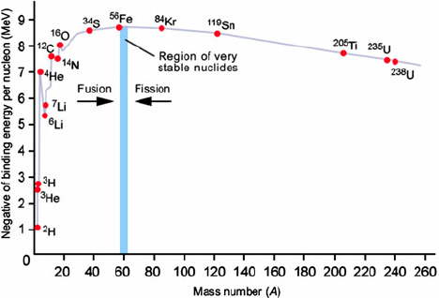

**Fig.III.1. Aston graph**

**III.1.5. Units of measurement**

The usual units of measurement are not adapted to the subatomic world.

**a.** The unit of atomic mass (u. a m. ): 1 a.u =1.66 .10-27 m !Kg

**b.** The electron volt

The electron volt is the energy acquired by an electron accelerated by a potential difference of 1 volt. Since the variation in the electron's kinetic energy is equal to the product of the electron's charge and the potential difference, we find that: 1 eV= 1.6 10-19 J

Multiples of the electron volt are often used: 1 KeV=103eV, 1 MeV=106 eV, 1 GeV=109eV. When calculating the mass energy balance Q, masses are often expressed in a. u., whereas the aim is to express Q in MeV. It can be shown that :

1 a.u .C2 = 931.5 MeV

**III.2. RADIOACTIVITY**

Radioactivity was discovered by Becquerel in 1886. He discovered that potassium uranyl sulfate K2UO2(SO4)2 emitted radiation capable of printing a photographic plate. The nuclei of certain atoms can undergo transformations, called transmutations, which can be spontaneous (natural) or provoked (nuclear reactions).

Of the hundred or so known elements, only the first 83 (with the exception of technetium (Z=43) and promethium (Z=61)) have at least one stable isotope.

In nature, there are stable and unstable or radioactive nuclei.

**III.2.1. Natural radioactivity**

Natural radioactivity is the property of certain elements to disintegrate spontaneously by emitting various types of radiation.

A chemical element is naturally radioactive if the ratio A-Z/Z≥1.5.

However, some radioactive atoms do not meet this condition , .

**III.2.2. Soddy and Fajans' law**

In a radioactive transformation, the total number of nucleons and the overall charge are conserved.

+

**III.2.3. Natural radioactivity families**

During decay, the resulting nucleus may be radioactive, with a series of nuclides appearing one after the other, forming a radioactive family. There are three (3) main natural radioactive families: generator isotope → final isotope.

1- Uranium 238 : ( series of transmutations)

2- Uranium 235 : ( series of transmutations)

3- Thorium 232 : ( series of transmutations)

**III.2.4. Types of radiation (radioactivity)**

1. **Radioactivity α**

Radioactivity α corresponds to the emission of helium nuclei (formerly called rays, or particles, α before the discovery of helium) by certain nuclei. This type of radioactivity concerns nuclei with an excess of nucleons, known as "heavy nuclei" (A > 200).

General equation : 

Example :



**b) Radioactivity β-**

Radioactivity **β-** corresponds to the emission of electrons (formerly called rays, or **β-** particles before the discovery of the electron) by certain nuclei. This type of radioactivity concerns nuclei with an excess of neutrons.

General equation : 

The antineutrino  is omitted.

Example: 

**c) Radioactivity β+**

Radioactivity **β+**+ corresponds to the emission of positrons (or positrons) by certain nuclei. Positrons are the antiparticles of electrons. This type of radioactivity concerns nuclei with an excess of protons. Radioactive nuclei **β+** are located below the valley of stability.

Radioactivity **β+** occurs mainly in artificial nuclides (prepared in nuclear reactors or particle gas pedals). It is extremely rare for natural nuclides.

General equation : 

The neutrino  is omitted.

Example:

**d) Radioactivity *γ***

If the son nucleus resulting from radioactive decay α or β is in an excited state, the excess energy is released in the form of very high-frequency electromagnetic radiation γ (of the order of Hz).

Example: 

Exemple :  followed by 

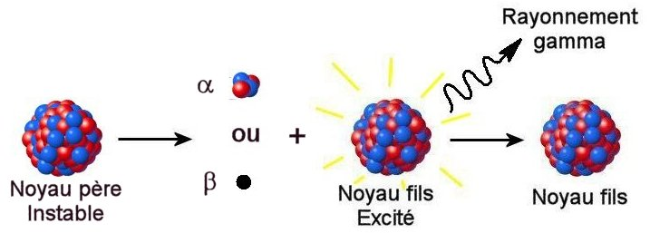

**III.2.5. Energy aspect**

In radioactivity, the total number of nucleons and the overall charge are conserved. This in no way implies conservation of mass; on the contrary, radioactive transmutations are always accompanied by a loss of mass ∆m corresponding to the release of the quantity of energy given by Einstien's relation: E= ∆m * c2

**III.2.6. Kinetic aspect**

**III.2.6.1 Law of radioactive disintegration**

This law applies to both natural and artificial radioactive nuclides. In a given sample, the number of radioactive atoms varies with time.

Radioactive disintegration depends neither on pressure nor temperature, nor on the chemical combinations in which the radioactive atoms are involved.

When the nuclide formed is not radioactive ; (A radioactive, B stable), we have:



A: absolute activity, i.e. the number of disintegrations per unit of time

N: number of radioactive atoms at time ''t

λ: radioactivity constant of the element studied

Evolution along time 

 

N0: initial number of atoms

Nt: number of atoms remaining at time ''t

The number of radioactive nuclei or atoms decreases exponentially with time.

1 mole of a radioactive element has mass M :

 and 

=  

Units of A :

A is expressed in :

* disintegrations per second (dps) or Becquerels (Bq)
* disintegrations per minute (dpm)
* Curies (Ci)

A source of 1 Curie undergoes 3.7. 1010 dps (1 g of Rd has an activity A = 1 Ci)

**III.2.6.2. Radioactive period :**

Some radioactive nuclides remain stable for billions of years, while others decay in a fraction of a second.

A disintegration process is characterized by its period T.

The period T or half-life t1/2 is the time required for half the substance to disintegration:

 

   and 

* The period T does not depend on the initial number of nuclei.
* Temperature and pressure do not affect the value of T.
* The period characterizes a given nuclide.

Examples

14C : T = 5700 years  

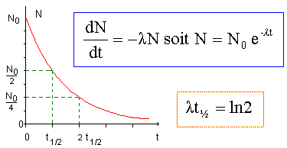

**Mise en évidence de la période T**

**III.3 Artificial nuclear reactions**

These reactions occur when nuclei are bombarded with subatomic particles such as proton, neutron, electron, helium, etc.

**III.3.1 Fission reaction**

The fission reaction is the breaking up of certain heavy nuclei into 2 fragments of comparable mass, under the impact of a projectile (usually a neutron) and the release of high energy.



A > 200 72 < A < 162

Once started, the reaction is self-sustaining, and the energy suddenly released is explosive (atomic bomb).

**III.3.2. Fusion reaction**

This is the union of 2 very light nuclei into a heavier one, with the expulsion of a neutron or proton and the release of very high energy.

Example 

The energy released is considerable, but the reaction requires a very high temperature ≈ 1million °C.

The hydrogen bomb is a direct application of these thermonuclear reactions). The control of the energy released has not yet been resolved.

III.3.3. Nuclear transmutations

These reactions produce nuclides with a mass number very close to that of the target nuclide.



**III.4. Applications of radioactivity**

**a. In chemistry :**

* Determination of molecular structures ;
* Reaction mechanisms
* Study of absorption and diffusion phenomena;
* Control of the efficiency of separation and purification methods;
* Measurement of the solubility of insoluble substances; Study of metabolisms, including the establishment of the carbon cycle in chlorophyll photosynthesis and hemoglobin biosynthesis. By introducing an isotope (13C, 2H, ….), into a molecule instead of a specific atom ((12C, 1H, ….), these isotopes can be tracked using their radiation.

**b. In medicine and biology:**

Radioisotopes are used to diagnose and treat diseases, and to provide valuable information on the mechanism of biological reactions.

Iodine-131 reduces rhyroid hyperactivity and enables the treatment of goiters.

**c. Rock dating:**

Determination of the ratio of 206Pb and 207Pb to in uranium ore.

**d. Dating archaeological finds**