**III. chromatography**

**III.4.1. Paper chromatography (CP)**

**III.4.1.3. Applications**

Paper chromatography is used for separation and the analysis and very polar compounds, such as amino acids, the sugars, flavonoids etc....

**III.4.2. Thin Layer chromatography (TLC)**

**III.4.2.7. Applications**

*Separation of small molecules such as: amino acids, fatty acids, simple sugars, pigments, medicines.

• It is a high sensitivity technique it is indicated to separate the low-volume substances. TLC is used in various fields: chemistry, biochemistry, biology, agri-food, environment, pharmaceutical, clinical, toxicology ......, it allows the separation and the analysis of many substances such as lipids, acids organic, carbohydrates, peptides, phenols, dyes natural and synthetic, vitamins and inorganic components.

* It allows an easy and fast control of the purity of a compound

organic, if the analyte, carried out with various solvents and different

adsorbents, reveals the presence of a single substance, we can then consider that this sample is probably pure.

*The TLC indicates the number of components of a mixture. We can

use it to track the progress of a reaction.

**III.5. Column chromatography**

**III.5.1. Exclusion chromatography**

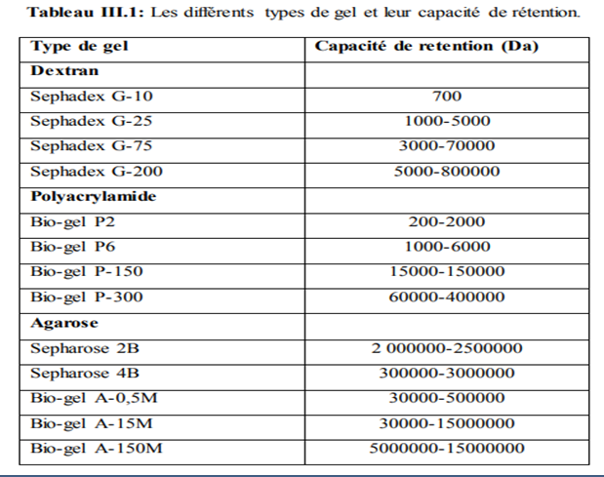

**III.5.1.5. Applications**

The applications of molecular exclusion are very diverse :

*Purification of proteins, peptides, polysaccharides, hormones, cofactors, nucleic acids.

* Determination of the molecular weight since the volume of elution is

approximately a linear function of log(molecular weight) in the separation zone (area of application).

*Concentration: high molecular weight substances can be concentrated by addition of dry gel (Sephadex G25 for example) which moisturizing absorbs small molecules (solvent).

*Desalination: a gel column (Sephadex G25) separates the substances

high molecular weight eluted in the exclusion volume, salts who are being held back. This method applies to nucleic acids, proteins and polysaccharides.

**III.5.2. Ion exchange chromatography**

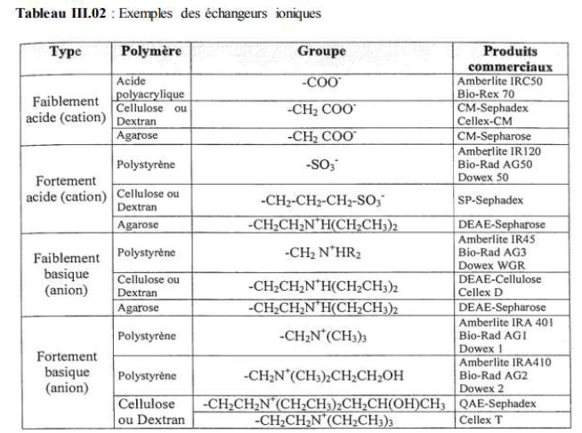

**III.5.2.3. Applications**

Ion exchange chromatography is applicable to a large number of molecules biological loaded. The nucleic acids are separated on an anionic exchanger.

Certain polysaccharides and peptidoglycans according to their fillers are also retained.

The proteins are stable in a narrow pH range, so the selected exchanger

must operate in this area. Generally if the analyte is more stable below

its isoelectric point, it has a net positive charge, and a cation exchanger must be used. Similarly, if the analyte is more stable above its isoelectric point (negative net charge) an anion exchanger must be implemented. For the stable substances in a wide pH range, the two types of exchangers can be used.

**III.5.3. Affinity chromatography**

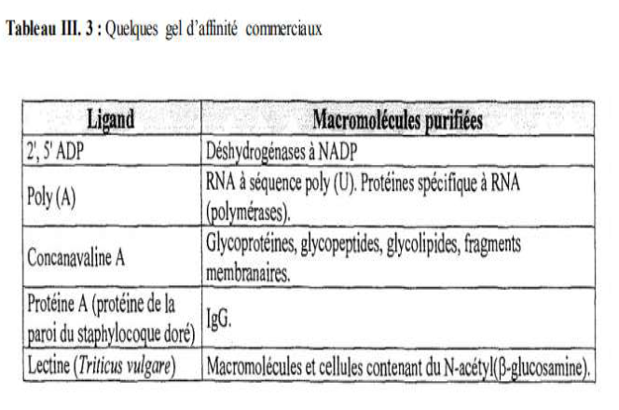

**III.5.3.4. Applications**

Affinity chromatography is suitable, either for the analysis, or for the

preparation of biological substances. It has been used in:

*Enzymology, for the extraction of enzymes and the purification of extract enzymatic.

*Immunology, for the purification of antibodies.

* Protein chemistry, for the study of membrane proteins.

*Nucleic acid chemistry, for the fractionation of various acids

nucleic acids (mRNA, rRNA, etc.)

**III.5.5.5 Applications**

CPG is the most widely used chromatography for non-polar analytes,

volatile and which do not require derivation., in particular, fatty acids, fatty acids amino acids, dares, steroids, toxicants, drugs…