***Topic # 2***

**The Implications of COVID-19 for Mental Health and Substance Use**

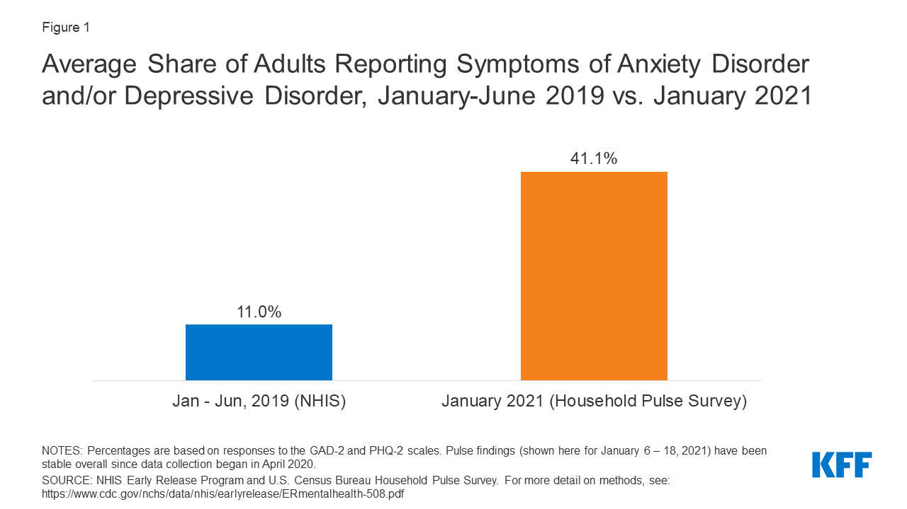The COVID-19 pandemic and the resulting economic recession have negatively affected many people’s mental health and created new barriers for people already suffering from mental illness and substance use disorders. During the pandemic, about [4 in 10](https://www.kff.org/other/state-indicator/adults-reporting-symptoms-of-anxiety-or-depressive-disorder-during-covid-19-pandemic/) adults in the U.S. have reported symptoms of anxiety or depressive disorder, a share that has been largely consistent, up from [one in ten](https://www.cdc.gov/nchs/data/nhis/earlyrelease/ERmentalhealth-508.pdf) adults who reported these symptoms from January to June 2019 (Figure 1). A [KFF Health Tracking Poll](https://www.kff.org/coronavirus-covid-19/report/kff-health-tracking-poll-july-2020/) from July 2020 also found that many adults are reporting specific negative impacts on their mental health and well-being, such as difficulty sleeping (36%) or eating (32%), increases in alcohol consumption or substance use (12%), and worsening chronic conditions (12%), due to worry and stress over the coronavirus. As the pandemic wears on, ongoing and necessary public health measures expose many people to experiencing situations linked to poor mental health outcomes, such as [isolation](https://www.cdc.gov/mentalhealth/learn/index.htm) and [job loss](https://www.cdc.gov/violenceprevention/suicide/riskprotectivefactors.html).

**Figure 1: Average Share of Adults Reporting Symptoms of Anxiety Disorder and/or Depressive Disorder, January-June 2019 vs. January 2021**

<https://www.kff.org/coronavirus-covid-19>

Read carefully the text above and answer the questions below.

1. **Comprehension of the text:**

* What is the topic of the text?
* ……………………………… COVID-19 and the Mental Health ……………………
* Where this study is made?

………………USA…………………

* Mention the symptoms that are reported in this survey:
* ………… difficulty sleeping …………………………………..
* ………… difficulty eating......................................................
* … worsening chronic conditions/ increases in alcohol consumption or substance use
* What is the percentage of adults reporting these symptoms during Covid-19?

……………………………40%………………………………….

* In the figure 1, what is representing the bar with 11%?

Average Share of Adults Reporting Symptoms of Anxiety Disorder and/or Depressive Disorder before Covid-19 / during the period of January-June 2019.

1. **Linguistic competency:**

* Propose an antonym for each word below:
  1. Negatively ≠ ……Positively…..
  2. New ≠ …………Old………….
  3. Disorder ≠ …………Order…………..
  4. Difficulty ≠ ..............Facility...................
  5. Increase ≠ …………Decrease…………….
* Give the equivalent in Arabic of the terms listed below:

1. Recession =…………الركود…………
2. Anxiety = ……القلق……. …
3. Alcohol = …………الكحول………
4. Outcomes = ……………المخرجات………..
5. Symptoms = ………الأعراض…………

* Translate in Arabic the below sentence:

During the pandemic, about [4 in 10](https://www.kff.org/other/state-indicator/adults-reporting-symptoms-of-anxiety-or-depressive-disorder-during-covid-19-pandemic/) adults in the U.S. have reported symptoms of anxiety.

خلال الوباء ، أبلغ حوالي 4 من أصل كل 10 بالغين في الولايات المتحدة عن أعراض القلق.