**Endocrinology:** is a branch of medicine that studies hormones, their functions, and their disorders. Its name means the study (logos) of internal (endo) secretion (crine). It studies a great many physiological phenomena (nutrition, growth, reproduction, etc.) because hormones are involved in numerous functions in many organisms, including humans.

**Hormones classification and mechanisms of action**

One of the body's two main communication systems, together with the neurological system, is the endocrine system (endo: inside and krinien: secreted). It is crucial for preserving the homeostasis of the organism.

The central nervous system (CNS) and the endocrine system are essential for controlling key biological processes, interacting with one another, and adapting to the environment:

- The CNS through the regulation of relational life with the environment by rapid regulation and brief responses.

- The endocrine system through slow but more lasting control.

The endocrine system is a set of secretory organs (glands and cells) that produce hormones and release them into the blood.

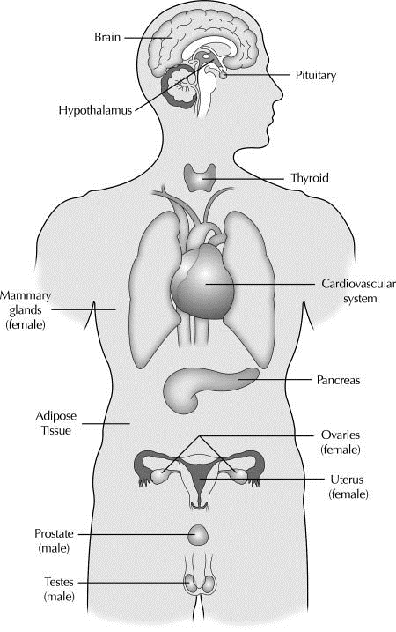

**Fig 1 :** The endocrine system (Diamanti-Kandarakis et al., 2009).

**Hormones** : (from the Greek hormôn, to excite or stimulate) are natural substances of organic nature that act as chemical messengers between different parts of the body. They control many functions including growth, reproduction, sexual function, sleep, hunger, mood, and metabolism.

Some cells in the body are composed of proteins called receptors that respond to a hormone. The way a cell reacts depends on the hormone it responds to.

**2. The glands**

There are two types of glands:

**Exocrine glands**

These are glands whose secretion is no longer released into the internal environment in the blood but is released into the external environment.

Exocrine glands are in contact with the surface of the organism (sweat gland, sebaceous gland) or the lumen of a hollow organ through an excretory duct (exocrine pancreas, gallbladder). It is through this excretory duct that the product of glandular secretion will be drained. However, there are exocrine glands located within the thickness of a covering epithelium; this is the case for unicellular exocrine glands and surface exocrine glands.

**Endocrine glands**

Glands that release their secretory products into the blood (internal secretion). Endocrine glands (cell or group of cells) secrete their products (hormones) into the interstitial space (extracellular environment = internal environment) surrounding the secretory cells following stimulation, through exocytosis. (et non dans des canaux).

The secretions then diffuse into blood capillaries and are transported by the blood. The endocrine glands constitute a communication system between the different organic cells, allowing them to coordinate their actions for the maintenance of homeostasis, their growth, and their development.

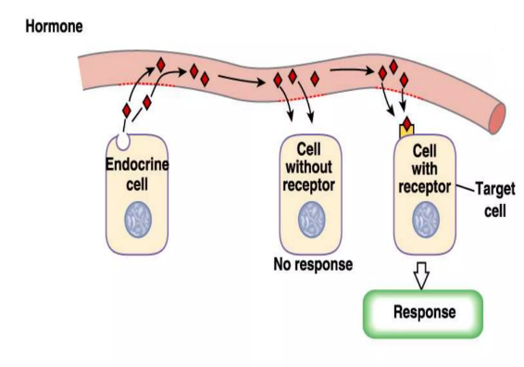

**Fig 2 :** Hormone-target cells (Nursat, 2020)

When discussing a structure that is only involved in hormone secretion, we refer to it as a real endocrine gland. The thyroid, adrenal glands, and pituitary gland are examples of true endocrine glands. Other organs, such as the gonads and hypothalamus, can perform both endocrine secretion and another physiological function. Multiple hormones can be secreted by the same endocrine gland.

**Note:** we have the example of the pancreas, which produces both insulin and glucagon (hormones) and digestive enzymes, released into the duodenum, and also the testicle, which produces testosterone (hormone) and sperm. These two glands are both endocrine and exocrine.

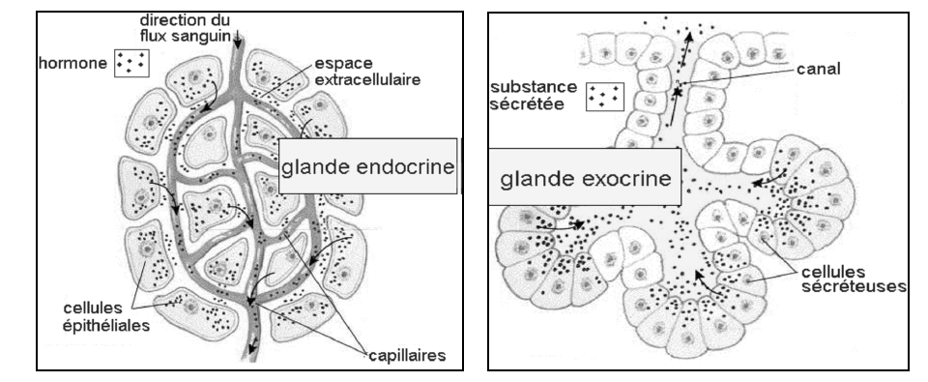

**Fig 3 :** Types of glands (Dee Unglaub Silverthorn, 2007).

**3. Classification of hormones**   
The endocrine glands produce three major categories of hormones.   
1°/ peptide hormones,   
2°/ Steroid hormones   
3°/ Monoamine hormones

**1-Peptide hormones:** these are small proteins. Once secreted into the blood, these hormones circulate freely. They act on target cells through protein receptors that traverse the plasma membranes of the target cells.

• The receptors are specific to a given hormone, but a hormone can have several types of membrane receptors.

• Examples of peptide hormones: insulin, glucagon, parathyroid hormone, prolactin, erythropoietin, GH, TSH, LH, FSH, ACTH, TRH….

• The mature hormone is packaged in secretory granules located beneath the plasma membrane.

• The signal triggering exocytosis is often a chemical messenger binding to a membrane receptor.

• The vesicle then fuses with the plasma membrane and its contents are delivered to the extracellular medium.

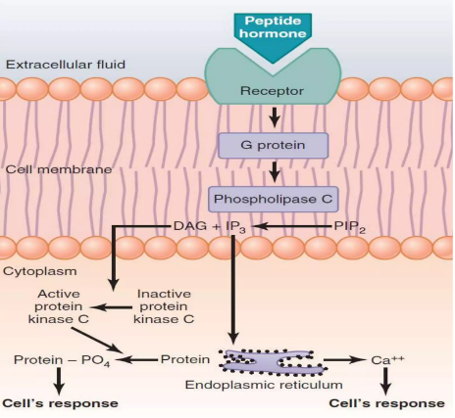

**Fig 4 :** Peptide hormone (Nursat, 2020).

**2- Steroid hormones:** these are lipids synthesized from a cholesterol nucleus. These steroids must bind with plasma proteins in order to be transported in the bloodstream.

- The steroid-protein complex is inactive; only the free steroid hormone has an endocrine action.

- The transport protein only releases the steroid hormone at the level of the blood capillaries that supply the target organs.

- These steroid hormones act on intracellular receptors.

- steroid hormones: cortisol, androgens, progesterone, estrogens...

**3-Monoamine hormones:** They all derive from an amino acid: tyrosine. These are small molecules and their mechanism of action on target cells is similar to that of peptide hormones; they circulate freely in the blood and act on target cells through transmembrane receptors:

• the first subgroup mainly contains adrenaline, noradrenaline, dopamine;

• and the other subgroup consists of thyroid hormones T3 and T4.

• they are bound to plasma proteins during their transport, which inactivates them

• They act on intracellular receptors.

• Only target cells that contain receptors are sensitive to hormones.

**4. Mode of action of hormones**

Hormones act through receptors to which they bind, which can be on the cell membranes, thus outside the cells. Or inside the cells, and there they must therefore cross the membranes.

**Hydrophilic hormones:** It includes peptide hormones and monoamines such as catecholamines (Adré Noradré) and serotonin. In this case, a gland will secrete a first messenger that will act on the target cell through a receptor. The latter is not capable of generating a biological effect in the cell. The receptor will capture the external signal, its binding with the primary messenger will activate an enzyme that allows the synthesis of a second messenger. A receptor is specific to a molecule.

The formation of the messenger/receptor pair leads to the activation of a transduction system that can stimulate an enzyme, an ion channel to provoke an intracellular response. It therefore acts by modifying pre-existing proteins. It most often circulates freely in the blood.

**Lipophilic hormones:** They include steroids and thyroid hormones. All these lipophilic hormones are derivatives either of fatty acids (cholesterol for steroids (Corticosteroids: glucocorticoids and mineralocorticoids and gonadosteroids, arachidonic acid for eicosanoids), or of tyrosine for pituitary hormones.

They circulate in the blood bound to a transport protein (albumin...).

Glucocorticoids "GC" target the nucleus where they perform gene regulation. Since the cytoplasm is hydrophilic, these "GC" need a receptor protein for transport in the cytoplasm and chaperone proteins (HSP) at rest.

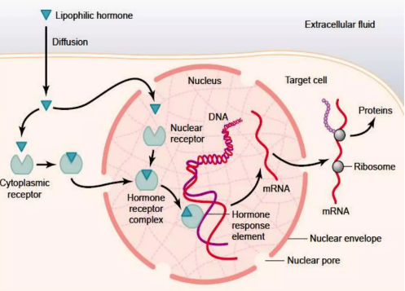

**Fig 5 :** Lipophilic hormones (Nursat, 2020)

**5. Mode of signal transmission**

-The "Paracrine" mode: This mode uses only the extracellular medium to convey the hormone. Example: inflammation hormones.

In paracrine signaling, molecules are secreted locally and modulate the activity of adjacent cells within the same tissue (for example, TNF produced by activated macrophages in the bone marrow stimulates DNA synthesis by neighboring osteoblasts).

-The "Autocrine" mode: In autocrine signaling, hormones act on the cells that secrete them. Example: Lymphocyte producing cytokines or tumorigenesis.