**VI) Polyelectronic atoms (Electronic configurations)**

All atoms in their stable state have more than one electron (+Ze protons and -Ze electrons), except the hydrogen atom. Each electron is subject to both the attraction of the +Ze nucleus and the repulsion of other electrons.

VI).1. Position of the problem: example of the two-electron atom

We propose to study the case of the first stable atom with two electrons: helium atom Z = 2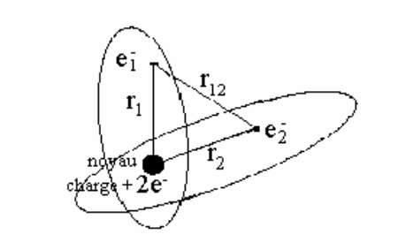

The nucleus is assumed to be fixed in space (Born Oppenheimer approximation). The wave function ψ that describes this system depends on the coordinates of the two electrons; the position of electron i is marked by spherical coordinates (ri, θi, ϕi) , or Cartesian coordinates (xi,yi,zi) .The general solution of the Schrödinger equation is then a function ψ of six variables. Its expression in spherical coordinates is written as follows:



The electrostatic potential energy of the system (Ep) is composed of three terms involving the three distances r1, r2, and r12 :

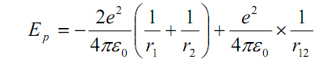

The Schrödinger equation corresponding to this system is written as follows: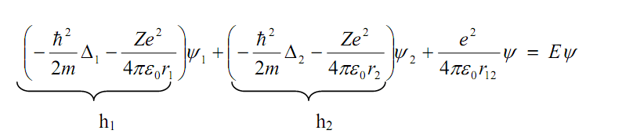

h1 and h2 are the monoelectronic Hamiltonians for which the solution is already known.

The Hi operators (i = 1, 2) act only on the variables ri, θi, ϕi; so ψ is written as :

where (ψ1) and ( ψ2): single-electron wave functions.

**VI ).2. Slater's monoelectronic approximation**

This approximation consists of grouping the electrons of an atom into a cloud around the nucleus, while isolating a single electron further away. In this case, we can calculate the energy of this isolated electron, since it is considered to be alone. The potential to which it is subjected is an average central potential. It is made up of the potential of the nucleus corrected by the presence of the other electrons. In effect, the electron cloud acts as a screen between the nucleus and the isolated electron, bringing us back to the model of the hydrogen atom and hydrogen ions. The potential of the zth electron is :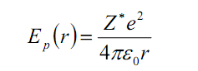

Z*: effective nuclear charge relative to the electron.

The effective charge at each moment is not the same. It takes into account both nucleus-electron attraction and electron-electron repulsion (screen effects).

**VI).2.1. Screen effect**

In Slater's approximation, the attraction between the atom's Zth electron and the nucleus is considered to be subject to the action of a nucleus whose charge number is no longer Z electrons. The charge of the atom's nucleus then becomes an effective charge Z*. This charge, which is weaker than the real charge of the nucleus, is obtained by subtracting from the real Z the shielding effects of the other electrons:

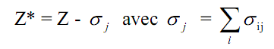

This formula is called Slater's monoelectronic attraction, where σ: screen constant. It depends on the position of the atom's (Z -1)th electrons relative to the Zth electron j.

σ ij : screening constant for each electron i that screens an electron j.

**VI).2.2 Calculation of the effective nuclear charge Z*.**

Slater has set out the rules for expressing the shielding constant σ ij for each electron i that exerts a shielding effect on an electron j.

- If electron i is further from the nucleus than j, its shielding effect on j will be very weak,

- If electron i is closer to the nucleus than j, its shielding effect on j will be very strong.

These rules are based on the following approach:

1- Divide the atomic orbitals into several groups in the following order: (1s) (2s, 2p) (3s,

3p) (3d) (4s, 4p) (4d) (4f) (5s, 5p)...

2- Choose the electron for which you're looking for the effective charge. All other electrons will make a partial contribution σij to the total screen constant σ. This contribution depends on :

- the electron's orbital type (s, p), (d), or (f),

- the electron's electronic layer n.

3- Calculate the screening coefficients σ ij reflecting the screening effects exerted by electrons belonging to the same or lower groups from the table below:

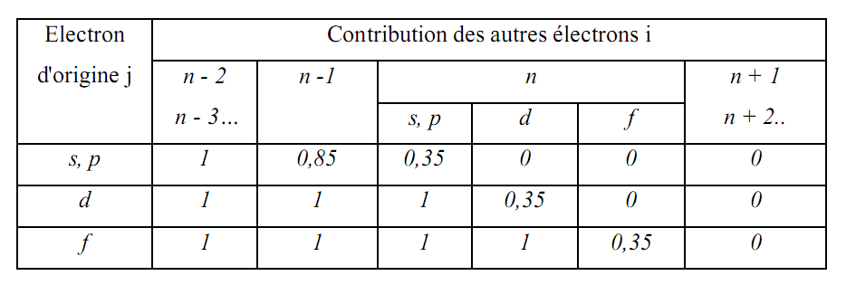

**I.3 Example of effective charge calculation**

- The atomic orbital distribution of nitrogen 7N is: 1s2s2p3. It can be written as :

An electron of the outer layer (2s, 2p) therefore has as screen electrons :

- 4 electrons (s, p) from the n layer: σ ij = 0.35

- 2 s electrons from the n-1 layer: σ ij = 0.85. We deduce:

σ ij = (2 × 0.85) + (4 × 0.35) = 3.10 So the effective charge: Z* = Z - σ ij = 7 - 3.1 = 3.9

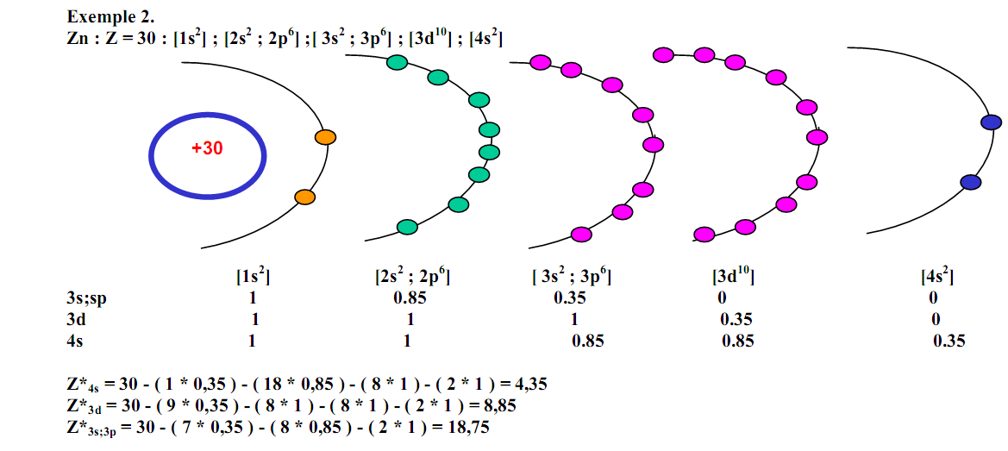

**VI).3. Electronic configurations of a monoatomic structure**

Establishing the electronic configuration of a monoelectronic atom or ion in a given state consists in indicating the distribution, in this state, of the Z electrons in the different monoelectronic spin orbitals 1s 2s 2p,...etc., the number of electrons being noted as an exponent.

Example: 1s2 means that two electrons are described by the orbital 1s. In other words, two electrons occupy the 1s orbital.

The filling of quantum bins or atomic orbitals must comply with the following four rules.

**VI ).3.1. Stability principle**

Electrons occupy the lowest possible energy levels (Principle of minimum energy).

**Practical consequence: 1s 2s 2p 3s 3p 3d 4s 4p 4d 4f 5s 5p 5d 5f....**

**VI ).3.2. Pauli's exclusion principle**

Two electrons in the same atom cannot have the same four quantum numbers: n, l, m, and s

Practical consequence: 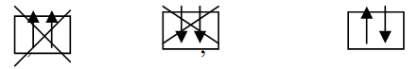

n, l, m are fixed in the same square. Only a maximum of two electrons with opposite spin quantum numbers can be placed.

**VI ).3.3. Hund's rule**

In the ground state, when several degenerate atomic orbitals are free, electrons are positioned to occupy as many of them as possible. Electrons occupy these degenerate orbitals with positive (parallel) spin moments, before moving to opposite spins.

The ground state is given by a maximum of parallel spins. We therefore occupy a maximum number of orbitals before saturating them.

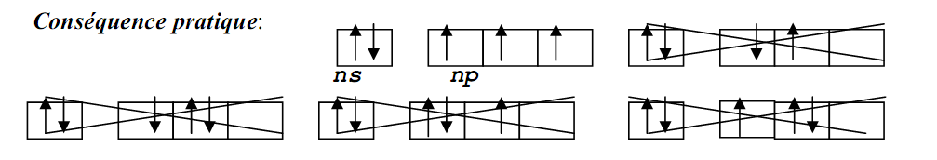

**VI ).3.4. Klechkowski's rule**

Layers and sub-layers are filled in order of increasing values of the pair (n + l ). If two or more (n + l ) pairs lead to the same value, they are ordered by increasing n.

Representation of Klechkowski's rule: The various layers and sub-layers are written in a table. Each row has an n value and each column has an l value.

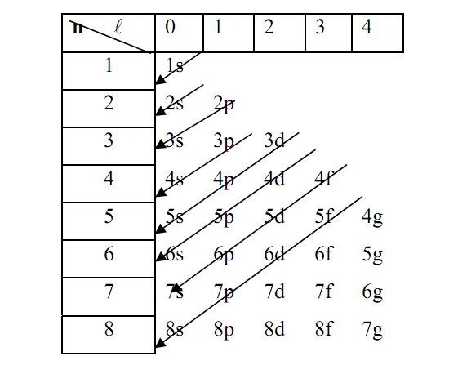

**Mnemonic representation**

The order of filling the quantum sublayers is: 1s 2s 2p 3s 3p 4s 3d 4p 5s 4d 5p 6s 4f 5d 6p 7s 5f 6d 7p

**IV.2 Core and valence electrons**

**IV.2.1. Definitions**- The valence shell is the outermost layer of the atom, occupied by electrons. It determines chemical properties.

If an inner sublayer is not filled, this sublayer is considered part of the valence layer.

Example: For Z = 14, the corresponding electronic configuration is: 1s22s2 2p63s2 3p4

The three layers occupied by the electrons do not play an equivalent role.

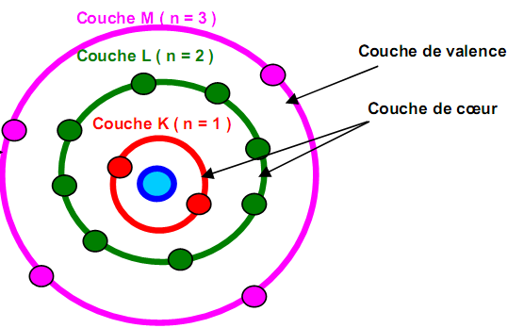

2- Rare (or noble or inert) gases are chemically stable and have an electronic configuration of the peripheral or valence layer: ns2 np6.

3- To quickly describe the electronic configuration of any electron without having to write down all the internal layers and sublayers, we'll write this configuration in condensed form.

Rare gas configuration) + (valence layer)

Helium (He, Z=2), Neon (Ne, Z=10), Argon (Ar, Z=18), Krypton (Kr, Z=36) Xenon (Xe, Z=54) Radon (Ra, Z=86) .

**V.2.2. Atomic Lewis diagram**

The valence layer is simply represented in the form of a diagram showing its various quantum bins and whether or not they are occupied by electrons.

**Examples** :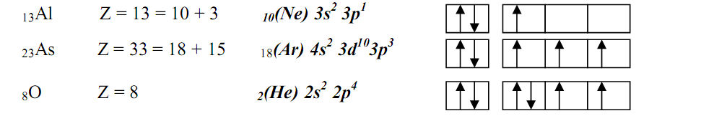

Electrons are represented by dots and paired electron doublets by dashes.

It is therefore essential to first write the diagram in the form of quantum dots before

the simplified Lewis diagram.

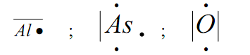

Simplified Lewis diagrams are only used for elements with only s or p sublayers on their valence layers.

**IV.2.3. Exceptions to Klechkowski's rule**

An empty, filled, or half-filled sublayer confers greater stability on the atoms.

This rule applies in particular to configurations of the type (n-1)d9 ns2(Cu, Ag and Au) and (n-1)d4 ns2(Cr, Mo), which will transform into (n-1)d10 ns1 and (n-1)d5 ns1 respectively (an electron from the s sublayer transits to the d sublayer to complete it with 5 or 10 electrons: the resulting configuration will be more stable than the initial configuration.

In the case of f-type electrons, the d level first receives an electron before the f level begins to fill up.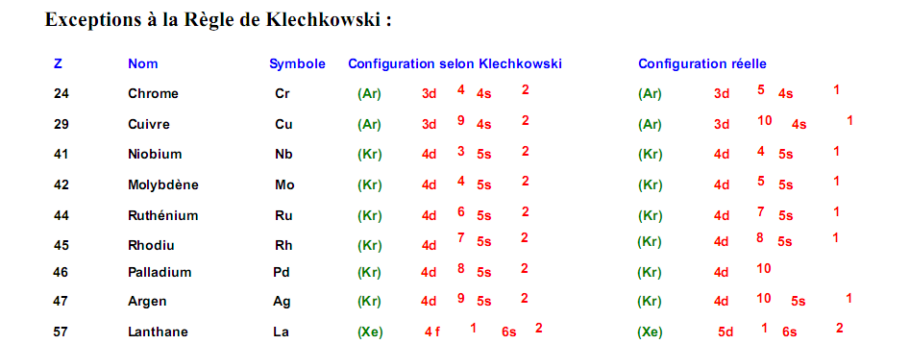

**Electronic structure of ions**

Find the element's electronic configuration: if it's a cation (+), remove one or more electrons; if it's an anion (-), add one or more electrons. In this case, pay attention to the filling order.

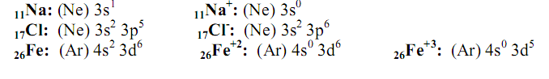

**V. Conclusion**

The simple model of the atom will lead us to the concept of the periodic table and will then be used to describe the main chemical properties.