Université Mohamed Boudif de M’sila | Chargé de TP : Dr. M. Hadjab

Faculté de Technologie | 2éme année Master

Département d’Electronique | Spécialité : Microélectronique

Filière : Electronique | Année universitaire : 2024/2025

**TP**

Simulation des cellules solaires à base de a-Si :H avec *wx*AMPS-1D

Réalisé par les étudiants :

1. ………………………………………..……..
2. ……………………………………………….
3. ……………………………………………….
4. **Partie théorique :**
   1. **L’objectif de TP**

………………………………………………………………………………………………………………………………………………………………………………………………………………………………………………………………………………………………………………………….

* 1. **Logiciel utilisé dans le TP**

………………………………………………………………………………………………………………………………………………………………………………………………………………………………………………………………………………………………………………………….

* 1. **Définition du logiciel utilisé**

………………………………………………………………………………………………………………………………………………………………………………………………………………………………………………………………………………………………………………………….

………………………………………………………………………………………………………………………………………………………………………………………………………………………………………………………………………………………………………………………….…………………………………………………………………………………………………………………………………………………………….…………………………………………………………………………………………………………………………………………………………….…………………………………………………………………………………………………………………………………………………………….…………………………………………………………………………………………………………………………………………………………….

* 1. **Prise en main de wxAMPS-1D**

…………………………………………………………………………………………………………………………………………………………….…………………………………………………………………………………………………………………………………………………………….…………………………………………………………………………………………………………………………………………………………….…………………………………………………………………………………………………………………………………………………………….…………………………………………………………………………………………………………………………………………………………….…………………………………………………………………………………………………………………………………………………………….…………………………………………………………………………………………………………………………………………………………….…………………………………………………………………………………………………………………………………………………………….…………………………………………………………………………………………………………………………………………………………….…………………………………………………………………………………………………………………………………………………………….…………………………………………………………………………………………………………………………………………………………….…………………………………………………………………………………………………………………………………………………………….

* 1. **Généralités sur les matériaux basés sur le Silicium (Si)**

…………………………………………………………………………………………………………………………………………………………….…………………………………………………………………………………………………………………………………………………………….…………………………………………………………………………………………………………………………………………………………….…………………………………………………………………………………………………………………………………………………………….…………………………………………………………………………………………………………………………………………………………….…………………………………………………………………………………………………………………………………………………………….…………………………………………………………………………………………………………………………………………………………….…………………………………………………………………………………………………………………………………………………………….…………………………………………………………………………………………………………………………………………………………….…………………………………………………………………………………………………………………………………………………………….…………………………………………………………………………………………………………………………………………………………….…………………………………………………………………………………………………………………………………………………………….

* 1. **Généralités sur les cellules solaires basées sur le Si**

…………………………………………………………………………………………………………………………………………………………….…………………………………………………………………………………………………………………………………………………………….…………………………………………………………………………………………………………………………………………………………….…………………………………………………………………………………………………………………………………………………………….…………………………………………………………………………………………………………………………………………………………….…………………………………………………………………………………………………………………………………………………………….…………………………………………………………………………………………………………………………………………………………….…………………………………………………………………………………………………………………………………………………………….…………………………………………………………………………………………………………………………………………………………….…………………………………………………………………………………………………………………………………………………………….…………………………………………………………………………………………………………………………………………………………….…………………………………………………………………………………………………………………………………………………………….…………………………………………………………………………………………………………………………………………………………….…………………………………………………………………………………………………………………………………………………………….…………………………………………………………………………………………………………………………………………………………….

1. **Manipulation**
2. Présenter la structure de la cellule solaire : **[le carbure de silicium amorphe hydrogéné de type p/ silicium amorphe hydrogéné de type n] = (p)a-SiC:H/(n)a-Si:H** en spécifiant chaque couche.

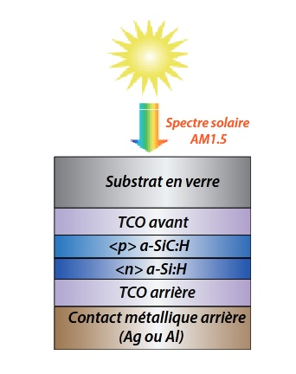

Figure – Structure schématique de la cellule p-n à simple jonction à base de a-Si:H simulée en à l’aide de wxAMPS-1D.

1. Entrer les paramètres d’entré pour chaque couche et des contacts à partir des tableaux suivants :

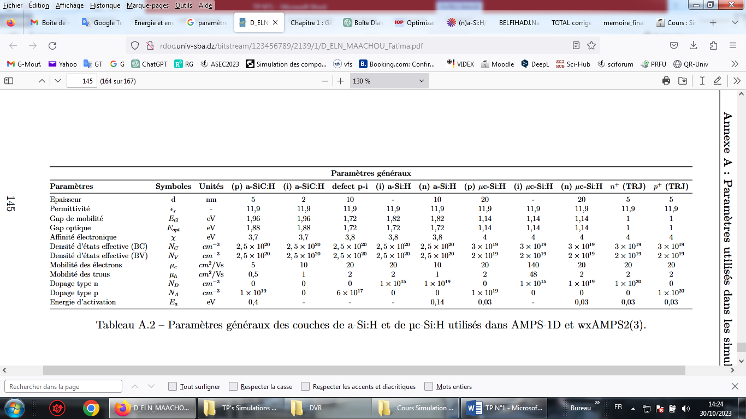

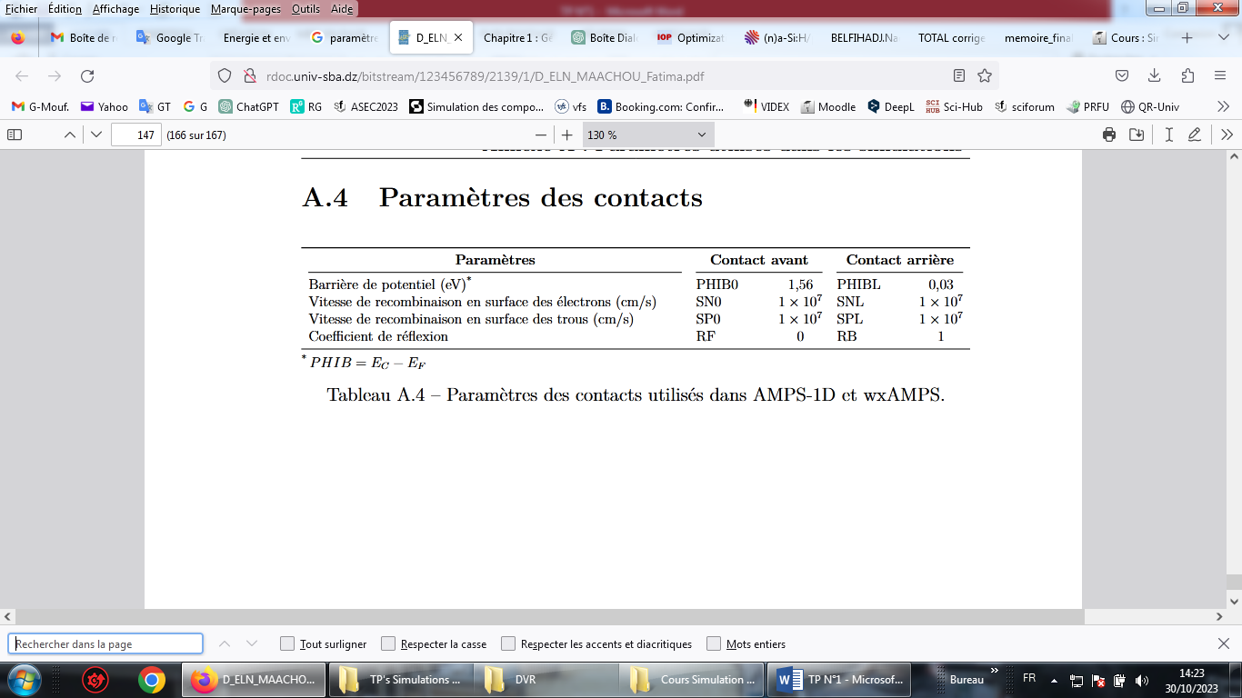

1. Optimiser les paramètres de dopage et de l’épaisseur pour chaque couche (absorbante et tampon)
   1. La couche absorbante :
      1. Optimisation de dopage (Na)

|  |  |  |  |  |
| --- | --- | --- | --- | --- |
| Valeur de Na | Voc | Jsc | FF | η |
|  |  |  |  |  |
|  |  |  |  |  |
|  |  |  |  |  |
|  |  |  |  |  |
|  |  |  |  |  |
|  |  |  |  |  |
|  |  |  |  |  |
|  |  |  |  |  |
|  |  |  |  |  |
|  |  |  |  |  |

η

Na

Na(Optimisé)= ……………………………………………

* + 1. Optimisation de l’épaisseur (Wabsorb)

|  |  |  |  |  |
| --- | --- | --- | --- | --- |
| Wabsorb (µm) | Voc | Jsc | FF | η |
|  |  |  |  |  |
|  |  |  |  |  |
|  |  |  |  |  |
|  |  |  |  |  |
|  |  |  |  |  |
|  |  |  |  |  |
|  |  |  |  |  |
|  |  |  |  |  |
|  |  |  |  |  |
|  |  |  |  |  |
|  |  |  |  |  |
|  |  |  |  |  |
|  |  |  |  |  |

η

Wabsorp

Wabsorb(Optimisé)(µm)= ……………………………………………

* 1. La couche tampon :
     1. Optimisation de dopage (Nd)

|  |  |  |  |  |
| --- | --- | --- | --- | --- |
| Valeur de Nd | Voc | Jsc | FF | η |
|  |  |  |  |  |
|  |  |  |  |  |
|  |  |  |  |  |
|  |  |  |  |  |
|  |  |  |  |  |
|  |  |  |  |  |
|  |  |  |  |  |
|  |  |  |  |  |
|  |  |  |  |  |
|  |  |  |  |  |

η

Nd

Nd(Optimisé)= ……………………………………………

* + 1. Optimisation de l’épaisseur (Wtampon)

|  |  |  |  |  |
| --- | --- | --- | --- | --- |
| Wtampon(µm) | Voc | Jsc | FF | η |
| 0.01 |  |  |  |  |
| 0.02 |  |  |  |  |
| 0.03 |  |  |  |  |
| 0.04 |  |  |  |  |
| 0.05 |  |  |  |  |
| 0.06 |  |  |  |  |
| 0.07 |  |  |  |  |
| 0.08 |  |  |  |  |
| 0.09 |  |  |  |  |
| 0.1 |  |  |  |  |
| 0.2 |  |  |  |  |
| 0.3 |  |  |  |  |
| 0.4 |  |  |  |  |

η

Wtampon

Wtanpon(Optimisé)(µm)= ……………………………………………

1. Optimiser la valeur d’énergie de gap pour la couche absorbante et étudier l’effet de la température sur les caractéristiques J-V
   1. Optimisation de la valeur de Eg

|  |  |  |  |  |
| --- | --- | --- | --- | --- |
| Eg (eV) | Voc | Jsc | FF | η |
| 1.1 |  |  |  |  |
| 1.5 |  |  |  |  |
| 1.96 |  |  |  |  |

η

Eg

ηoptimisé=……………………..…………

* 1. L’étude de l’effet de Température (T°)

|  |  |  |  |  |
| --- | --- | --- | --- | --- |
| T° (K) | Voc | Jsc | FF | η |
| 250 |  |  |  |  |
| 275 |  |  |  |  |
| 300 |  |  |  |  |
| 350 |  |  |  |  |
| 400 |  |  |  |  |
| 450 |  |  |  |  |
| 500 |  |  |  |  |
| 550 |  |  |  |  |
| 600 |  |  |  |  |
| 650 |  |  |  |  |
| 700 |  |  |  |  |

η

T

* 1. Trace des caractéristiques J-V avec les valeurs optimisées :

J

Voc= ……………………………..…..

Jsc= …………………………..…..…..

FF= …………………………..…..…..

η= …………………..…………….…..

V

1. Conclusion (1)

…………………………………………………………………………………………………………………………………………………………….…………………………………………………………………………………………………………………………………………………………….…………………………………………………………………………………………………………………………………………………………….…………………………………………………………………………………………………………………………………………………………….…………………………………………………………………………………………………………………………………………………………….…………………………………………………………………………………………………………………………………………………………….…………………………………………………………………………………………………………………………………………………………….…………………………………………………………………………………………………………………………………………………………….…………………………………………………………………………………………………………………………………………………………….

Simulation des cellules solaires à base d’une structure pin avec *wx*AMPS-1D

1. Trace des caractéristiques J-V avec les valeurs optimisées :

J

Voc= ……………………………..…..

Jsc= …………………………..…..…..

FF= …………………………..…..…..

η= …………………..…………….…..

V

1. Conclusion (2)

…………………………………………………………………………………………………………………………………………………………….…………………………………………………………………………………………………………………………………………………………….…………………………………………………………………………………………………………………………………………………………….…………………………………………………………………………………………………………………………………………………………….…………………………………………………………………………………………………………………………………………………………….…………………………………………………………………………………………………………………………………………………………….…………………………………………………………………………………………………………………………………………………………….…………………………………………………………………………………………………………………………………………………………….…………………………………………………………………………………………………………………………………………………………….