**V: MODEL BASED ON WAVE MECHANICS**

**V.1. INTRODUCTION**

Bohr's quantum model contains two essential ideas concerning electrons: 1- Electron energy is quantized: this idea is preserved in the wave model. 2- Electron motion occurs on stable, geometrically well-defined circular trajectories or orbits (Bohr). This representation has been abandoned, and replaced by the notion of probability of presence.

The electron is a very elementary and very fast particle => the a need for new mechanics applicable to the atomic domain.

**V.2. DE BROGLIE HYPOTHESIS**

Postulates that matter, like light, has a dual aspect: undulatory and corpuscular. Any moving particle, especially e-, must be associated with a wave called a pilot wave.

**λ=h/me.V** ……………..(**1**)

**V.3. HEISENBERG'S UNCERTAINTY PRINCIPLE**

This principle states that it is impossible to simultaneously and accurately measure the position and momentum of a corpuscle:

**ΔPx=m.Δvx** ……………..(**2**)

It is written :

**Δ (mv). Δx ≥ ħ => m (Δ v). Δx ≥ ħ avec ħ=h/2π** ……………..(**3**)

Exp: Calculate for two particles the uncertainty on the abscissa ∆x. The relative error on the velocity being assumed equal to 10-5, the uncertainty ∆v will be 10-5 v and ∆p will be 10-5 m v.

**m (Δ v). Δx ≥ ħ => Δx = ħ/ m (Δ V) => Δx = ħ/ 10-5 m v**

Solution: According to the relationship:

Macroscopic scale Microscopic scale

Particle: an hunting lead electron of hydrogen atom

Masse : 1 g 9.11 10-31 Kg

Vitesse : 30m/s 3 106 m/s

Précision : 10-5 10-5



Unappreciable result Important result

So Heisenberg's uncertainty principle is important at the atomic scale.

**V.4. WAVE FUNCTION**

Each state of a microscopic system is characterized by a function of coordinates x, y, z, t, called the state (wave) function. This wave function is a mathematical function that characterizes the behavior of a particle at a point M (x, y, z) in space at an instant t. It is denoted: ψ (x, y, z,t). It is the square of this function ψ 2 that has physical significance, representing the probability density of the particle's presence.

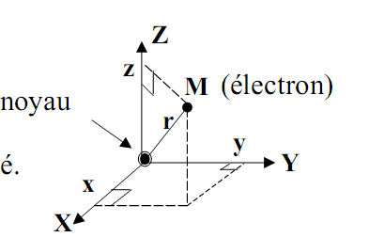

**V.4.1 Probability of presence.**

The probability of finding the electron in a volume dV at point M (x, y, z) is written :

dP=│ψ│2 dV .................(4)

The classical notion of position is replaced by the notion of the probability density of presence:

**V.4.2 Normalization condition:**

Probability of finding e- in all space = 1⇒ ∫ ψ2 dV = 1

**V.5. SCHRÖDINGER'S EQUATION**

In 1926, Schrödinger postulated that the wave function ψ (t, z, y, x) is a solution of the following equation:

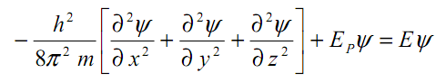…………….(5)

It's a partial differential equation where m is the mass of the particle and Ep=-Z k e2/r its potential energy. This equation expresses the conservation of total energy E. if we note :

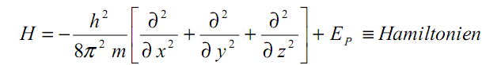

Schrödinger's equation is written in a more condensed form: H ψ =E ψ .................(6)

Schrödinger's equation synthesizes the corpuscular and wave aspects of the microscopic particle. . In this equation, the unknowns are E and Ψ(x).

**V.5.1. Eigenvalues and eigenfunctions of the Hamiltonian (H)**

Solving Schrödinger's equation shows that it only has physically acceptable Ψ solutions for certain energy values: these particular energy values are called energy eigenvalues, and the corresponding Ψ functions the eigenfunctions.

Schrödinger's equation HΨ=EΨ can therefore be written, taking into account the energy eigenvalues and eigenfunctions: HΨn =EnΨn; n being an integer.

**V.6. RESULTS OF THE SOLUTION OF SCHRÖDINGER'S EQUATION**

**V.6.1. Hydrogen atom in quantum mechanics**

**Schrödinger's equation is written :**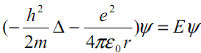

The choice of Cartesian coordinates to study this problem is unsuitable and because of the spherical symmetry of the atom, we choose the spherical coordinates r, θ, ϕ, Ψ( r, θ, ϕ).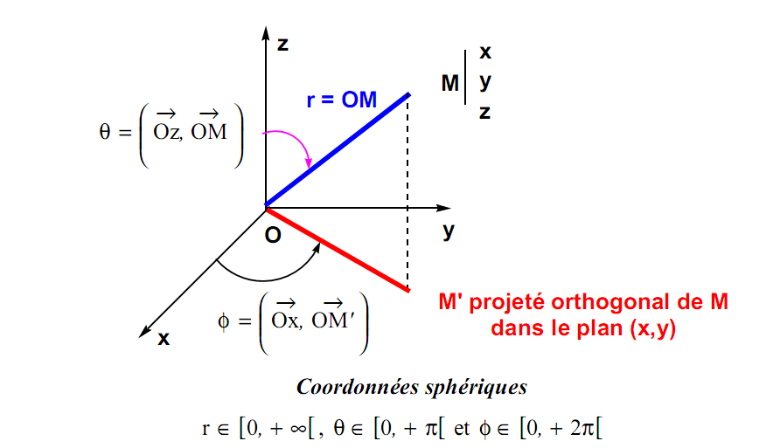

X= r sin θ cos Φ : 0 ˂ r ˂ ∞

Y= r sin θ sin Φ : 0 ˂ θ ˂ π

Z= r cos θ : 0 ˂ Φ ˂ 2 π

Nb: Volume element

r2dr = 4πr2dr

So : 4πr2dr

This is solved by putting the function Ψ( r, θ, ϕ) into the form of a product of two functions:

Ψ( r, θ, ϕ)= R (r) Y(θ, ϕ).

Solving HΨ=EΨ will only lead to physically acceptable solutions for certain energy values. For the hydrogen atom, the energy eigenvalues are given by the relation :

En=-13.6/n2

and Ψn , l, m ( r, θ, ϕ)= Rn, l (r) Yl, m (θ, ϕ)

Where: n, l, m are three integers called quantum numbers.

In the expression of atomic orbitals, the values r, θ, ϕ are separated into a radial part ( Rn, l (r)) and an angular part (Yl, m (θ, ϕ)).

For the same value of En, there are several possible Ψn , l, m orbitals. These orbitals differ in the numbers n, l and m. This implies that the En energy level is degenerate.**V.6.2. Les nombres quantiques**

**a) The principal quantum number: n**

n is the integer that is related to the energy level of the A.O. In the case of the hydrogen atom and hydrogenoids, it is used to calculate the En energy levels (see previous lesson).

n > 0 (n ∈ ℕ*) ↔ n = 1, 2, 3, 4, ... (K, L, M, N, O, ...). n determines the layer and only intervenes in the radial part, it gives us information on the effective volume of the atomic orbital but does not give its shape.

b) The secondary (or azimuthal) quantum number: ℓ

l is linked to the quantization of the modulus of the orbital angular momentum  of the electron rotating around the nucleus:

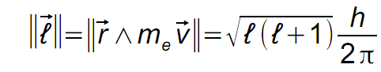

ℓ is a positive integer, strictly smaller than n, (ℓ < n) and its values range from 0 to n - 1 ⇒ ℓ ∈ ℕ and 0 ≤ ℓ < n, i.e. n different values.

As ℓ intervenes in the radial and angular part of the A.O., it gives the general shape of the A.O.

As ℓ intervenes in the radial and angular part of the A.O., it gives the general shape of the A.O.

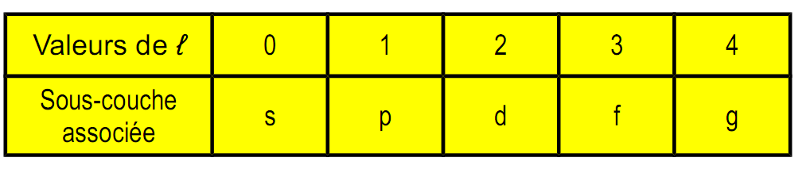

Thus: n = 1, ℓ = 0, so there is only one s sublayer.

n = 2, ℓ = 0 and 1, so there are 2 sublayers s and p.

n = 3, ℓ = 0, 1 and 2, so there are 3 sublayers s, p and d.

c) The tertiary (or magnetic) quantum number: mℓ

mℓ is related to the quantization of the projection ℓz of the electron's orbital angular momentum onto the direction of the magnetic field applied along the direction Oz :

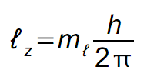

mℓ is a positive and negative integer between -ℓ and +ℓ. It can take 2ℓ + 1 values.

⇒ mℓ∈ ℤ and -ℓ ≤ mℓ≤ ℓ

As mℓ intervenes in the angular part of the A.O. it gives the orientation of the A.O. with respect to a reference direction Oz (imposed by a magnetic field directed along Oz).

For example, when ℓ = 1 we are in the presence of the sublayer p , mℓ can take the following 3 values mℓ= -1, mℓ= 0 and mℓ= +1.

⇒ there are 3 O.A. p of different directions (p-1, p0 and p+1).

**d) The fourth quantum number s: the spin quantum number**

This intrinsic kinetic moment can be associated with the electron's rotational motion on itself. For an electron in an A.O., there are 2 different energy levels, corresponding to 2 different intrinsic kinetic moments. For an electron: s can only take 2 values: +½ and -½

The notion of orbital spin: we now need to replace the monoelectronic wave function or O.A. by the atomic orbital spin ψ n,ℓ,m, s ⇒ probability of finding the electron in the state: n, ℓ, m, s

Conclusion: to a level n corresponds n² O.A. ψ n,ℓ,m and therefore 2n² spin-O.A. ψ n,ℓ,m, s

**V.6.3. Expressions of the functions Rn, l (r) and Y l, m(θ, ϕ).**

The mathematical form of the radial and angular parts of the solutions of the SCHRÖDINGER equation is shown below for hydrogen ions (and the hydrogen atom); z denotes the charge of the nucleus.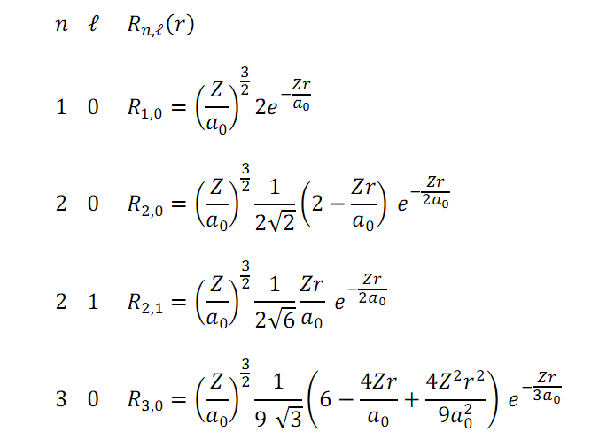

In addition, the angular parts (spherical harmonic functions) take the following forms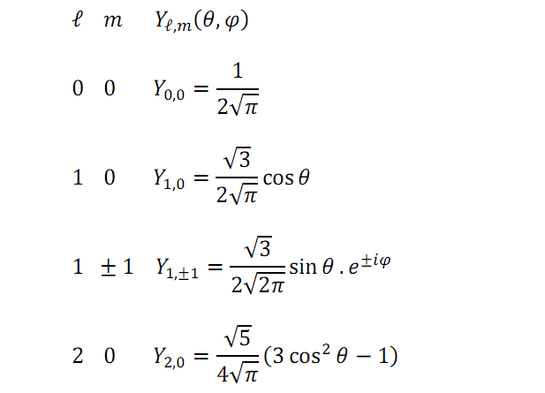

**V.6.4. Description of the different A.O.s. ψ n,ℓ,m**

A triplet {n, ℓ, m} defines an A.O.: ψn,ℓ,m for the electron in the hydrogen atom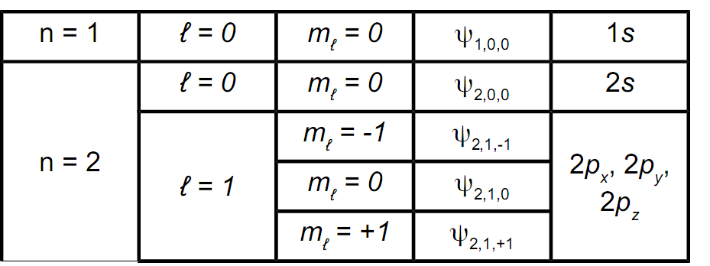

**Consequence:** when n is fixed, n² possible A.O.s can be found for the electron.

**V.6.5. Graphical representation of ψn,l,ml functions**

**V.6.5.1. Description of the "s" orbital.**

The condition l = 0 implies m = 0.

These wave functions are written: Ψn,0,0 or Ψns For s orbitals, the probability density Ψ2 of presence of the electron at the surface of a sphere of radius r is the same in all directions of space, but varies with r. The orbital is said to have spherical symmetry.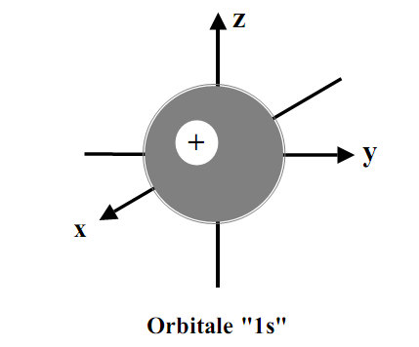 Note: the + sign shown inside the sphere is the sign of the Ψ1s wave function.

**V.6.5.2. Radial probability density: D = dP/ dr**

This is the probability of finding the electron in the volume dV of a spherical film of thickness dr at a distance r from the nucleus.

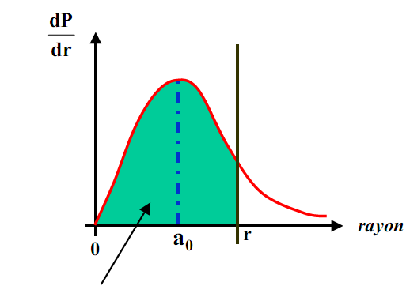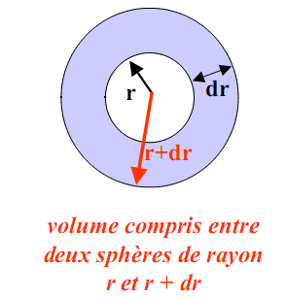

***This surface represents the probability of finding the electron between 0 and r of the nucleus***

*a0 = radius of the Bohr atom = 0.53 Å . For r = a0 = 0.53 Å ⇒ there is a 33% chance of finding the e- inside the sphere. For r = 4.2 a0, P = 99% and for r ≈ 6 a0, P = 99.9%.*

***V.6.5.3. Description of "p" orbitals.***

*The p orbitals (l = 1) can be represented by two roughly spherical, adjoining lobes with the x, y and z axes of symmetry of the reference trihedron. They are therefore called "n px", "n py" and "n pz" depending on the value of ml(n ≥ 2).*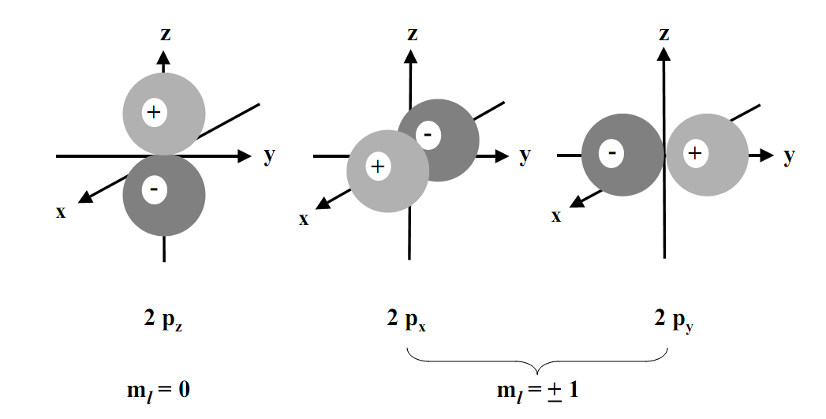

Note: the + or - sign indicated in each lobe is the sign of ψ.

**V.6.5.4. Description of "d" orbitals.**

l = 2 ⇒ m = −2, −1, 0, 1, 2 (n ≥ 3).

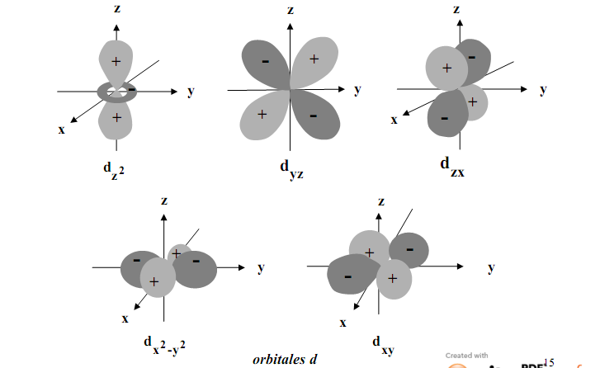

**V.6.5.5. Description of "f" orbitals.**

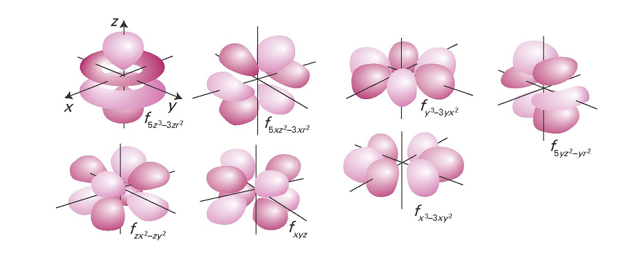

**V.6.5. 5 Electronic structure of atoms.**

-Energy diagrams.

-Hydrogen and hydrogenoids (hydrogenoid: single electron; Z ≠ 1) Example: 2He+

⇒ E depends only on n : E(eV) = -13.6. Z2/ n2

Energy degeneracy occurs in the s, p, d and f sublayers of the same electronic layer ( FIG1).

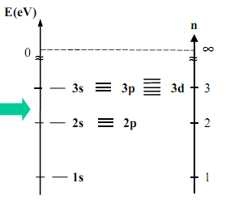 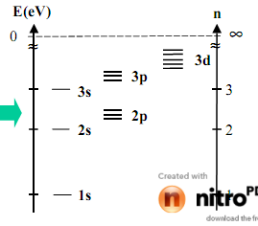

**(FIG1). (FIG2).**

- Polyelectronic atoms

E depends on n and l: degeneracy of the s, p, d, f sublayers of the same electronic layer is lifted (FIG2).