**COURSETITLE: CHEMICALTHERMODYNAMICS**

# CONTENTS

# Equationofstate

**1.0 Introduction**

# 2.0 Objectives

* 1. **Maincontent**

# Development ofequation ofstate

* + 1. **Boyle’slaw**

# Charles’law

* + 1. **Dalton’slaw**

# Idealgasequation

* + 1. **vanderWaal’sequation**

# Introduction

The Equation of state is a thermodynamic model that relates some state functions. The statefunctions in the equation of state describe the state of matter under a given condition. Observableproperties (pressure, temperature, mass, density, volume, etc) of gases are significant becausetheir values determine the state of the gas. Therefore, variation in one or more property, whileothers are held constant, can provide useful information for predicting the state of a gas, throughthe establishmentoftherelationshipbetweenthem.Forexample,

* + 1. If the pressure and temperature are held constant, the volume of the gas depends onthe mass (i.e amount) indicating that the relationship between mass and volume of thegas(i.edensity)canbeverified.
    2. If the mass and temperature are held constant, the product of the pressure and volumewillbealmostconstantforrealgasbutexactlyconstantforidealgas.
    3. Ifthemassandthepressureareheldconstant,thevolumewillbedirectlyproportional to temperature, indicating that the ratio of the volume to temperature willbe constant.

Other properties of gases can be verified through other relationships and the necessary equationsobtainedfromsuchverificationconstituteequationofstate.Theequationofstateisalsoapplicable to other states of matter. For example, equation of state for modelling the transition ofsolid from one crystalline state to another, equation of state for perfect fluid (in cosmology) andequation of state for modelling the interior of stars (which includes neutron stars, dense matterandradiation.However,sincethebehaviourofgasescaneasilybemodelled,weshallconcentrateongases.

# Objectives

Attheend ofthismodule,studentsareexpectedtounderstandthefollowing;

* + 1. Toknowthe meaningofequationofstate withrespecttogases
    2. To followthetrendinthe developmentofequationofstate
    3. ToknowandapplyBoyle‘slawinsolvingmathematicalproblems
    4. ToknowandapplyCharles‘lawinsolvingmathematicalproblems
    5. ToknowandapplyDaltonlawinsolvingmathematicalproblems
    6. Toknowandapplyidealgas lawinsolvingmathematicalproblems
    7. ToknowandapplyvanderWaalsequationinsolvingmathematicalproblems

# Maintext

* 1. **Developmentofequationofstate**

# Boyle’slaw

Robert Boyle (1662) was the first to develop a documented equation of state, which he obtainedthrough series ofexperiments using J-shaped glass tube to study the variation of the volume of afixed mass of a gas with pressure (at constant temperature). In support of Robert Boyle work,Edme Mariotte (1676) also confirmed the relationship between pressure and volume of a fixedmass of a gas atconstant temperature. Boyle‘slaw states thatatconstant temperature, thevolume of a fixed mass of a gas is inversely proportional to its pressure. Mathematically, Boyle‘slaw canbeexpressedasfollows,

1

𝑉𝛼𝑃

𝑃𝑉=𝐾

Therefore,accordingtoBoyle‘slaw,theproductofthepressureandvolumeforagivenmassofa gas will always be constant provided the temperature is constant. It also implies that a plot ofvolume (V) against the inverse of pressure (1/P) and also a plot of pressure against volume willfollow predictedpatternsas showninthefiguresbelow,

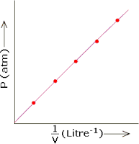

# Fig. 1: Variation of pressure of ideal gas with the inverse of its volume according to Boyle’slaw

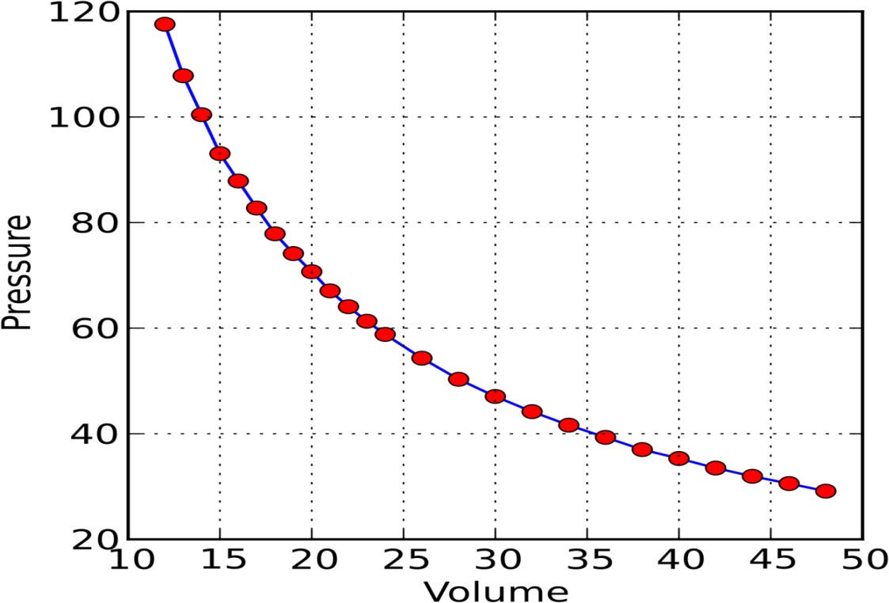

**Fig. 2Variation ofpressurewithvolumeaccordingtoBoyle’slaw**

# Charleslaw

The next level of development of equation of state for gases was pioneered by Jacques Charles(1787) and Jospeh Louis Gay-Lussac (1802). Charles found that the expansive behaviour of airand some gases over a range of temperature, followed a similar pattern.In repeating similarexperiments,Gay-Lussacfoundthattherewasalinearrelationshipbetweenvolumeandtemperature. Charles law states that at constant pressure, the volume of a given mass of a gas isdirectly proportional to its absolute temperature.Mathematically, Charles‘ law can be expressedasfollows,

𝑉𝛼𝑇

𝑉

𝑇=𝐾

Hence, according toCharles‘ law, the ratio of the volume of afixedmass of a gas toitstemperature, will always be a constant provided the pressure is held constant. This also translateto interprets a plot of V against T aslinear with zero intercept and slope, equal to K. GraphicalrepresentationofCharles‘lawinvariousformsarepresentedinFig.3below

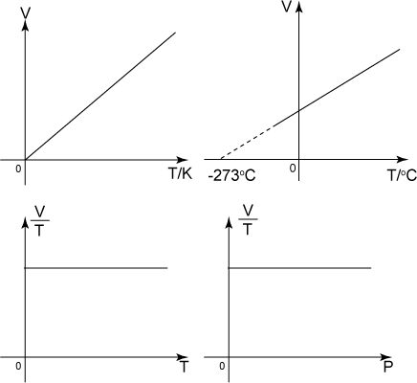

# Fig,3:VariousplotsrepresentingCharles’law

* + 1. **Daltonlaw**

Daltonlaw(1801) isconcernedaboutthepartialpressureexertedbygasesinamixture.Thelawstates that for a mixture of gases which do not react chemically, the total pressure of the gas isthe sum of the partial pressures exerted by the individual gases in the mixture. This implies thatifacomponentsofagasmixturearelabeled asA,B,C,D N,thenthetotalpressureofthe

gaswillbeexpressedas

𝑁

𝑃𝑇= 𝑃𝐴+ 𝑃𝐵+ 𝑃𝐶+ 𝑃𝐷 ………..+𝑃𝑁=∑𝑃i

i=𝐴

# The idealgas equation

TheidealgasequationwasdevelopedbyEmileClapeyron,whocombinedBoyleandCharleslawsin1834.Theequationcanbewrittenas,

𝑃𝑉=𝑛𝑅𝑇

wherenisthenumberofmolesofthegasandRistheuniversalgasconstant,whichisnumericallyequalto8.314J/mol/K

# VanderWaalequationofstate

In 1974, J. D. Van der Waals derived an equation of state that can be used to interpret thebehaviourofrealgases.Thiswasnecessarybecause realgasesdonot obeytheidealgasequationandathighpressuresor lowtemperatures.Therefore,vander Waalequationisamodificationofthe realgas equationandcanbewrittenas,

a

(PV)cor= (P+

(PV)cor= (P+

V2)(V−b)=RT(for1moleofa gas)

a

V2)(V−b)=RT(fornmolesofagas)

Fromtheabove,thepressuretermiscorrectedbya/V2whilethevolumetermiscorrectedby‗b‘.This equation expects that for a real gas, the pressure will increase by a factor of a/V2 while thevolume willdecrease by‗b‘,comparedtoanidealgas.

# Solvedproblem1

Calculate the volume of 1 mole of an ideal gas at 1 atm pressure and at 0 C.Comment on yourresults,withrespecttotheexpectationforallidealgases

# Solution

TheneededequationisPV=nRT. Where

P is the pressure, given as 1 atm= 102325 Panisthe numberofmolesgivenas1

Risthegasconstant,whichis numericallyequalto8.3144J/K/molTis thetemperature,givenas0C = 273K

Therefore,

𝑉=

𝑛𝑅𝑇

𝑃 =

1×8.3144𝐽𝐾−1𝑚𝑜𝑙−1

102325𝑁𝑚−2

=0.0224𝑚3=22.4𝑑𝑚3

Thevolumeoccupybyonemoleofanidealgasunderstandard temperatureand pressureisthesameforallgases andis calledmolarvolume ofa gas.

# Solvedproblem2

If the density of ethane is 1.264 g/dm3 at 20  C, calculate the molar mass of ethane. Given thatH=1.00794and C=12.0107comparetheresult obtainedfromyourcalculationwiththeactualmolecularmass.Accountforanydifference,ifitexists.

**Solution**

1 dm3= 0.001 m3 of ethane weigh 1.264 g at 283 K (i.e, 20  C). Applying the ideal gas law, wehave,

𝑃𝑉=𝑛𝑅𝑇

𝑃𝑉=

𝑀𝑎𝑠𝑠𝑜ƒ𝑒𝑡ℎ𝑎𝑛𝑒

𝑀𝑜𝑙𝑎𝑟𝑚𝑎𝑠𝑠𝑜ƒ𝑒𝑡ℎ𝑎𝑛(𝑅𝑇)

𝑀𝑜𝑙𝑎𝑟𝑚𝑎𝑠𝑠𝑜ƒ𝑒𝑡ℎ𝑎𝑛𝑒=

𝑀𝑎𝑠𝑠𝑜ƒ𝑒𝑡ℎ𝑎𝑛𝑒×𝑅×𝑇

𝑃×𝑉

𝑀𝑜𝑙𝑎𝑟𝑚𝑎𝑠𝑠𝑜ƒ𝑒𝑡ℎ𝑎𝑛𝑒=

1.264×8.3144𝐽𝐾−1𝑚𝑜𝑙−1×293𝐾

101325𝑁𝑚−2×0.001𝑚3 =30.40𝑔/𝑚𝑜𝑙

The formula of ethane is C2H6 indicating that its molar mass = 2(12.0107) + 6(1.00794) =24.0214 +6.04764 =30.07g/mol.Thedifferencebetweenthetwo setofvaluesis0.33.Thisisdue to the fact that in a real gas, there exist intermolecular forces which are not taken intoconsiderationintheidealgasmodel.

# Solvedproblem3

1. Amixtureof6.5molofhydrogengasand3.5molofoxygengaswasplacedina3m3containerat273K.Calculate the partialpressuresoftheindividualgases.
2. Alsocalculatethetotalpressureofthegasmixture

**Solution**

(a) According toDalton‘slaw,𝑇𝑜𝑡𝑎𝑙=𝑃𝐻2+𝑃02

But theidealgaslawstatesthatPV=nRT,therefore,

𝑃 =𝑛𝐻2𝑅𝑇and𝑃

=𝑛02𝑅𝑇

𝐻2 𝑉

02

𝑃𝐻2=

𝑃02=

𝑉

6.5𝑚𝑜𝑙×8.314𝐽𝑚𝑜𝑙−1𝐾−1×273𝐾

3𝑚3 =4917.97𝑃𝑎

3.5𝑚𝑜𝑙×8.314𝐽𝑚𝑜𝑙−1𝐾−1×273𝐾

3𝑚3 =2648.01𝑃𝑎

(b) According toDalton‘slaw,thetotalpressureofthegasmixtureisthesumofthepartialpressures.Therefore,

𝑃𝑇𝑜𝑡𝑎𝑙=𝑃𝐻2+ 𝑃02

𝑃𝑇𝑜𝑡𝑎𝑙

=𝑛𝐻2𝑅𝑇

𝑉

+ 02𝑅𝑇

𝑉

𝑃𝑇𝑜𝑡𝑎𝑙=4917.97𝑃𝑎+2648.01𝑃𝑎=7565.98𝑃𝑎

# Solvedproblem4

1. Agivengasmixture consists of2.24molofnitrogenand1.37molofoxygen;Use theidealgasequationtocalculate thetotalpressure of10m3ofthe gasmixtureat273K.
2. Usethemolefractionoftherespectivecomponentsofthegasmixtureto calculatethecorrespondingpartialpressures.

**Solution**

1. Thetotalpressureinthegasmixturecan bewrittenas,

𝑃𝑇𝑜𝑡𝑎𝑙=𝑃𝑁2+ 𝑃02

𝑃 =𝑛𝑁2𝑅𝑇

+ 𝑛02𝑅𝑇 = 𝑅(𝑛

+ 𝑛 )

𝑇𝑜𝑡𝑎𝑙 𝑉

𝑉 𝑉

𝑁2 02

=8.314𝐽/𝑚𝑜𝑙/𝐾×273(2.24+ 1.37)𝑚𝑜𝑙=819.27Pa

10𝑚3

1. Themolefractionofnitrogenandoxygencanbecalculatedasfollows,

X = 𝑛𝑁2

2.24

= =0.6205

𝑁2

𝑛𝑁2

+ 02

3.61

X = 𝑛02

02

1.37

= =0.3795

𝑛𝑁2 +𝑛02

3.61

Thetotalpressureofthegasmixtureisrelatedtothemolefractionaccordingtothefollowingequation,

𝑃𝑁2=X𝑁2𝑃𝑇𝑜𝑡𝑎𝑙=0.6205𝑥819.27𝑃𝑎=508.35𝑃𝑎

𝑃02=X02𝑃𝑇𝑜𝑡𝑎𝑙=0.3795𝑥819.27= 310.91𝑃𝑎