**Faculty of Letters and Languages – M’sila**

**Department of English**

**Level:** Master 01

**Course:** British Civilization.

**Lecture**: The Country

**Lecture number**: 01

**Instructor:** Bennaa Youcef.

**INTRODUCTION**

The ‘British way of life’ and British identities are partly determined by how people function within and react to national and local structures, whether positively or negatively. These are not remote abstractions but directly influence individuals in their daily lives. For example, government policies affect citizens and families; commercial organizations influence choices in music, clothes and fashion; the media try to shape news values and agendas; sponsorship and advertising may determine sports activities; and local government partly conditions community life. These features cover a range of practices on both high and popular cultural levels. Their number and variety mean that there are many different ‘ways of life’ in Britain and all contribute to the diversity and pluralistic identities of contemporary society.

In earlier centuries, England, Scotland, Wales and Ireland experienced very varied events and conflicts in their historical growth. But, since 1707 when England and Wales were united with Scotland as Great Britain and since 1801 when the United Kingdom (England, Scotland, Wales and Ireland) was formed, British state structures and a resulting social life have generally evolved slowly, unevenly and pragmatically, rather than by violent change.

These characteristics have often been attributed to the allegedly insular and conservative mentalities of island peoples, with their supposed preference for traditional habits and institutions. Some influences have come from abroad. But the absence of any successful external military invasion of the islands since the Norman Conquest of AD 1066 has allowed England, Scotland, Wales and Ireland to develop internally in distinctive ways, despite wars and disputes between them. The resulting social principles, such as parliamentary democracy and religion, have often been imitated by other countries, or exported overseas through the creation of an empire and a commercial need to establish world markets for British goods.

**Geographical Identities:**

Most British people identify themselves at one level with the larger political and geographical areas in which they live. The country’s title for constitutional and political purposes is the United Kingdom of Great Britain and Northern Ireland, with the short forms ‘UK’ and ‘Britain’ being used for convenience. It is part of those islands, known geographically as the British Isles (but more correctly as the British-Irish Islands), which lie off the north-west coast of continental Europe. The mainlands of England, Scotland and Wales form the largest island with the political title of Great Britain. Northern Ireland shares the second-largest island with the Republic of Ireland (Ireland or Eire), which has been independent of Britain since 1921–22.

‘Regionalism’ and ‘localism’, as cultural factors, are significant in British life, but opinions differ on how strong they actually are. They can illustrate a sense of belonging, which becomes more evident with increasing distance from London and the UK government. They may reflect a determination by regional or local populations to assert their individual identities. These have increased in Scotland, Wales and (arguably) Northern Ireland with the devolution of political power from London and the establishment (1999–2000) of a Parliament in Edinburgh and Assemblies in Cardiff and Belfast.

**PHYSICAL FEATURES AND CLIMATE**

Britain’s geographical position is very small compared to other European countries, yet it also possesses a great diversity of physical features, which surprises those visitors who expect a mainly urban and industrialized country. The many beauty spots and recreation areas, such as the ten National Parks in England and Wales and areas of natural beauty in Scotland and Northern Ireland, may be easily reached without much expenditure of time or effort. Britain’s physical area covers 242,842 square kilometers. Most is land and the rest comprises inland water such as lakes and rivers.

England has 129,634 sq km, Wales has 20,637 sq km, Scotland has 77,179sq km and Northern Ireland has 13,438 sq km. England is significantly larger than the other countries and also has (2017) the biggest population (55,268,067) in a UK total of 65,648,054. These factors partly explain the English dominance in British history and the mixed attitudes of Scotland, Ireland and Wales towards their large neighbor.

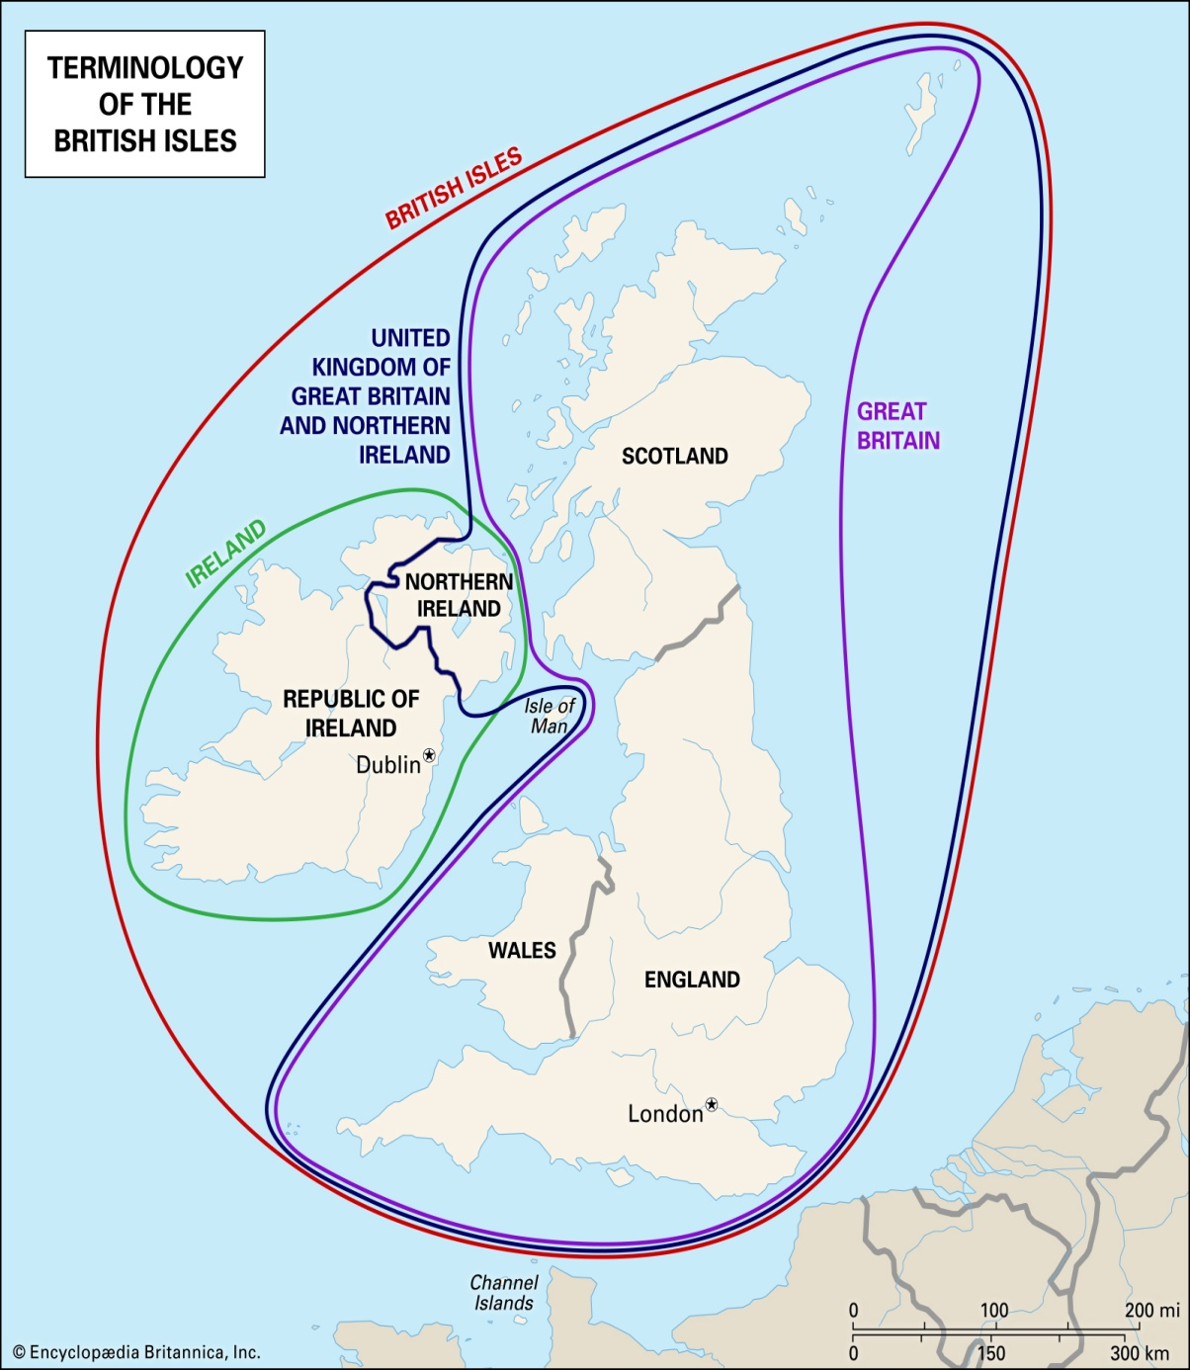

**An Interesting Fact: The Commowealth Realm**.

A **Commonwealth realm** is a [sovereign state](https://en.wikipedia.org/wiki/Sovereign_state) in which [Queen Elizabeth II](https://en.wikipedia.org/wiki/Elizabeth_II) is the reigning [constitutional monarch](https://en.wikipedia.org/wiki/Constitutional_monarchy) and [head of state](https://en.wikipedia.org/wiki/Head_of_state). Each realm is independent from the other realms. As of 2018, there are 16 Commonwealth realms: [Antigua and Barbuda](https://en.wikipedia.org/wiki/Antigua_and_Barbuda), [Australia](https://en.wikipedia.org/wiki/Australia), [The Bahamas](https://en.wikipedia.org/wiki/The_Bahamas), [Barbados](https://en.wikipedia.org/wiki/Barbados), [Belize](https://en.wikipedia.org/wiki/Belize), [Canada](https://en.wikipedia.org/wiki/Canada), [Grenada](https://en.wikipedia.org/wiki/Grenada), [Jamaica](https://en.wikipedia.org/wiki/Jamaica), [New Zealand](https://en.wikipedia.org/wiki/Realm_of_New_Zealand), [Papua New Guinea](https://en.wikipedia.org/wiki/Papua_New_Guinea), [Saint Kitts and Nevis](https://en.wikipedia.org/wiki/Saint_Kitts_and_Nevis), [Saint Lucia](https://en.wikipedia.org/wiki/Saint_Lucia), [Saint Vincent and the Grenadines](https://en.wikipedia.org/wiki/Saint_Vincent_and_the_Grenadines), [Solomon Islands](https://en.wikipedia.org/wiki/Solomon_Islands), [Tuvalu](https://en.wikipedia.org/wiki/Tuvalu), and the [United Kingdom](https://en.wikipedia.org/wiki/United_Kingdom). All 16 Commonwealth realms are members of the [Commonwealth of Nations](https://en.wikipedia.org/wiki/Commonwealth_of_Nations), an intergovernmental organization of 53 [member states](https://en.wikipedia.org/wiki/Member_states_of_the_Commonwealth_of_Nations). Elizabeth II is [Head of the Commonwealth](https://en.wikipedia.org/wiki/Head_of_the_Commonwealth).

In 1952, Britain's [proclamation of Elizabeth II's accession](https://en.wikipedia.org/wiki/Proclamation_of_accession_of_Elizabeth_II) used the term *Realms* to describe the seven sovereign states of which she was queen—the United Kingdom, Canada, Australia, New Zealand, [South Africa](https://en.wikipedia.org/wiki/Union_of_South_Africa), [Pakistan](https://en.wikipedia.org/wiki/Dominion_of_Pakistan) and Ceylon (modern day Sri Lanka) . Since then, new realms have been created through independence of former colonies and dependencies and some realms have become republics.

There are 16 Commonwealth realms currently with a combined area (excluding [Antarctic](https://en.wikipedia.org/wiki/Antarctic) claims) of 18.7 million km2 (7.2 million mi2) and a population of 144 million, of which all but about two million live in the six most populous: the [United Kingdom](https://en.wikipedia.org/wiki/United_Kingdom), [Canada](https://en.wikipedia.org/wiki/Canada), [Australia](https://en.wikipedia.org/wiki/Australia), [Papua New Guinea](https://en.wikipedia.org/wiki/Papua_New_Guinea), [New Zealand](https://en.wikipedia.org/wiki/New_Zealand), and [Jamaica](https://en.wikipedia.org/wiki/Jamaica).

**EXERCISES**

**1-**Explain and examine the following terms

Britain-U.K.-Regionalism-Localism-Pluralistic-Colonies-Dependencies.

**2-Write a short essay about:**

The Geographical and political differences between Great Britain and the UK, while also stating the countries that still have the British Queen as their head of state.

**REFERENCES**

Oakland, John. 2002. *British Civilization: an Introduction.* London: London University Publication Office.

Mcdowall, David. 2008. *An Illustrated History of Britain*. New York: The McGraw-Hill Companies, Inc.

Wikipedia contributors, "Commonwealth realm," *Wikipedia, The Free Encyclopedia,* <https://en.wikipedia.org/w/index.php?title=Commonwealth_realm&oldid=866538346> (accessed November 5, 2018).