The Minister of Higher Education and Scientific Research (MESRS)
University of Mohamed Boudiaf, M’sila –UMB–
Faculty of Technology
1st Year, Common Base, ST S2 - 2022/2023
Module: English 02
Lecture 02:
Passive versus Active: Impersonal versus Personal Forms

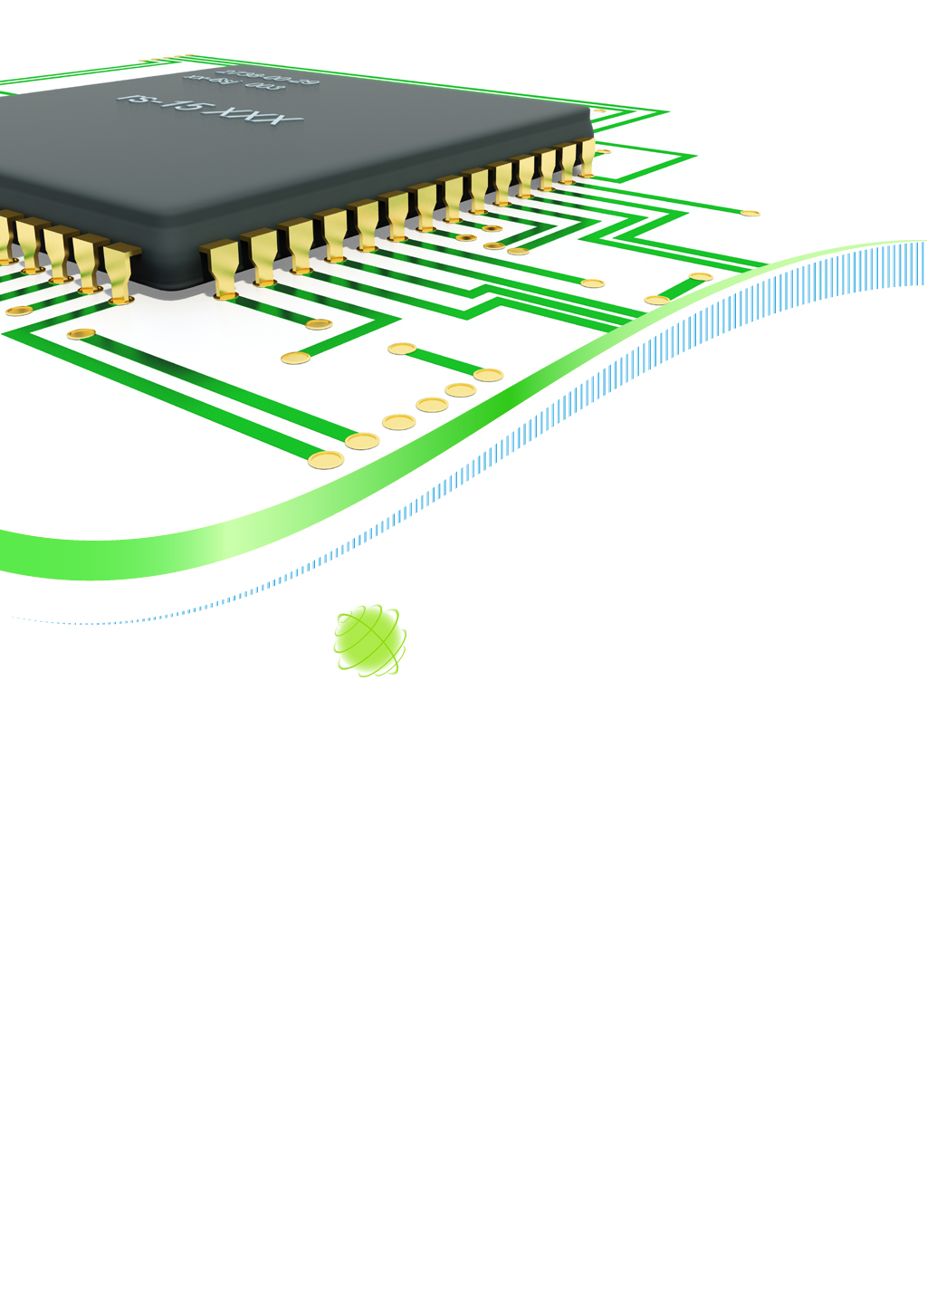

Authored by:
- Dr. S. BELAGOUNE
- Dr. B. BAADJI
- Dr. S. MEZBACHE

I- Active voice: is when the subject of the sentence performs the action.
Example: in the sentence “The scientist conducted the experiment” the subject (scientist) is performing the action (conducting the experiment), making it an active voice sentence.
II- Passive voice: is when the subject receives the action.
Example: in the sentence "The experiment was conducted by the scientist," the subject (experiment) is receiving the action (being conducted), making it a passive voice sentence.
III- Advantages and disadvantages of using active and passive voice in scientific writing:
Active voice is generally more direct and concise, making it easier to understand. It can also emphasize the importance of the subject or the action being performed. For example, "Our research team discovered a new drug" places emphasis on the importance of the research team and their discovery. In contrast, the passive voice "A new drug was discovered by our research team" places the emphasis on the drug itself rather than the team.
On the other hand, passive voice can be useful in certain situations. It is often used to emphasize the object or result of an action rather than the subject. For example, "The results of the study were analyzed in detail" places emphasis on the results rather than who analyzed them. Passive voice can also be used to avoid assigning blame or responsibility, particularly in cases where it is unclear who performed the action.
Most books on good writing advocate preferring the active form to the passive form. Also, software applications that automatically check a text for grammar and style, will usually highlight any usages of the passive and recommend using the active as an alternative.
Overuse of passive voice can lead to mystery and lack of clarity. It can also make writing seem mysterious or impersonal. Therefore, it is generally recommended to use active voice whenever possible, particularly in scientific writing where clarity and directness are essential.
However, in research manuscripts, the passive is often a much better option.
IV- Main uses of passive:
The passive is generally used in preference to the active in all the cases below. The active equivalent might be preferential when giving oral presentations or in other more informal contexts:
- To describe processes. In such cases the main interest is not in who or what carried out the actions; the most important item is the subject of the sentence. Typically this is found in the Methods section. Only use “We” in the Methods if it is not clear who carried out the action.
- When making general references to the literature or to what is happening in the world in general.
- When it is unnecessary, difficult, or impossible to identify the originator of the action.
- To report what is commonly believed to be true.
- To report formal decisions or to make announcements.

PASSIVE |  | ACTIVE
1 | The rust was removed by acid-treatment. | We removed the rust by acid-treatment.
1 | An aerosol solution was added to make the flame front visible. | We added an aerosol solution to make the flame front visible.
2 | Several attempts have been made to explain this phenomenon [17, 24, 33]. | Several researchers have attempted to explain this phenomenon [17, 24, 33].
2 | Much progress is being made in the field of telecommunications. | They are making much progress in the field of telecommunications.
3 | The surface of the steel piping was fractured. | Something had caused the steel piping to fracture.
3 | A large sum of money was recently donated to the hospital. | Someone recently donated a large sum of money to the hospital.
4 | This drug is known to have serious side effects. | Serious side effects typically arise from the use of this drug.
5 | The law is expected to be passed next year. | It is likely that the government will pass this law next year.
V- Passive better than active: more examples
Consider using the passive to avoid:
- An excessive use of we and us, but prefer an active form if possible.
- Using the impersonal form one. The use of one has become quite archaic.
- Sequences of nouns.
Note:
- The passive is generally used with verbs such as install, upload and download.
YES |  | OK (1–3), WRONG (4)
1 | An example of this effect is shown in Figure 4. | We show an example of this effect in Figure 4.
 | Figure 4 shows an example of this effect.
1 | The example can be strengthened by means of the circuit in Fig. 3b. | Let us strengthen the example by means of the circuit in Fig. 3b.
2 | On the other hand the other case of a branch is only obtained at the TTC input. | On the other hand one obtains the other meaning of a branch only at the TTC input.
3 | Costs can be further reduced since the components can be placed in arbitrary positions in the memory space. | Further reductions in costs follow from the possibility to place the components in arbitrary positions of the memory space.
4 | The system is installed automatically. | The system installs automatically.
4 | Files are downloaded directly from source. | Files download directly from source.
VI- Active better than passive
- An active sentence helps to the reader to understand exactly, who is the agent (in our case, the author/researcher) of an action. Thus, if your journal permits the use of we, then use we to avoid any confusion about whether you or another author performed a certain action.
- Active sentences do not necessarily have to be personal. Use the active form if this helps to shift the verb nearer to its subject.
Some passive constructions sound awkward or wrong in English, particularly with the verbs to aim and to focus
YES |  | NOT RECOMMENDED
1 | We compared our results with those of Alvarez. | The results were compared with those of Alvarez.
 |  | Possibly ambiguous, but fine if it is clear from the context who did what
2 | The following section outlines the state of the art in cybertronics. | In the following section the state of the art in cybertronics is outlined.
2 | Figure 1 shows the relevant trends. | The relevant trends are shown in Figure 1.
2 | The system supports: x, y and z. | The following features are supported by the system: x, y and z.
3 | The main aim of this project is t develop an alternative to the Internet. | This project is mainly aimed at developing an alternative to the Internet.
3 | This paper focuses on the best way to control the activities of potentially rogue traders. | This paper is focused on the best way to control the activities of potentially rogue traders.
VII- Ambiguity with passive
Some journals insist that you do not use the personal pronoun we. This means that instead of writing we did x (active), you have to write x was done (passive). Unfortunately, the passive form does not tell the reader with 100% certainty who performed the action.
If you are talking about the literature and you use the passive both to refer to your own work and that in the literature, then the reader will have difficulty distinguishing between the two. There are various devices that are essential to avoid such confusion:
- Use the names of authors preferably within the main sentence and use the active form. The problem with only using the reference without the name of the author, is that the reader is forced to check to see in the bibliography whether the reference refers to you or to another author.
- Although some journals dislike we, they don’t seem to have problems with our! So one good way to avoid possible misunderstanding is to use expressions such as our results show, in our work, in our study. Using such expressions is vital when you are constantly switching from talking about the literature to talking about your work.
- Be careful when using expressions such as in a previous work – it must be very clear that you are talking about your own previous work, rather than the previous work of an author you have just mentioned.
YES |  | POSSIBLY AMBIGUOUS
1 | Peters found that children perform such tasks better than adults [34]. | It was found that children perform such tasks better than adults [34].
2 | These features are generally characteristic of this species [Smith 2010, Carsten 2013]. However, in our study, it was found that they are also characteristic of some completely unrelated species. | These features are generally characteristic of this species [Smith 2010, Carsten 2013]. However, it was found that they are also characteristic of some completely unrelated species.
3 | Ying et al. noted that red is most people’s favorite color. However, in a previous work carried out by our group, it was noted that green was … | Ying et al. noted that red is most people’s favorite color. However, in a previous work it was noted that green was …
VIII- Passive and active voices in the different tenses:
There are 12 different tenses in English, which are divided into four categories: simple, progressive, perfect, and perfect progressive. Each tense is used to indicate a specific time frame, and each has a different form of the verb. Here are the 12 tenses in English with examples:
1- Present simple tense: used for habitual or repeated actions, general truths, and states of being.
Active voice: I solve my exercises from 08 pm to 10 pm every day.
Passive voice: My exercises are solved from 08 pm to 10 pm every day.
2- Past simple tense: used to describe completed actions in the past.
Active voice: She repaired her phone yesterday.
Passive voice: Her phone was repaired yesterday.
3- Future simple tense: used to describe actions that will take place in the future.
Active voice: She will pass an English exam next week.
Passive voice: An English exam will be passed next week.
4- Present continuous tense: used to describe actions that are happening now or in the near future.
Active voice: He is presenting now his conference paper.
Passive voice: His conference paper is being presented now.
5- Past continuous tense: used to describe actions that were ongoing in the past.
Active voice: We were revising the last physics lecture at her home from 10 pm to 11 pm.
Passive voice: The last physics lecture was being revised at her home.
6- Future continuous tense: used to describe ongoing actions that will happen in the future.
Active voice: She will be writing her lab report next weekend from 7 pm to 9 pm.
Passive voice: Her lab report will be being written next weekend from 7 pm to 9 pm.
7- Present perfect tense: used to describe actions that began in the past and continue in the present or have just finished.
Active voice: I have eaten breakfast already.
Passive voice: The breakfast has been eaten already.
8- Past perfect tense: used to describe actions that were completed before another action in the past.
Active voice: By the time she arrived, I had finished my homework.
Passive voice: By the time she arrived, my homework had been finished.
9- Future perfect tense: used to describe actions that will be completed before a specified future time.
Active voice: By next year, I will have completed my training course.
Passive voice: By next year, my training course will have been completed.
10- Present perfect continuous tense: used to describe ongoing actions that began in the past and continue in the present. Most reference books say that the present perfect continuous tense has no passive form. However, some books included the passive voice for this tense.
Active voice: I have been working on this project for two weeks.
Passive voice: This project has been being worked on for two weeks.
11- Past perfect continuous tense: used to describe ongoing actions that were completed before another action in the past.
Active voice: When she arrived, I had been revising Math’s lessons for three hours.
Passive voice: When she arrived, Math’s lessons had been being revised for three hours.
12- Future perfect continuous tense: used to describe ongoing actions that will be completed before a specified future time.
Active voice: By the end of the year, I will have been writing my thesis at this university
Passive voice: By the end of the year, my thesis will have been being written at this university.
It's important to note that verb tense is just one aspect of English grammar, and understanding the context in which each tense is used is crucial for effective communication.
Conclusion: the choice of active or passive voice in scientific writing depends on the context and the information being transferred. While passive voice can be useful in certain situations, active voice is generally preferred for its clarity and directness. It is important to keep in mind the audience and the purpose of the writing when choosing which voice to use.

