Correction exercice1

*C8H18 +12,5 O2 ---> 8CO2 +9 H2O*

1 g → mO2

8*12+18=114 → 12.5*32= 400

3.51 g → 0.2095

m(air)= → 1

mO2 = 400/114= 3.51g

M(air)= 3.51/0.2095= 16.7 g

1 mole de *C8H18* → 114 g

n mole de *C8H18* → 0.075 g

1 mole de *C8H18* → 5,55×106 J

0.00066 mole de *C8H18* → Q

r=1250/3660= 0.34

n= 0.075/114= 0.00066 mol

Q= 3663 J

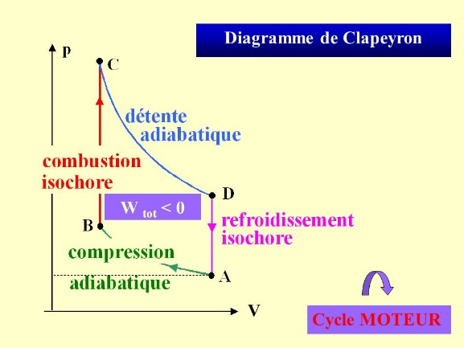

|  |  |  |  |  |  |
| --- | --- | --- | --- | --- | --- |
| Transformation | AB | BC | CD | DA | Cycle |
| W (J) | 660 | 0 | -2690 | 0 | -2030 |
| Q (J) | 0 | 3650 | 0 | -1620 | +2030 |

Rendement η=2030/3650= 0.55 = 55%

4- ηcarnot = 1-Tfroide/Tchaude =1-(20+273)/(2100+273)= 0.87 = 87% >> η