**CHAPTER IV: ELECTRONIC STRUCTURE OF THE ATOM**

**IV.1. WAVE STRUCTURE OF LIGHT**

Light is a progressive electromagnetic plane wave (electric field and magnetic field dependent on space and time). These vectors, themselves orthogonal, are perpendicular to the direction of propagation (FIG. 1). Light radiation is characterized by :

- Its energy E (in J)

- Its wavelength λ (in m). In parallel, we use the wave number σ, defined by :

σ =1 /λ and expressed in m1-.

- Its period T (in s). In parallel, we use the frequency ν of the wave, defined by :

ν= 1/T and expressed in hertz (Hz) when T is expressed in seconds.

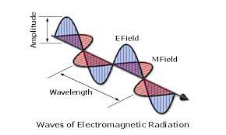

**Figure 4.**The wave nature of light

Let's remember the following relationships, linking light radiation energy, frequency, period and wavelength:

E=h. ν

λ = C .T=C/ ν therefore: E=hc/ λ

h: plank constant = 6.62 . 10-34 J.S

The very nature of electromagnetic radiation depends on its wavelength (and therefore on the energy conveyed), so let's remember the following important result: visible radiation has a wavelength between 400 nm (blue light) and 750 nm (red light). The electromagnetic spectrum (nature of radiation as a function of wavelength) is shown below (fig. 2).

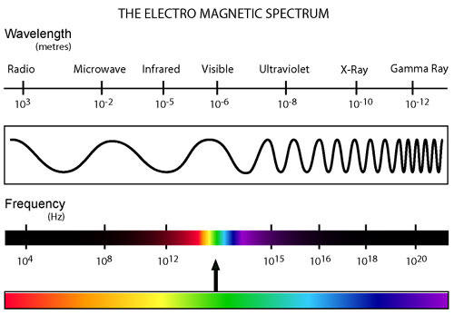

**Figure. 2:** Domains of the electromagnetic spectrum

**IV.2. VISIBLE LIGHT SPECTRUM**

The visible spectrum is only a small part of the complete spectrum of electromagnetic radiation. It is also the part of the complete spectrum to which the human eye is sensitive, the color of the light observed depending on the frequency or frequency interval. The visible spectrum ranges from red to violet. The following diagram shows the relationship between color and λ.

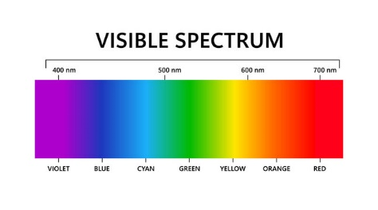

**IV.3. PHOTOELECTRIC EFFECT**

According to EINSTEIN, light carries grains of matter, "quanta", also called "photons", each carrying an energy E equal to the product of two terms: PLANCK's constant and the frequency of the radiation: E = h ν.

Experiment: If a metal plate is illuminated with monochromatic light of frequency ν higher than the threshold frequency ν 0, the excess energy over the metal's characteristic energy E0 = hν0 is dissipated in the form of kinetic energy taken up by the electrons. EC=E-E0 = hν- hν0 =h(ν- ν0)

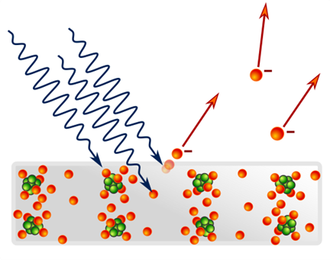

**Figure 5.** Photoelectric effect

Remarks:

1- Only light of frequency ν ≥ν0 determines electron emission;

2- If a photon of energy (E =h ν) ≥ ( E0 =h ν0) is absorbed, the emitted electron will reach a maximum kinetic energy:

EC =1/2mv2= h(ν- ν0)

**IV.4. EMISSION SPECTRUM OF THE HYDROGEN ATOM**

**Expérience :**

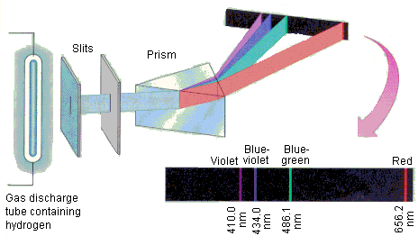

**Figure. 3:** Experimental setup for the hydrogen atom spectrum.

To obtain the emission spectrum of hydrogen atoms, a sample of gaseous dihydrogen molecules excited by electric discharges leads to bond breaking and the formation of hydrogen atoms in an excited state, according to the following reaction:

H2 (g) 2 H*(g)

2 H*(g) 2 H (g) +E (ν)

Photons are then emitted, and their spectrum (distribution of emitted wavelengths) can be analyzed using a dispersive optical system (grating, prism)

Luminous lines are then observed in the emission spectrum in the ultraviolet (UV), visible and infrared (IR) ranges. In fact, only 4 lines are visible (n=2; n'=3, 4, 5 or 6). These series of lines bear the name of their inventor, and are characterized by their wave number, verifying:

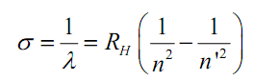

Where n' and n are natural numbers other than 0, such that n' > n and RH is the Rydberg constant for the hydrogen atom. RH =109 677.6 cm 1¬.

The first studied spectral lines of hydrogen are located in the visible range of the spectrum, although they narrow towards a limit in the near ultraviolet.

This series of lines is called the "Balmer series", after the Swiss physicist who discovered the law governing the wavelength spacing of the lines. The first lines are numbered using the Greek alphabet. The first line, Hα, has a wavelength of 656.2 nm and is therefore red; the second, Hβ, is blue at 486.1 nm, the third, Hγ, is violet at 434.0 nm, and so on.

The last are very close together; there are no more lines at wavelengths shorter than 364.6 nm. This limiting wavelength is the "Balmer series limit".

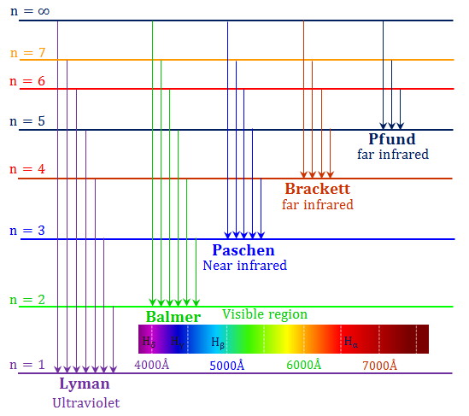

**IV.5. HYPOTHESES**

What assumptions can be made from these experimental data?

1. the unirradiated H atom is in a stable state (no emission) of energy E1 (ground state).

2. under excitation, for example by absorption of a photon, it will enter a higher-energy state Ei > E1.

Ei corresponds to an excited, unstable state with a limited lifetime. The H atom will return to the ground state, emitting radiation of frequency ν :

**ν = E i -E1/h**

This return to the ground state can take place in one or more stages.

Experimentally, only certain values of ν are observed, as only certain well-defined energy states Ei are allowed: the electron's energy in the atom is quantized.

These assumptions can be illustrated by the following diagram, which depicts the absorption and emission of light during an electron jump in an atom.

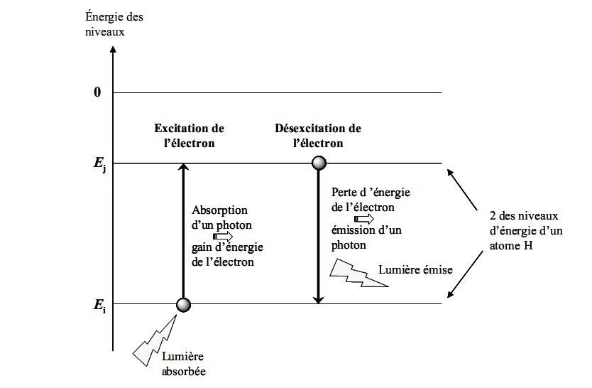

The energy difference between the two levels is related to the frequency (and wavelength) of the emitted photon:

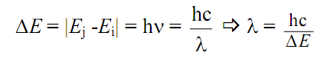

Knowing that the mass of the nucleus is much greater than that of the electron, we can consider that the center of gravity of the nucleus (charge +Ze) + electron (charge -e) system merges with that of the nucleus, assumed to be fixed. The energy of the system can be compared to the energy of the electron in the electric field created by the nuc

**Ee-= Ec + Ep**

**IV.6. THE BOHR MODEL: (case of the hydrogen atom)**

In the Bohr atom, the nucleus is immobile, while the electron of mass m moves around the nucleus in a circular orbit of radius r.

To resolve the above contradictions, Bohr proposes three postulates:

1.The electron can only be found in privileged orbits without emitting energy; these are called "stationary orbits".

2.When an electron moves from one level to another it emits or absorbs energy: ΔE = h.ν

3.The electron's angular momentum can only take on integer values (quantization of angular momentum): **mvr = n.h/2π**

h: Planck's constant and n: natural number.

**IV.6.1 Quantitative aspect of the Bohr atom**

In an atom with a stationary nucleus of charge +Ze and surrounded by Z electrons (of negative charge), the system is stabilized by the two forces Fe and Fc .

the two forces Fe and Fc . Fc: Coulombic attraction Fe: Centrifugal force

For a hydrogen atom ,H, we have :

- Coulombic force: Fe = k e2/r2

- Centrifugal force: Fc = mev2/r

The system is in equilibrium if : =≥ k e2/r2 = mev2/r ………… (1)

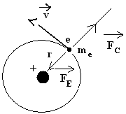

 C. à d.: **k e2/r2 = mev2/r (1)**

**- IV.6. 1. 1 Total energy ET of the system:**

ET = Ec + Ep ( Ec : kinetic energy, Ep : potential energy, due to the attraction of the nucleus)

EC = 1/2mv2=1/2 (k e2/ r)

EP (linked to the electron's position), the electron moves from an orbit of radius r to another of radius r

performs work: dw = Fdr = d EP

Here F = Fe = k e2/r2 then: EP = (k e2/r2)dr => EP = -k e2∫ dr/ r2

The sign - to express that EP decreases from r to + ∞, obviously at ∞ we have EP = 0; thus:

EP = - k e2 / r …………. (2)

Then: ET = EC + EP = 1/2mv2 - k e2 / and from (1): 1/2(mv2) = 1/2 (k e2/ r), we have

ET = - k e2 / r + 1/2 (k e2/ r)

ET = - k e2 / 2r ……….(3): electron energy at steady state.

**IV.6. 1. 2. Orbit radius :**

The only possible states are such that the electron's angular momentum is a multiple of h/2Π, i.e. :

mvr = n.h/2π (4), n natural number.

==> v2 = n2h2 / 4Π2m2r2 (5)

from (1) v2 = ke2/m r ==> r = n2h2 / 4 π 2m e2k and k=1/4 π ε0

r = h2 ε0 n2/ π m e2 (6); k = 9x109 SI units. And ε: permittivity of vacuum

If n = 1 (ground state) ==> r1 = h2 ε0 / π m e2 = 0.53 A° (Bohr radius) (1A° = 10-10 m)

If n = n rn =h2 ε0 n2/ π m e2 ==> rn = n2r1 (A°) (7) (r1=0.53 A° : Bohr radius )

IV.6. 1. 3 Expression of total energy :

The radius of the orbit in which the electron moves is quantized. If we replace (6) in (3) with

k=1/4 π ε, we obtain :

ET ==> -m e4/8 ε02h2 n2 (8)

The total energy of an electron is therefore discrete or quantized.

- For n=1 (ground state: the electron occupies the orbit of radius r1 and energy E1)

E1 = -21.78.10-19 j = -13.6 eV

(9)

IV.6. 1. 4 Energy absorption and emission

An electron can only absorb or release energy c. d. radiate only by moving from one level (orbit) to another.

According to Bohr's second postulate, the passage of an e- from an orbit defined by ni to an orbit defined by nf, involves an exchange of a quantum of energy (Planck's relation):

ν: frequency of radiation; λ: wavelength;

c: speed of light: c = 3.108 m.s-1; h: Planck's constant: h = 6.626.10-34 J.s

ΔE = l Ef - Ei l = hν Ef : final state

Ei : initial state

Absorption: When an electron passes from a level n (orbit of radius rn) to a higher level n' (n'>n) (orbit of radius rn'), it absorbs radiation of frequency νn-n'.

Emission: When an electron passes from an n' level to an n level (n' > n), it emits radiation of frequency νn'-n.



IV.6.2 Applying Bohr's model to hydrogenoids

A hydrogenoid is an atom that has lost all but one of its electrons; the charge of the nucleus is +Z.e and that of the peripheral electron (-e). examples :He+ ; Li++ ; Be+++......

The problem of an electron moving around a nucleus of charge +Ze is similar to that of hydrogen.

The attractive force in this case is -Z K e2/r2 and the orbit stability condition is :

mev2/r = Z K e2/r2 and the orbit stability condition is: mev2/r =ZK e2/r

Similar reasoning to that followed for the hydrogen atom leads to a value of r such that :

**r = h2 ε n2/ πme2**Z==>  (10)

 (11)

**σ = 1/λ = RH .Z2 ( 1/n2-1/p2)** (12)

II.6.3 Inadequacy of Bohr's model

In the end, Bohr's model simply recalls the experimental results for the hydrogen atom. The model was enthusiastically received by physicists, and Bohr was awarded the Nobel Prize in 1922.

The shortcomings of Bohr's model :

- It fails to explain certain fine features of the hydrogen atom's emission spectrum, such as the splitting of certain lines under the influence of a magnetic field.

- It only works for hydrogen atoms, not for polyelectronic atoms, as it does not take into account the influence of a given electron on its neighbors.

- It cannot describe chemical bonds (especially covalent bonds).

Sommerfield proposed complicating the model by using elliptical orbits instead of Bohr's simple circular orbits (the solar system's analogy with Kepler's elliptical orbits). This modification introduced two more quantum numbers (l and m), but also failed to describe large atoms properly. This model was finally abandoned and replaced by the more "advanced" quantum model of the atom.

Appendix

1-The emission spectrum of the hydrogen atom.

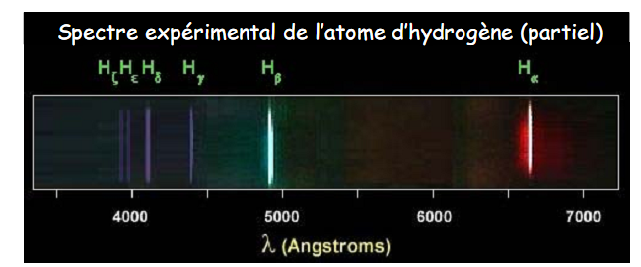

**2-Séries de spectre d’émission de l’atome d’hydrogène**

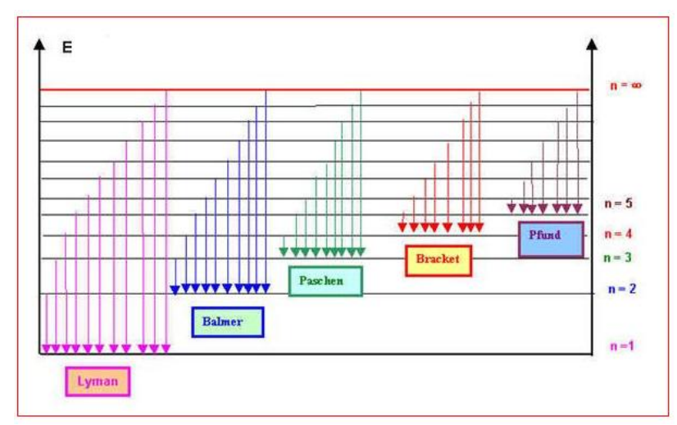

**3- Niveau d’énergie de l’électron**

