Education System in the United Kingdom
‘Education is the most Powerful Weapon which you can use to change the world’
By Nelson Mandela
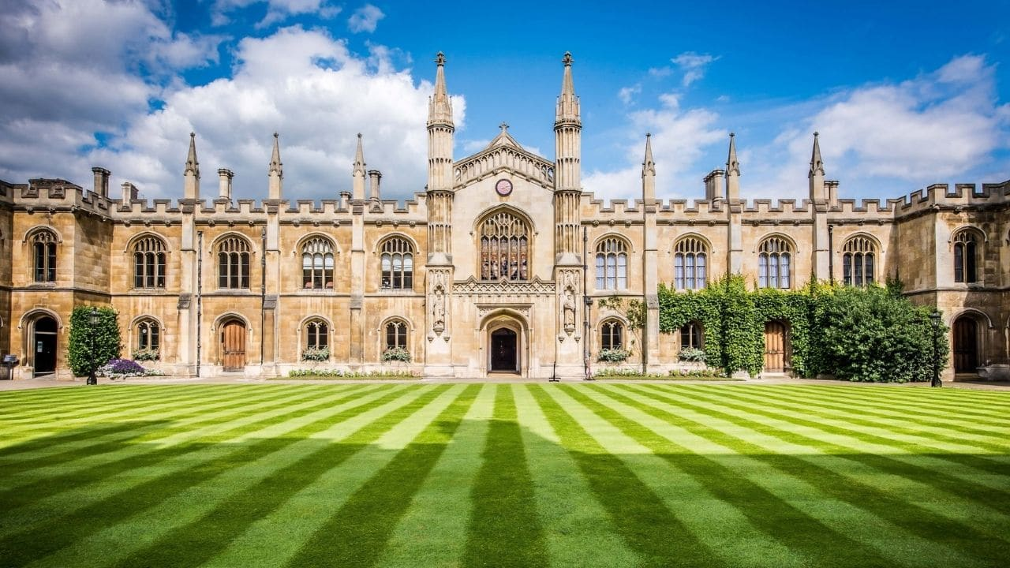
Picture: Cambridge University
Overview
Across the UK there are five stages of education: early years, primary, secondary, Further Education (FE) and Higher Education (HE). Education is compulsory for all children between the ages of 5 (4 in Northern Ireland) and 16. Further education is not compulsory and covers non-advanced education which can be taken at further (including tertiary) education colleges and higher education institutions. The fifth stage, higher education, is study beyond General Certificate of Education A levels and their equivalent which, for most full-time students, takes place in universities and other higher education institutions and colleges.
Early Years Education (Kindergarten)
In England since September 2010, all three and four year olds are entitled to 15 hours of free nursery education for 38 weeks of the year. Early Years education takes place in a variety of settings including state nursery schools, nursery classes and reception classes within primary schools, as well as settings outside the state sector such as voluntary pre-schools, privately run nurseries or childminders. In recent years there has been a major expansion of Early Years education and childcare. The Education Act 2002 extended the National Curriculum for England to include the Foundation Stage which was first introduced in September 2000, and covered children’s education from the age of 3 to the end of the reception year, when children are aged 5. The Early Years Foundation Stage (EYFS) came into force in September 2008, and is a single regulatory and quality framework for the provision of learning, development and care for children in all registered early years settings between birth and the academic year in which they turn 5. The EYFS Profile (EYFSP) is the statutory assessment of each child’s development and learning achievements at the end of the academic year in which they turn 5.
In Wales, children are entitled to a free part-time place the term following a child’s third birthday until they enter statutory education. These places can be in a maintained school or a non-maintained setting such as a voluntary playgroup, private nursery or childminder which is approved to provide education. The Foundation Phase is a holistic developmental curriculum for 3 to 7-year-olds based on the needs of the individual child to meet their stage of development. Statutory rollout of the Foundation Phase framework started in September 2008 and the process was completed in the 2011/12 school year.
In Scotland, education typically starts with pre-school. Local authorities have a duty to secure a part-time funded place for every child starting from the beginning of the school term after the child's third birthday. Pre-school education can be provided by local authority centres, or private and voluntary providers under a partnership arrangement. In Scotland, early years education is called ante-pre-school education for those who are start receiving their pre-school education in the academic year after their 3rd birthday until the end of that academic year (note: depending on when the child turned 3 years of age, some children may only receive part of an academic year’s worth of ante-pre-school education (e.g. 1 term), whereas other children may receive an entire academic year of pre-school education). All children are entitled to receive a full academic year’s worth of pre-school education in the academic year before they are eligible to, and expected to, start primary school.
The commitment in the Northern Ireland Executive’s Programme for Government is to ‘ensure that at least one year of pre-school education is available to every family that wants it.’ Funded pre-school places are available in statutory nursery schools and units and in those voluntary and private settings participating in the Pre-School Education Expansion Programme (PSEEP). Places in the voluntary/private sector are part-time whilst, in the statutory nursery sector, both full-time and part-time places are available. Pre-school education is designed for children in the year immediately before they enter Primary 1. Taking into account the starting age for compulsory education in Northern Ireland this means children are aged between 3 years 2 months and 4 years 2 months in the September in which they enter their final pre-school year. The Programme incorporates a number of features designed to promote high quality pre-school education provision in all settings including a curriculum which is common to all those involved in pre-school education.
Primary
The primary stage covers three age ranges: nursery (under 5), infant (5 to 7 or 8) (Key Stage 1) and junior (up to 11 or 12) (Key Stage 2) but in Scotland and Northern Ireland there is generally no distinction between infant and junior schools. In Wales, although the types of school are the same, the Foundation Phase has brought together what was previously known as the Early Years (from 3 to 5-year-olds) and Key Stage 1 (from 5 to 7-year-olds) of the National Curriculum to create one phase of education for children aged between three and seven. In England, primary schools generally cater for 4-11 year olds. Some primary schools may have a nursery or a children’s centre attached to cater for younger children. Most public sector primary schools take both boys and girls in mixed classes. It is usual to transfer straight to secondary school at age 11 (in England, Wales and Northern Ireland) or 12 (in Scotland), but in England some children make the transition via middle schools catering for various age ranges between 8 and 14. Depending on their individual age ranges middle schools are classified as either primary or secondary.
The major goals of primary education are achieving basic literacy and numeracy amongst all pupils, as well as establishing foundations in science, mathematics and other subjects. Children in England and Northern Ireland are assessed at the end of Key Stage 1 and Key Stage 2. In Wales, all learners in their final year of Foundation Phase and Key Stage 2 must be assessed through teacher assessments.
Secondary
In England, public provision of secondary education in an area may consist of a combination of different types of school, the pattern reflecting historical circumstance and the policy adopted by the local authority. Comprehensive schools largely admit pupils without reference to ability or aptitude and cater for all the children in a neighbourhood, but in some areas they co-exist with other types of schools, for example grammar schools. Academies, operating in England, are publicly funded independent schools. Academies benefit from greater freedoms to help innovate and raise standards. These include freedom from local authority control, the ability to set their own pay and conditions for staff, freedom around the delivery of the curriculum and the ability to change the lengths of terms and school days. The Academies Programme was first introduced in March 2000 with the objective of replacing poorly performing schools. Academies were established and driven by external sponsors, to achieve a transformation in education performance. The Academies Programme was expanded through legislation in the Academies Act 2010. This enables all maintained primary, secondary and special schools to apply to become an Academy. The early focus is on schools rated outstanding by Ofsted and the first of these new academies opened in September 2010. These schools do not have a sponsor but instead are expected to work with underperforming schools to help raise standards. In Wales, secondary schools take pupils at 11 years old until statutory school age and beyond.
Education authority secondary schools in Scotland are comprehensive in character and offer six years of secondary education; however, in remote areas there are several two-year and four-year secondary schools.
In Northern Ireland, post-primary education consists of 5 compulsory years and two further years if students wish to remain in school to pursue post GCSE / Level 2 courses to Level 3. Ministerial policy is that transfer should be on the basis of nonacademic criteria, however legally post primary schools can still admit pupils based on academic performance.
At the end of this stage of education, pupils are normally entered for a range of external examinations. Most frequently, these are GCSE (General Certificate of Secondary Education) in England, Wales and Northern Ireland and Standard Grades in Scotland, although a range of other qualifications are available. In Scotland pupils study for the National Qualifications (NQ) Standard grade (a two-year course leading to examinations at the end of the fourth year of secondary schooling) and NQ Higher grade, which requires at least a further year of secondary schooling. From 1999/00 additional new NQ were introduced in Scotland to allow greater flexibility and choice in the Scottish examination system. NQ include Intermediate 1 & 2 designed primarily for candidates in the fifth and sixth year of secondary schooling, however these are used in some schools as an alternative to Standard Grades.
Further Education
Further education may be used in a general sense to cover all non-advanced courses taken after the period of compulsory education. It is post-compulsory education (in addition to that received at secondary school), that is distinct from the education offered in universities (higher education). It may be at any level from basic skills training to higher vocational education such as City and Guilds or Foundation Degree.
A distinction is usually made between FE and higher education. Higher education is education at a higher level than secondary school. This is usually provided in distinct institutions such as universities. Further education in the United Kingdom therefore includes education for people over 16, usually excluding universities. It is primarily taught in further education colleges, work-based learning, and adult and community learning institutions. This includes post-16 courses similar to those taught at schools and sub-degree courses similar to those taught at higher education colleges (which also teach degree-level courses) and at some universities.
Colleges in England that are regarded as part of the further education sector include General Further Education (GFE) and tertiary colleges, Sixth form colleges, Specialist colleges (mainly colleges of agriculture and horticulture and colleges of drama and dance) and Adult education institutes.
In addition, further education courses may be offered in the school sector, both in sixth form (16-19) schools, or, more commonly, sixth forms within secondary schools.
In England, further education is often seen as forming one part of a wider learning and skills sector, alongside workplace education, prison education, and other types of non-school, non-university education and training. Since June 2009, the sector is overseen by the new Department for Business, Innovation and Skills, although some parts (such as education and training for 14-19 year olds) fall within the remit of the Department for Education.
Higher Education
Higher education is defined as courses that are of a standard that is higher than GCE A level, the Higher Grade of the SCE/National Qualification, GNVQ/NVQ level 3 or the Edexcel (formerly BTEC) or SQA National Certificate/Diploma. There are three main levels of HE course:
- Postgraduate courses leading to higher degrees, diplomas and certificates (including Doctorate, Masters (research and taught), Postgraduate diplomas and certificates as well as postgraduate certificates of education (PGCE) and professional qualifications) which usually require a first degree as entry qualification.
- (ii) Undergraduate courses which include first degrees (honours and ordinary), first degrees with qualified teacher status, enhanced first degrees, first degrees obtained concurrently with a diploma, and intercalated first degrees (where first degree students, usually in medicine, dentistry or veterinary medicine, interrupt their studies to complete a one-year course of advanced studies in a related topic).
- Other undergraduate courses which include all other higher education courses, for example SVQ or NVQ: Level 5, Diploma (HNC/D level for diploma and degree holders), HND (or equivalent), HNC (or equivalent) and SVQ or NVQ: Level 4 and Diplomas in HE.
As a result of the Further and Higher Education Act 1992, former polytechnics and some other higher education institutions were designated as universities in 1992/93. Students normally attend higher education courses at higher education institutions, but some attend at further education colleges.

