Most Common Sports Injuries
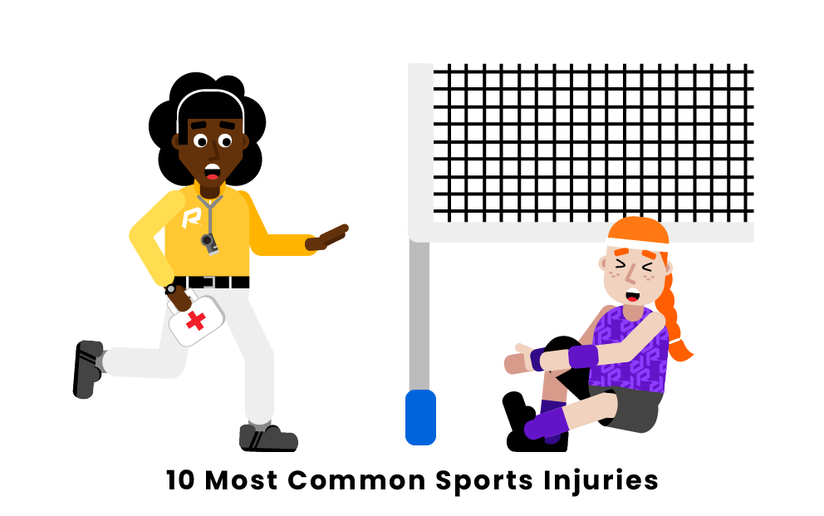

1. Sprains
2. Patellofemoral Syndrome
3. Strains
4. Plantar Fasciitis
5. Concussions
6. Fractures
7. Tennis Elbow
8. Sciatica
9 Dislocations

what are the most common sports injuries?

1. Sprains
If you have ever played a sport, it is likely that you have fallen victim to some minor spraining. Not to be confused with a strain, sprains typically occur around joints, and occur when an athlete has overstretched or torn the ligaments that help to bind two of their bones together.
When running, shifting directions, jumping, throwing, skating, hitting, tackling, swinging, or doing any number of other sports related movements, athletes are susceptible to sprains. Most common is the ankle sprain, which can render a player inactive for days or even weeks.
To prevent spraining, athletes are always encouraged to stretch well before partaking in any physical activity.
2. Patellofemoral Syndrome
Perhaps just as common as sprains and strains, knee injuries, also known as Patellofemoral Syndrome, plague players of many sports. In fact, 55% of sports injuries fall within this category.
Often referred to as "jumper's" or "runner's knee, " this syndrome can be very painful. It is caused by the knee joint hitting the leg bone repeatedly, or while falling onto one's knees. Athletes who partake in sports that utilize constant leg motion, like track and field or cycling for example, are most likely to suffer from this syndrome often.
Many of the injuries listed here can be treated by what health professionals refer to as the R.I.C.E. method or treatment, and knee injuries are no exception. This method instructs athletes to rest their injury, apply ice to it, compress the injury, and elevate the injured area.
3. Strains
Strains often get confused with sprains, and it isn't hard to see why. Both injuries are very similar in name, and in what area of the body they affect. Like spraining, straining occurs most commonly in joints, yet they occur when an athlete has overstretched or torn tendons or muscles, as opposed to ligaments. Typically, a "muscle strain" is referred to as a "pulled muscle, " which helps athletes better understand how the injury is affecting them. Athletes who want to avoid common muscle strains are encouraged to stretch via light calisthenics before partaking in any physical activity.
Athletes with minor strains will most likely heal quickly, given that they rest properly. Straining occurs throughout nearly every sport, so be sure to stretch well!
4. Plantar Fasciitis
The foot area of the body is susceptible to a very common form of sports injury known as Plantar Fasciitis. This specific injury describes a pain in the arch of the foot, caused by tendon inflammation. Runners and joggers most frequently experience Plantar Fasciitis, however the injury is also commonly seen in basketball, football, soccer, and cycling athletes. The pain caused by Plantar Fasciitis can render athletes unable to walk comfortably for quite some time.
To treat Plantar Fasciitis, it is recommended that athletes stretch often and well, and that they rest often while they are injured.
5. Concussions
Perhaps one of the most dangerous sports injuries, concussions directly affect the head and brain. Contrary to what some believe, American football is not the only sport where concussions can occur. Concussions can happen just as frequently among hockey players, soccer players, and many other athletes, and the effects of one can range from mild to extremely severe.
Athletes can identify whether or not they have a concussion by either observing the symptoms (such as headache or dizziness), or by taking a baseline concussion test. It is crucial that athletes diagnosed with a concussion do not return to the sport until they are given the all clear from their doctor.
6. Fractures
Perhaps one of the most recognizable injuries by sight, as many athletes who receive bone fractures wear casts or splints, fractures can happen to any athlete in nearly any sport.
A fracture happens when a bone is impacted suddenly and with great force. Typically, athletes know right away when they have fractured a bone, as the affected area will produce severe pain and, in extreme cases, bones may protrude near the skin. Athletes may require that their bones be set back in place as treatment; however, oftentimes they will simply require rest or a cast of some sort.
7. Tennis Elbow
A common injury that primarily affects athletes between 30 and 60 years of age, tennis elbow describes a condition brought on by overuse of the elbow. Such overuse can cause ligaments near and around the elbow to tear, causing pain and fatigue near the area.
Athletes who frequently participate in tennis, golf, rowing, or other sports that involve heavy use of the elbow should consider investing in an elbow brace in order to prevent this type of injury.
Tennis elbow, interestingly, affects roughly 3% of people between the ages of 30 and 50, however it is most common in those who play sports utilizing constant elbow motion.
8. Sciatica
One of the more preventable injuries on this list, Sciatica refers to a specific type of back pain, typically centered around the lower back area. Interestingly, athletes who play a number of different sports may all experience sciatica to some degree Common sports where athletes experience sciatica include American football, cycling, golf, and track and field. While resting one's body serves as the primary mode of treatment for sciatica, athletes may require back braces to heal or prevent further injury. Oftentimes, bulging and slipped disks are associated with such lower back injuries, and are treated similarly.
9. Dislocations
Unlike a fracture, where bones break, dislocations involve the dislocation of a bone. These can occur as a result of a hard hit, say in American football, or by falling hard enough onto a surface, and can shift bones out of place. This action causes a good amount of pain, however these injuries are not necessarily as serious as they seem. Usually, dislocations can be dealt with with ample rest. In some cases, athletes may require a sling to properly heal.

How Does Scoring Work In Sports?
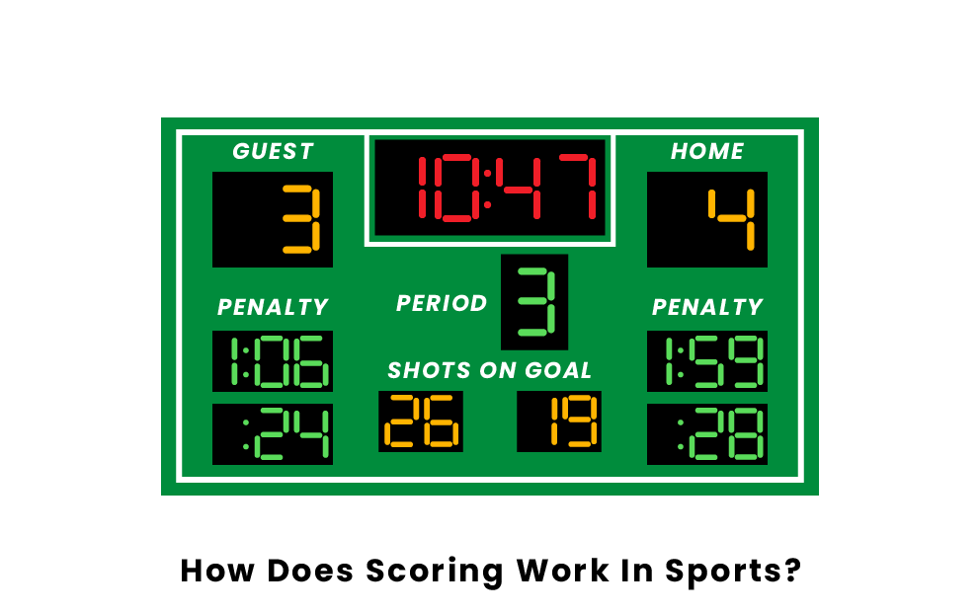
There are many different ways that scoring can occur in the many sports that exist. A good way of keeping track of the numerous ways is to group sports into categories. The most notable and popular group of all types of sports are the basket/net sports. Another remarkable grouping of sports is the racquet sports. There is also a group that is prevalent as well and that is the target sports. Additionally, you have some sports that are just unique in their own respect; baseball, bowling, and football are all one of a kind just because there are no other sports that come close to them in terms of similarity.

- Basket/Net Sport Scoring
- Racquet Sport Scoring
- Target Sport Scoring
- Esport Scoring

Basket/Net Sport Scoring
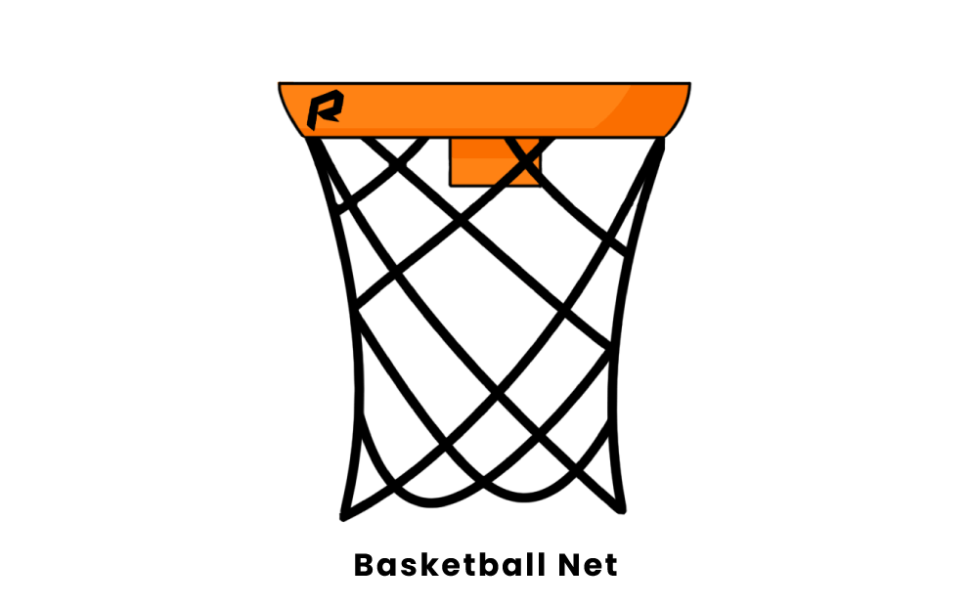
The basket/net sports almost always count points scored when their spherical ball enters the basket/net. In every one of these sports, the only way in which to score is by putting the ball through the net. The basket in the very telling 'basketball' is the objective through which to put the ball in a game. It does not have a keeper and, in fact, the points count if the team on defense is caught "goaltending." There are one-point "free throws, " earned if one is fouled, two-point "field goals" , and three-point field goals shot from farther than the two-pointers.
In soccer, like basketball, the only way to score is by putting the ball into the net. The difference is that soccer has more players on the field and the field is bigger. One can either conventionally put the ball into the net during regular time, or if a foul is committed by the opposite team in the penalty area, the offensive team can shoot a free throw-like shot in which it is a free one-on-one with the goalkeeper. Soccer and basketball were the examples used because they are very popular and speak for the other net sports (e.g. lacrosse, hockey, etc.)
Racquet Sport Scoring
Racquet sports have a pretty rigid standard for scoring conventions. In these sports, which includes tennis, badminton, ping pong, and more, a point is scored when the other team cannot return the objective (i.e. tennis ball, shuttlecock, etc.). On the other hand, an offending team can give the defending team a point if they hit the objective out of bounds. These sports usually have no time limit, rather there is a score to be achieved to win, as opposed to basket/net sports, where time is a factor. I would include volleyball in this group because, even though there are no racquets, it has the exact idea of scoring that identifies with this group.
Target Sport Scoring
Target sports, such as darts, archery are a little more complicated. In short, the objective is to get as close to the target as possible. More points are allocated the closer one gets to the target.
Esport Scoring
Esports introduce even more ambiguity to a convention of scoring. There are many games that are all different in their own way. Usually, though, esports, similar to tennis, have an amount of rounds and one team needs to win more rounds in order to be victorious

List Of Sports Nonprofits
To many people globally, sports are inaccessible. However, there are many wonderful organizations which make it their mission to help children around the world learn the values of teamwork and reap the benefits of fun competition and physical activity. They provide children with a safe environment to learn sports in is helpful for building confidence, good sportsmanship, getting exercise, and keeping children out of trouble. Below is a list of sports non-profit organizations who make it their mission to help children and others in need.
List of Sports Nonprofits
Athletes for Hope
Ball to All
Beyond Sports Network Foundation Inc.
Challenged Athletes Foundations
Fresh Air Fund
Global Sports Foundation
Good Sports
Karsyn's Krusaders
PeacePlayers International
Play it Forward
- Athletes for Hope
Athletes for Hope was started in 2007 by a group of star athletes, whose mission was to get professional athletes working on charitable causes which helped athletes around the world. Big names like Mia Hamm, Muhammad Ali, and Tony Hawk, to name just a few founders, have a commitment to providing opportunities to those in need. They realized that many professional athletes want to give back, but they do not know where to begin. This is where Athletes for Hope steps in. They recruit athletes to encourage good sportsmanship practices in places that need it, as well as visiting hospital wards where children are suffering from life-threatening illnesses. As an organization they harness the power of athletes who want to help the community.
- Ball to All
Ball to All is a non-profit which helps children around the world receive balls for sports. Their goal is to help children in communities that are afflicted by war and violence. By providing sports opportunities, they hope to lead children away from crime and acquiring weapons. Their focus is on countries where children suffer from a lack of resources. Their founder, Ori Eisen, believes that boredom and a lack of structure for children will lead to some children resorting to criminal behaviors. Ball toAll ships balls and air pumps to communities most affected by poverty and violence to encourage community building and sportsmanship.
- Beyond Sports Network Foundation Inc.
The Beyond Sports foundation is a non-profit organization that raises awareness and funding for organizations which encourage sports in underprivileged communities for social change. They provide support for over 300 organizations globally and believe in the importance of play and physical activity for children. Their work also helps to create jobs in other countries who need it. In Africa, they provide ethical employment through the sale and manufacturing of sports balls.
With the wage for these jobs being above the average national wage, employees are better able to provide for their families and provide them with medical insurance. They also do work bridging the gender gap and providing sports opportunities for young women, encouraging them to engage in exercise and sportsmanship practices.
- Challenged Athletes Foundations
The Challenged Athletes Foundation is committed to helping athletes with physical challenges to be able to participate in sports. The costs of being physically disabled make it so that physical activity is not always accessible to people around the world. As most insurance companies do not cover basic necessities for disabled people such as prosthetic limbs or wheelchairs, The Challenged Athletes Foundation makes it their mission to provide the disabled with athletic opportunities by funding this sort of equipment, especially equipment designed for physical exercise. On their impact page, they show statistics that 21 million people in the United States live with a physical disability, and that 50% of those who are disabled get little to no physical exercise, with obesity rates being higher in children with disabilities. This program provides opportunities to athletes who suffer from disabilities or life threatening illnesses at every level, from youth sports to Paralympian.

- Fresh Air Fund
The Fresh Air Fund helps underprivileged children in New York City to participate in summer camp experiences with sleepaway camps and host family volunteers. Over their 140 years they have helped more than 1.8 million children in the New York Community be able to have great camp experiences every summer. The Fresh Air Fund makes sure that they fund the children who need their help the most, and 75% of the families of these children reapply after their children's first session. The Fresh Air Fund sees the importance in letting children explore nature and the outdoors, while also learning more independence and social responsibility. While not necessarily a sports nonprofit, it makes the list due to its emphasis on the importance of outdoor activities in nature for children.
- Global Sports Foundation
The Global Sports foundation is a non-profit with a focus on baseball and supplying underprivileged children and adults with lightly used and new baseball equipment. They also hold charity baseball games with the money going towards those in the United States who suffer from ALS and cancer. Their Midnight Madness Baseball Marathons puts a focus on a chosen afflicted family who needs the money for medical treatments and living expenses. David Fantin, the president of the company, has traveled the world and makes it his mission to provide equipment globally to kids with an interest in baseball who it would usually not be accessible to. As someone who lost loved ones to ALS and cancer, he also makes it his charity's goals to help those and their families afflicted by life threatening illness.
- Good Sports
Good Sports is a wonderful charity which provides sporting equipment to children that would usually not have access. They have partnered with many sports brands for their mission, with some of the bigger names including Adidas, Reebok, New Balance, Spalding, and Nike. Good Sports works with other charitable organizations to increase the amount of children involved in sports and physical activity. Children in sports are able to learn lifelong lessons about teamwork and respect while also building their confidence.

- Karsyn's Krusaders
Karsyn's Krusaders is a not for profit charity organization whose goal is to raise awareness for childhood cancer through racing. It was founded by Jessica and Andy Miller, whose beautiful daughter Karsyn was diagnosed with high risk leukemia at the age of three. Through the tragedy that befell their family, The Miller's focused on how they could help other families who had to struggle with a cancer diagnosis for their child. Although they lost Karsyn to cancer, the Miller's took their love for modified dirt car racing and integrated it with their commitment to raise awareness about childhood cancer. They now raise money for families who have children with cancer through merchandise, racing, and working with other charities. The charity's motto is to "Kick cancer's butt, one lap at a time!"
- Peace Players International
Peace Players International is a basketball non-profit which helps disadvantaged children globally in South Africa, Northern Ireland, Cyprus, Israel, and the West Bank. Their focus is to bring together communities who experience divide based on race, religion, class, etc. They do this by encouraging sports for young people and offering peace education. Through the game of basketball, they hope to bridge the gap between divided communities by making great and dynamic leaders for the world of tomorrow.
- Play it Forward
Play it Forward is a non-profit which focuses on providing sporting equipment to underfunded schools. Many schools do not have the basic P.E. equipment that children need such as balls, jump ropes, and hula hoops. It was started by twelve year old Emily Eisner in 2012, her goal being to help kids play sports in underfunded elementary schools. To this day, the non-profit is still run by children whose goal is to help other children in schools by supplying them with equipment which correlates to the schools; direct needs for physical education. Schools that are interested may inquire online to see if they qualify for support.

- List of Sports Skills
There are many different skills you need to play any one particular sport. Each sport has skills in common but they are all also unique. The list below will show you what skills you need to develop in order to be good at a specific sport.
- Table of Contents
- List of Football Skills
- List of Basketball Skills
- List of Soccer Skills

List of Football Skills
Throwing
Throwing the ball is very important to the game of football. It is one of the means of playing offense. Being able to throw both long and short is essential to success. It helps you move the ball towards the end zone when running plays are not working.
Catching
It is hard to play football if you cannot catch. This is important for every position on the field. Quarterbacks must catch the snap, running backs and wide receivers must catch on pass plays, and defenders must catch in order to get an interception.
Kicking
Kicking the ball may seem like one of the more unimportant aspects of football but teams rely on their kicking team to be very good at their job. You must be able to to kick the ball deep on kickoffs and accurately make field goals from a variety of distances. Punts are also a kick and are usually specialized to a single player.
Tackling
It is important that you learn how to tackle correctly. This is because you want to stop the opponent from scoring as well as not getting yourself injured. Tackling is mainly accomplished with the arms and shoulders.
Blocking
It is important to block so you can assist your teammates with moving the ball up the field. Make sure not to hold and keep the defender in front of you so he cannot get by you. There are two main types of blocking; run blocking and pass blocking.
Running
This skill is involved throughout the game, most specifically with running backs. In order to score and make tackles, you need to be able to run for extended periods of time. Increasing your stamina is also a good idea.
Juking
Scoring becomes much easier when you are able to juke. A juke is a move where you make the defender unable to tackle you by faking one direction and actually going the other way.
Spinning
Another move in order to get defenders out of your way is the spin move. This helps you become "slippery" and it makes it hard for players to grab onto you. This can also be used by defensive lineman trying to evade players on offense.
Hurdling
This skill can be helpful when trying to escape defenders or any other obstacle on the field. Mainly used by ball carriers, a hurdle is successful when a defender is attempting to make a low tackle.
Diving/Sliding
This skill is essential in two ways. Diving is useful when attempting to gain extra yards or score a touchdown. Sliding is important as a QB when trying not to get injured while running with the ball.
List of Basketball Skills
Shooting
The entire point of basketball is to get the ball in the hoop, which requires accurate shooting. Practice this skill from all areas of the court to make sure you can make a shot at all times.
Blocking
This skill is important for defenders. It is meaningful because it stops the opponent from making a pass or basket, helping your team have the opportunity to get more points and a bigger lead.
Handling
In order to score you have to outsmart the defense. Handles like a crossover and between the legs can confuse the opponent and allow you to get a wide open shot.
Running
You are almost always running during a basketball game. You must do this in order to get open for a shot or go to the other side of the court and either score or defend.
Passing
This skill is very good to have because you cannot be the only person on the team who scores. This is why you have to be good at passing the ball to teammates who also can shoot. Being accurate is important because there are many tight spaces on the court.
List of Soccer Skills
Running
The soccer field is so big that you must run to make your way around. It is important to outrun your opponent when you have the ball in order to get an open shot.
Shooting
You must be good at all kinds of shots in order to play soccer, since the goal is to shoot the ball into the net. You can shoot high, low, and in many directions. You should be able to shoot with both feet.
Dribbling
This skill is important because you need to avoid turning the ball over to the opponent. Keep the ball close so that a defender cannot steal it or has to foul you in order to get the ball.
Tackling
Tackling is what prevents most goals against your team. You can tackle anywhere on the field but make sure to win the ball or you will be penalized. You can either slide tackle or tackle while standing up, using your foot to steal the ball.
Passing
Passing might be the most important skill in soccer because all positions must be good at it. Since the field is so big, you must be able to pass long and short in order to reach teammates.
Saving
You can save the ball with your legs and arms as a goalie. It is important to know where the ball is being kicked so you can reach it before it goes in the net.

Top 10 Sports Brands
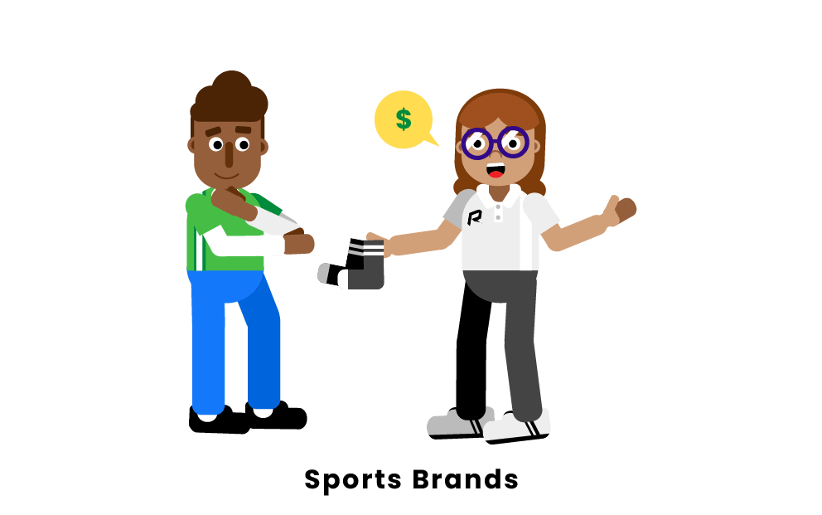
If you are an athlete, chances are that you have a favorite brand you purchase most of your equipment from. Many brands specialize in sports equipment, as some sports require personal protective gear. Some sports brands sell more than just equipment and others have been involved in the business of sports for over a century. Famous sports brands that almost everyone has heard of are Nike, Adidas, Under Armor, and Puma. Other brands thrive in only a single sport such as Everlast, Easton, and Louisville Slugger. This list compiles the ten most popular sports brands for fans and athletes alike. The world of sports would not be complete without a discussion of the businesses that co-exist with the games.
What are the most popular sports brands?
1. Nike
2. Adidas
3. Puma
4. Under Armour
5. Reebok
6. New Balance
7. Jordan
8. Champion
9. Columbia Sportswear
10. Patagonia
- Nike
Nike is known as the biggest sports brand in the world. With an estimated net worth of 36.8 billion dollars, Nike is by far the most valuable sportswear company, more than doubling the net worth of Adidas, it's closest competitor. Known primarily for their shoes, Nike has expanded into clothing and sports equipment. Priding itself on innovation, Nike has been at the forefront of sports technology since its founding in 1964 as a track and field shoe company. Nike is also known for its endorsements with big names like Lebron James, Cristiano Ronaldo, Tiger Woods, and Colin Kaepernick. Nike has diversified itself in university sponsorships. The University of Oregon is the most well-known Nike sponsor as the school was also the brand's founding location. Nike has a sponsorship with over 52% of FBS College Football programs and is the sole manufacturer of jerseys for Major League Baseball, the National Basketball Association, and the National Football League.
- 2. Adidas
Founded in 1949 as a European sports shoe brand, Adidas has been a staple of international sports for years, especially European Football (soccer). In recent years Adidas has been a close competitor to Nike and a secondary brand in terms of finances and popularity. Adidas began with footwear exclusively with a focus on soccer, but the brand has expanded to all sports equipment and clothing over the years. Adidas's focus has continued to be soccer, designing and manufacturing the official FIFA World Cup ball starting in 1970. Adidas is most famous for sponsoring Lionel Messi, one of the most decorated soccer players in history. Other sponsored athletes include baseball's Kris Bryant, hockey's Sidney Crosby, and football's Von Miller.
Adidas has university sponsorships as well, including Louisville University, The University of Miami, and Mississippi State. Adidas has established itself as a fashion brand as well as a sports brand, most recently collaborating with the artist Beyonce Knowles on a fashion line. Though it plays secondfiddle to the more popular Nike, Adidas is a well established sports brand in its own right.
- 3. Puma
Puma has had a resurgence in recent years. In 2019 Puma made Forbes Fab 40 for the first time and reported a 74% increase in shares as opposed to 46% for Adidas and 25% for Nike. Founded by the Dassler brothers in 1919 in their home in Germany, Puma took a few years to become a major shoe brand. Famously, Jesse Owens wore Dassler brand spikes in his historic victories at the 1936 Berlin Olympic Games. In 1948 the official Puma brand was born and began the production of soccer cleats. These grew in popularity both within Germany and internationally. Considered the best soccer player of all time, Pele wore the Puma brand in his World Cup matches for Brazil. Today Puma still specializes in shoes, especially soccer, track, and field, but has developed into a major international clothing brand. For instance, Rihanna has a deal with Puma and has produced her Fenty line of clothing with the company. Though Puma works with the London College of Fashion on their designs, they do not have major university sponsorships. On the professional level, Puma's most famous athlete is Usain Bolt, who has worn Puma spikes in multiple World Record Olympic races.
- 4. Under Armour
Under Armour was born in 1996 out of one product, a skintight shirt called "the shorty" , designed to wick off sweat faster than other athletic shirts. The Baltimore-based company was born, specializing in clothing meant to keep athletes dry, cool or warm, depending on the product and situation. After an appearance in the film "Friday Night Lights, " its products began to soar. In the two decades since its inception, Under Armour has expanded into footwear, starting with a football cleat and ultimately growing to running shoes, basketball sneakers, and more. Under Armour penned a college sponsorship with the University of Maryland, where the company was born, and has expanded to other schools; UCLA, Notre Dame, Army, Hawaiiand Wisconsin to name a few. Famous athletes sponsored by the company include Tom Brady of the NFL, Stephen Curry of the NBA, and Bryce Harper in the MLB. Tom Brady's wife, Gisele Bundchen is a sponsored non-athlete, as is Dwayne "The Rock" Johnson, the former WWE wrestler and movie star.
- 5. Reebok
Along with Nike, Adidas, and Puma, Reebok is considered one of the major sports shoe ware companies of the twentieth century. Founded under a different name in 1895, "Reebok" was born in 1958, named after an African Antelope. In the 1970s and 80s Reebok expanded into the US and its profits began to boom. Reebok made clear that it had three focuses for growth. The first was exercise, the second was the increase of women in sports, and third was streetwear or casual wear. In 2005 Adidas bought Reebok but the two brands, now merged, continued to be branded separately. Reebok's boom occured in the 1990s and famous athletic sponsorships include Shaquille O'neal of the NBA, Venus Williams, and the Manning brothers, Peyton and Eli. Today Reebok is still the official sponsor of the Ultimate Fighting Championship (UFC). Currently Reebok has no collegiate sponsorships though for a brief period in the early 2000's Reebok was the uniform designer for Boston College.
- 6. New Balance
Unlike other major sportswear brands, New Balance was not founded with sports in mind. In 1906 it was founded by William J. Riley and focused on orthopedics and foot support for working class people such as police officers. In the late 1950s athletes started to ask for New Balance. In 1961 the company, under new management, released the New Balance Trackster, a shoe for running built with traction in mind. The company was sold once again but maintained its focus on high performance running shoes. Today, New Balance has footwear in running, baseball, and basketball to name a few. The British founded company has sponsorships with many of UK's track athletes and recently signed star basketball player Kawhi Leonard for a basketball shoe deal, making him one of the faces of the company. New Balance provides equipment to some universities but does not have a sponsorship with any today, having a deal with Central Michigan University until 2009.
- 7. Jordan
Jordan is perhaps the most well-known shoe brand in the world. Founded when Michael Jordan created the Air Jordan 1 with Nike, the Jordan Brand has grown into one of the biggest in the world. Though owned by Nike, the Jordan Brand alone reported over 3 billion dollars of revenue in 2019. When a new Jordan shoe is released, lines form in shoe stores worldwide for people to get a chance to buy the shoes. With rare Jordans going for thousands of dollars on different sneaker markets, the brand revolutionized the sneaker business and made Michael Jordan the most money on a sneaker deal by more than double his nearest competitor. Michael Jordan, the brand's face and logo, is their most famous athlete, but others representing the brand include Zion Williamson and Jason Taytum of the NBA, and Derek Jeter in the MLB. Famous people all over the world wear Jordans. Spike Lee is known to wear colorful pairs courtside at Knicks games and donned golden Jordan shoes at the Oscar Awards. Schools affiliated directly with Jordan include the alma matter of the brand's namesake, North Carolina, and the University of Michigan.
- 8. Champion
Though in 2020 Champion is known as a more upscale street wear brand with tracksuits and jackets, it was founded in 1919 for the University of Michigan. Champion quickly became known for being the brand of choice for collegiate bookstores across the country. The brand was known for knitwear; socks, sweatpants and sweatshirts especially. In the 1960s the brand partnered with the NCAA and NFL to provide uniforms to their teams. More recently, in the early 2000s, the brand was the official equipment provider for Purdue University as well as Notre Dame and Minnesota. Celebrities such as Chance the Rapper have been seen sporting the Champion brand, as have countless athletes who, though not sponsored, have worn the clothing on their way into a stadium. With earnings of over two billion in its centennial year, the Hanes brand owned clothing brand exceeded expectations and has cemented itself as a brand at the forefront of the sportswear fashion industry, making a comeback that few could have seen coming.
- 9. Columbia Sportswear
Unlike other sportswear companies, Columbia emphasizes the outdoors and hiking in their products. Started in 1938 in Oregon as a hat manufacturer, Columbia grew into an apparel empire, accumulating a net worth of 6.3 Billion in early 2020. Columbia apparel owns other mountaineering sports apparel companies, including HardWare, SOREL, and PrAna. Hiking boots are a large draw of Columbia Sportswear's profits, as outdoor sports' popularity continues to grow. Columbia also sells cold weather gear, watches, backpacks, and other necessities for outdoor activities. Columbia's biggest sponsorship deals are with professional sports fishers and golfers, though none are considered household names. Some may argue its place on a list of sports brands, but Columbia is an international powerhouse in the outdoor sports market and rightfully belongs on this list.
- 10. Patagonia
Much like Columbia Sportswear, Patagonia is a brand most well known for their outdoor adventure clothing. Founded by climber Yvon Chouinard in 1953, the brand was unlike others in that it did not start with clothing, starting instead with climbing pitons. Before Chouinard, pitons were placed into a rock for climbing and left there, but his invention of sturdy pitons that could be reused fueled a business that boomed in the second half of the twentieth century. The well-known climber decided to start wearing more colorful clothing when he climbed, something that spiked his climbing friends' interest. Soon a clothing brand was born, one that he named Patagonia. From that day forward Patagonia has been at the forefront of colorful, weather resistant and environmentally friendly clothing for outdoor activities such as climbing. Yvon Chouinard built his company until he was worth just over a billion dollars, with Patagonia at the forefront of sustainable clothing manufacturing. Today Patagonia sponsored athletes include climbers, fly fishers, surfers, snowboarders, and ultra-marathon runners. The company has maintained popularity over the years as a leading brand for outdoor sports.

