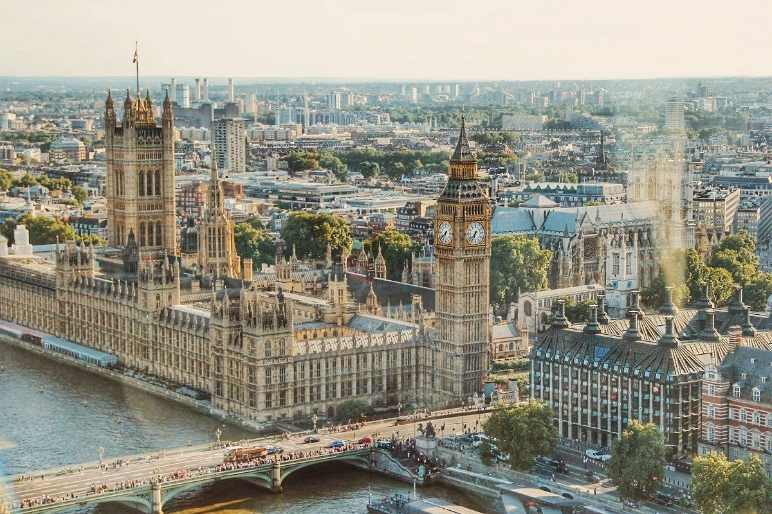

**III British Politics and Foreign Policy**

British politics can seem very confusing – there are lots of different political parties and branches of government, and even though British people have a monarchy they are also a democracy. In this lecture, I introduce you to British political system and foreign policy which experienced many transformations in the contemporary period.

**Constitutional and Parliamentary Monarchy**

The United Kingdom is a parliamentary democracy under a constitutional monarchy. This means that while a monarch – in this case, Queen Elizabeth II – is the head of state, she is not the head of government. She does not get to make most of the decisions about how the government is run; that job belongs to the Prime Minister, or PM.

The English monarchy used to have absolute power, but that was a long time ago – over 800 years in fact. 2015 was the 800th anniversary of the [**Magna Carta**](https://www.bl.uk/magna-carta/videos/what-is-magna-carta), or the Great Charter. This document spelled out the rights and responsibilities of King John of England and the ruling class in 1215. The Magna Carta is regarded as the first statement of citizen rights in the world.

[**The Bill of Rights of 1689**](https://www.parliament.uk/about/living-heritage/evolutionofparliament/parliamentaryauthority/revolution/collections1/collections-glorious-revolution/billofrights/) – which is still in effect – lays down limits on the powers of the crown and sets out the rights of Parliament and rules for freedom of speech in Parliament, the requirement for regular elections to Parliament, and the right to petition the monarch without fear of retribution.

Nowadays the Queen’s role is mostly ceremonial.

**Local governments of England, Scotland, Wales, and Northern Ireland**

Contemporary politics operate on UK, devolved and local government levels (see diagram below). The UK Parliament and government in London organize the UK as a whole. A Parliament in Scotland, Assemblies in Wales and Northern Ireland and a London Authority have varying degrees of devolved self-government. Local government throughout Britain organizes society at local level.

UK Parliament

UK government

Scottish Parliament Welsh Assembly Northern Ireland Assembly

Scottish local government Welsh Local Goverment Northern Ireland Local Governent English Local Government

England is the most powerful country of the four and the British Government works for the Queen, who is an English monarch. Scotland, Wales, and Northern Ireland are all ultimately beholden to English law. However, Scotland, Wales, and Northern Ireland all have governing bodies that work exclusively on issues in their own countries.

Scotland is the most politically independent country. The Scottish National Party (SNP) have 56 seats in the House of Commons and the [**Scottish Government**](https://www.gov.scot/) is responsible for running day-to-day matters in Scotland such as education, transport, and health.

Wales has the [**Welsh Government**](https://gov.wales/) and the [**National Assembly for Wales**](http://www.assembly.wales/en/Pages/Home.aspx), which are in charge of things like making laws for Wales and agreeing Welsh taxes.

At the moment Northern Ireland does not have a sitting government but Northern Ireland does have the Northern Ireland [**Executive**](http://www.niassembly.gov.uk/) and [**Assembly**](https://www.northernireland.gov.uk/) which has powers closer to those already devolved to Scotland.

**Making the laws in the UK**

The UK’s government has three basic types of power: legislative, executive, and judiciary.

***Legislative power*** is the power to make new laws or remove old ones. This power is held by Parliament, which is made up of the House of Lords and the House of Commons. The Scottish Parliament, the Welsh Assembly, and the Northern Irish Assembly also have legislative powers; however, they do not have as much authority as Parliament.

***Executive power*** – the power to implement and enforce laws – is controlled by the British government, which works on behalf of the Queen, as well as the devolved governments of Scotland and Wales and the Northern Ireland Executive.

***Judiciary power***, which is the power to prosecute those who break the law, is kept independent of the legislature and the executive. The highest court in the UK is the Supreme Court of the United Kingdom.

**Political parties and their ellected members**

People vote in elections for Members of Parliament (MPs) to represent them. The party that gets the most seats in Parliament forms the Government. For example, right now the Conservatives have the most seats in Parliament, so the UK has a Conservative Government. If, in the next election, Labour wins more seats, we will have a Labour Government.

There are lots of political parties in the UK, but the big ones are:

* [**The Conservative Party**](https://www.conservatives.com/)**(currently led by Boris Johnson).** The Conservatives are “right wing,” or conservative. They typically believe that business shouldn’t be regulated and that we should all look after ourselves.
* [**The Labour Party**](https://labour.org.uk/)**(currently led by Jeremy Corbyn).** Labour are “left wing,” or liberal. People who are left wing believe that the state should support those who cannot support themselves. Ideas like the redistribution of wealth, the [**NHS**](https://greatbritishmag.co.uk/student-guide/what-is-the-national-health-service-nhs-in-the-uk/), and job seeker’s allowance are fundamentally left-wing ideas.
* [**The Liberal Democrats**](https://www.libdems.org.uk/with-jo?splash=1)**(currently led by Jo Swinson).** The Lib Dems, as they’re called, fall between the Conservatives and Labour. Even though they have “liberal” in their name they are really a mix of liberal and conservative.
* [**Scottish National Party**](https://www.snp.org/)**(currently led by Nicola Sturgeon).** The SNP is left wing and Scotland is, politically-speaking, more liberal than England.

**Vote in the UK**

Members of the UK Parliament are elected in [**General Elections**](https://www.gov.uk/elections-in-the-uk), which typically take place every five years. To vote in a General Election you must be:

* Registered to vote
* 18 or over on the day of the election (‘polling day’)
* A British, Irish or qualifying Commonwealth citizen
* Resident at an address in the UK (or a British citizen living abroad who has been registered to vote in the UK in the last 15 years)
* Eligible to vote – i.e. you cannot be legally excluded from voting

**The voting system in the UK**

The UK voting system operates on a majority vote system. The political party that wins the most votes wins the election. For a political party in the UK to form a government they need an overall majority.

If the winning party does not have an overall majority then there is a hung parliament. If this happens, one large party will join up with a smaller party to form a coalition. By doing this, they exclude the main opposition and still have power – although it is now shared between the two coalition parties.

**Attitudes to Politics**

Polls reveal that British politicians, political parties and Parliament do not rate highly in people’s esteem. A National Opinion Poll (NOP) in 1997 found that politicians were the least admired group and a MORI poll in June 2001 found that 75 per cent of respondents agreed with the proposition that politicians never answer the questions people put to them. They are criticized and satirized in the media and allegations of sleaze, corruption and unethical behaviour in both Labour and Conservative Parties have led to stricter controls on politicians and their outside interests. The Labour government has faced accusations of ‘cronyism’ (favouring political supporters for public and official positions) since 1997. A MORI poll in May 1997 showed an increase in political apathy, particularly among the young, and a distrust in politicians to rectify social ills. This partly resulted in a 59 per cent turnout at the 2001 general election, the lowest in any general election since 1918. A MORI poll in July 2001 found that 47 per cent of respondents were dissatisfied with the Labour government’s performance (42 per cent satisfied).

**Foreign and Defence Policy**

Britain’s international position today is that of a medium-sized country which ranks economically behind Germany, the USA and Japan. Yet some of its leaders still believe that it can have international influence and a global role. For example, the Labour government had earlier developed a foreign policy with an ‘ethical dimension’ which focused on human rights and shifted away from aggressive unilateral action to persuasive partnership.

It is argued that Britain’s foreign policy and self-image do not reflect the reality of its world position and conflict with domestic matters. Britain has engaged in joint military actions (for example the Gulf, the Balkans and Afghanistan). But, while it has gradually reduced its defence expenditure and overseas commitments, some critics feel that the current costs in these areas should be directed to domestic problems in Britain.

Britain’s foreign policy and membership of international organizations is based on the principle that overseas objectives can be best attained by persuasion and co-operation with other nations on a regional or global basis. The imperial days of unilateral action are now largely past, although Britain did take such action in the 1982 Falklands War. But its foreign policy can reflect particular biases, with support for one country outweighing that for another. The USA has been Britain’s closest ally in recent years; it is often considered, rightly or wrongly, that a ‘special relationship’ exists between the two; and a majority of Americans regard Britain as a close ally of the USA.

Britain has diplomatic relations with over 160 nations and is a member of some 120 international organizations, ranging from bodies for economic co-operation to the United Nations (UN). Support for the UN and the principles of its charter has been part of British foreign policy since 1945, although there has sometimes been a scepticism about its effectiveness as a practical body.

All the major British political parties are in favour of retaining the NATO link and, according to opinion polls, the public would not support any party which tried to take Britain out of the alliance. Membership of NATO also allows Britain to operate militarily on the international stage. Its defence policy is based on NATO strategies and it assigns most of its armed forces and defence budget to the organization.

The British Empire was built up over eight centuries. It began with the attempted internal domination of the British-Irish Isles by the English, together with military conquests in Europe. These were followed by trading activities and colonization in North and South America. Parts of Africa, Asia and the West Indies were also exploited commercially over time and many became colonies. Emigrants from Britain settled in countries such as Australia, Canada, South Africa and New Zealand. By the nineteenth century, British imperial rule and possessions embraced a quarter of the world’s population.

British membership of the EU is difficult. It has complained about its contribution to the EU budget (which was eventually reduced); objected to the agricultural and fisheries policies; and opposed movements towards greater political and economic integration. Critics argue that Britain’s sovereignty and independence are threatened by EU developments. Some British politicians want economic and political integration on federal lines, while others see the EU as a free-trade area in which national legal rights and interests are firmly retained. But all the major political parties are pro-European in the sense of wanting to be in Europe, although there are opposition groups (Eurosceptics) in the Labour and (particularly the) Conservative parties. The country is now so closely tied to Europe in economic and institutional ways that withdrawal would be difficult in practical terms, although it is possible constitutionally.

Opinion polls in recent years indicate a weariness by a majority of the mainland British population with both sides in Northern Ireland. They are in favour of Irish unification and do not accept the Labour government’s strategy of British withdrawal only with the consent of the majority in Northern Ireland. A *MORI* poll in August 2001 of people in mainland Britain found that 26 per cent of respondents believed that Northern Ireland should remain in the UK and 41 per cent believed that the province should join the Irish Republic.

On June 23, 2016, the United Kingdom voted by 52% to 48% to leave the European Union (EU). The vote for “Brexit” sent shockwaves around the world, rocking financial markets and rekindling global debates about the appeal of national populism, as well as the long-term viability of the EU. Aside from challenging liberalism and global markets, the vote for Brexit also highlighted deepening divides that cut across traditional party lines in British politics. On one level, the vote for Brexit served as a powerful reminder of the sheer force of Britain’s entrenched Eurosceptic tradition and of the acrimonious splits among the country’s political elite over Britain’s relationship with Europe. But on a deeper level, Brexit should also be seen as a symptom of longer-term social changes that have quietly been reshaping public opinion, political behavior, and party competition in the UK as well as in other Western democracies.

**Political terms to check and use**

Commonwealth- Falklands- Treaty of Rome-decolonialization-Boyne- NATO- direct rule- Stormont – referendum- power-sharing- Trident- ‘special relationship’- Sinn Fein –Maastricht- European Commission- EFTA- IRA- pro-marketeer-euro- Unionists- EEA- ‘consent’- decommissioning- British-Irish Council

**Suggested topics**

1 Should Northern Ireland be reunited with the Irish Republic? Give your reasons.

2 Does the Commonwealth still have a role to play today?

3 Discuss possible future developments in the European Union.

4 Does Britain still have a world role?

**Further reading**

Chapters in Black, J. (2000) *Modern British History from 1900* London: Macmillan

Dixon, P. (2001) *Northern Ireland: The Politics of War and Peace* London: Palgrave/ Macmillan

Warner, G. (1994) *British Foreign Policy since 1945* Oxford: Blackwell

Young, J.W. (2000) *Britain and European Unity 1945–1999* London: Macmillan

**Websites**

Foreign and Commonwealth Office: www.fco.gov.uk

Department for International Development: www.dfid.gov.uk

The Commonwealth: www.thecommonwealth.org

Ministry of Defence: www.mod.uk

NATO: www.nato.int

European Union: http://europa.eu.int/