The Minister of Higher Education and Scientific Research (MESRS)
University of Mohamed Boudiaf, M’sila –UMB–
Faculty of Technology
1st Year, Common Base, ST S2 - 2022/2023

Module: English 02
Lecture 03: Scientific Texts
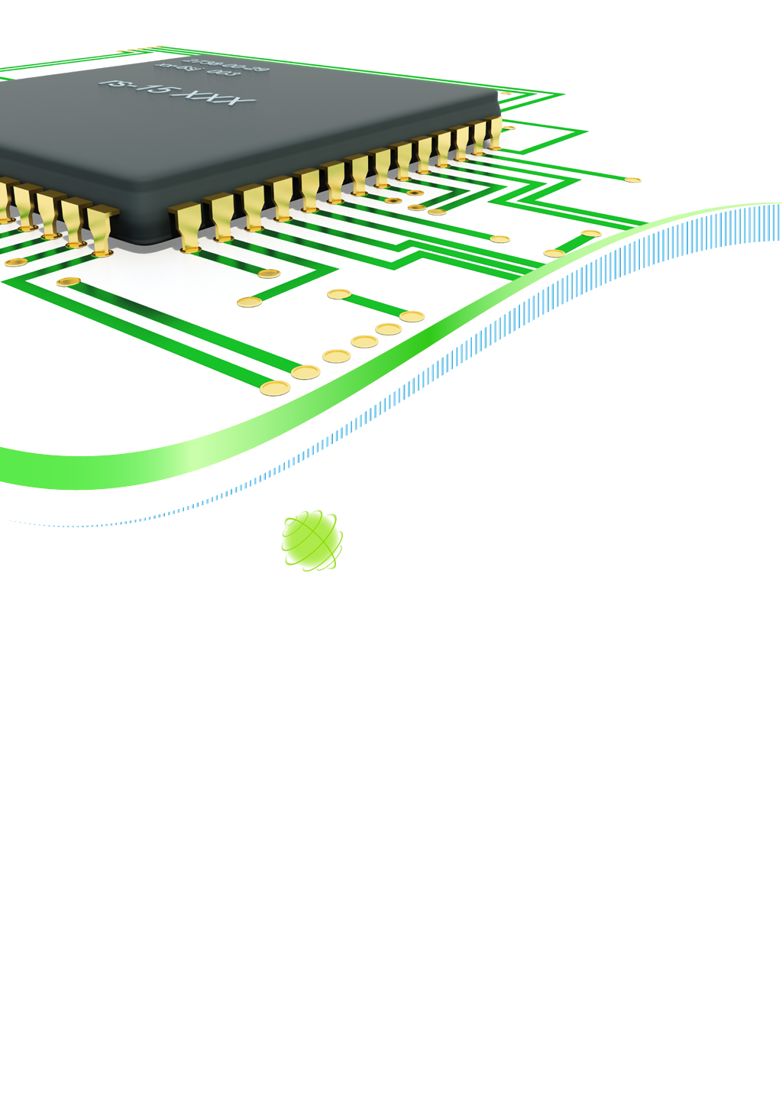

Authored by:
- Dr. S. BELAGOUNE
- Dr. B. BAADJI
- Dr. S. MEZBACHE

Node Analysis
Node analysis, also known as the "node-voltage method" or "modified nodal analysis," is a technique used in electrical circuit analysis to determine the unknown voltages at each node in a circuit. The basic idea behind node analysis is to use Kirchhoff's Current Law (KCL) to write an equation for the current flowing into each node in terms of the node voltages. This results in a system of equations that can be solved simultaneously to find the voltage at each node. Node analysis can be a very powerful tool for solving complex circuits that have multiple voltage sources and resistors. It can help identify the voltage drop across each resistor and the voltage at each node in the circuit.
Mesh Analysis
Mesh analysis is a technique used in electrical circuit analysis to determine the current in each mesh or loop of a circuit. A mesh is a closed loop in a circuit that does not contain any other closed loops. To perform mesh analysis, the circuit is first divided into meshes. Then, Kirchhoff's voltage law (KVL) is applied to each mesh to obtain a set of equations. These equations are then solved simultaneously to determine the current in each mesh. Mesh analysis is a useful technique for solving complex circuits, particularly when there are multiple voltage sources in the circuit. It allows for the analysis of each individual loop, simplifying the overall analysis of the circuit.
The Resistor
A resistor is a fundamental electrical device that is used to resist the flow of electrical current in a circuit. It is a passive device that does not amplify or store energy like other components such as transistors or capacitors. Instead, it converts electrical energy into heat energy. Resistors are used in electronic circuits for a variety of purposes. They can be used to limit the amount of current flowing through a circuit. This can be useful in protecting other components from damage due to excessive current. In addition, they can be used for voltage dividers. A voltage divider is a circuit that uses resistors to divide a voltage into smaller parts in a circuit. Resistors can be used to change the amplitude, frequency or phase of an electrical signal. Some resistors are designed to change their resistance with changes in temperature. These are called thermistors and are used in temperature sensors to measure the temperature. They are often color-coded to indicate their value, using a standardized color-coding scheme.
The Capacitor
A capacitor is an electrical device that stores electrical energy by accumulating electric charge on its plates. It consists of two conductive plates separated by a dielectric material. The capacitance (c) of a capacitor, measured in farads (F), determines its ability to store charge. The capacitor reactance $X_{c}$is equal to $\frac{1}{2πfc}$ Ohms. Capacitors have many applications in electronic circuits. They are commonly used to store energy in electronic circuits. They can be used to filter unwanted frequencies in an electronic circuit by allowing high frequency AC signals to pass through while blocking DC signals. Capacitors can be used to couple two circuits together while blocking DC signals.
The Inductor
An inductor is a passive electronic component that stores energy in a magnetic field when electric current flows through it. It is essentially a coil of wire that is wound around a core made of magnetic material such as iron. When a current flows through an inductor, the magnetic field around the coil expands and contracts, which induces a voltage in the coil. This voltage opposes the flow of the current, causing the current to rise and fall more slowly than it would in a circuit without an inductor. This property of inductors is called inductance (L) and is measured in henneries (H). The inductor reactance $X_{L}$is equal to $2πfL$ Ohms. Inductors have many applications in electronics, including filtering and energy storage. They are often used to filter out high-frequency signals and provide a stable DC voltage to the circuit. They are also used in communication circuits to block or pass certain frequencies. Additionally, inductors are used in transformers, which are used to step up or step down AC voltages in power distribution systems.
The Impedance
Impedance is a measure of the opposition that a circuit component, such as a resistor, capacitor or inductor, offers to the flow of alternating current (AC). It is denoted by the symbol Z and is measured in ohms. Impedance is a complex quantity that consists of two components: magnitude and phase angle. The magnitude of impedance represents the total opposition to the flow of AC, while the phase angle represents the difference in timing between the voltage and current waveforms. The formula to calculate impedance depends on the type of circuit component and whether the circuit is in series or parallel. Here are the formulas for some common components. The resistor impedance is Z = R, the capacitor impedance is Z = -j$X_{c}$and the inductor impedance is Z = j $X_{L}$ where j is the imaginary unit. Impedance plays an important role in AC circuit analysis and design, as it is used to calculate the current and voltage in the circuit, and to design filters and other circuit components that affect the flow of AC.
The Complex and Apparent powers
Complex power and apparent power are two important concepts in electrical engineering that describe different aspects of the power consumed by an electrical circuit. The complex power (S) is the total power consumed by a circuit, including both active power and reactive power where$S=P+jQ=V_{rms}{I^{*}}_{rms}=\left|V_{rms}\right|\left|I_{rms}\right|∠θ_{v}-θ_{i}= \left|S\right|∠φ$ where $φ$ is the power factor. The complex power is measured in volt-amperes (VA) and is the product of the voltage and current in an AC circuit. The apparent power $\left|S\right|$ is the magnitude of complex power S and it is measured in volt-ampere (VA)
The active and reactive powers
The active power (P), also known as real power, is the portion of the apparent power that is actually used to perform useful work in a circuit. It is measured in watts (W) and is the product of the voltage, current, and power factor in an AC circuit, P=$\left|V_{rms}\right|\left|I_{rms}\right|\cos{φ}=\left|S\right|\cos{φ}$. The reactive power (Q) is the portion of the apparent power that does not perform any useful work but is instead used to establish and maintain magnetic fields in the circuit. It is measured in volt-amperes reactive (VAR) and is proportional to the amount of inductive or capacitive load in the circuit, Q=$\left|V_{rms}\right|\left|I_{rms}\right|\sin{φ}=\left|S\right|\sin{φ}$. Active power and reactive power make up the total power consumed by a circuit. The power factor of a circuit is the ratio of active power to apparent power, and is a measure of how efficiently the circuit is using its power. High power factor circuits are more efficient and consume less energy than low power factor circuits.
Principle of superposition
Electronic superposition is a fundamental principle in electronics that describes how the response of a linear circuit to a set of inputs can be determined by the sum of the responses to each individual input. In other words, if a circuit is subjected to two or more signals simultaneously, the response of the circuit to each signal can be calculated independently, and the total response of the circuit is the sum of the individual responses. The principle of electronic superposition applies to linear circuits, which are circuits where the output signal is proportional to the input signal. Nonlinear circuits, on the other hand, do not obey the principle of superposition. The principle of electronic superposition is often used in circuit analysis and design, as it simplifies the analysis of complex circuits by breaking them down into simpler components. For example, if a circuit is subjected to two input signals, the circuit response can be calculated for each signal individually, and then the responses can be combined using the principle of superposition to obtain the total response of the circuit.
RLC Circuits
RLC circuits are electronic circuits that consist of a resistor (R), an inductor (L), and a capacitor (C), connected together in various configurations. These circuits are widely used in electronic devices and systems. The behavior of RLC circuits depends on the values of R, L, and C, as well as the frequency of the input signal. At low frequencies, the inductor and capacitor act as short and open circuits, respectively where at high frequencies, the inductor and capacitor act as open and short circuits, respectively. There are several types of RLC circuits, including series RLC circuits, parallel RLC circuits, and series-parallel RLC circuits. Each type of circuit has its own unique characteristics and behavior. The analysis and design of RLC circuits are important skills for electronic engineers, as these circuits are used in many different applications and systems.
The Diode
A diode is a two-terminal electronic component that allows current to flow in only one direction and blocks current flow in the reverse direction. It is made of a semiconductor material. Diodes are used in a wide range of electronic circuits for various applications. Diodes can be used to convert an alternating current (AC) to a direct current (DC) by only allowing current to flow in one direction. Diodes can be used to protect electronic components from damage caused by voltage spikes or transient voltages. Light-emitting diodes (LEDs) are a type of diode that emit light when current flows through them. They are commonly used in lighting applications.
The Transistor
A transistor is a three-terminal electronic device that can be used as an amplifier or a switch for signals. It is a crucial component in modern electronics and has revolutionized the field of electronics since its invention. Transistors have many applications in electronics, including in radio and television receivers, computer processors, and digital circuits. They are also used in power supplies, voltage regulators, and oscillators. They are widely used in amplifiers to boost the signal strength and in digital circuits to switch and control the flow of current. In short, transistors are a fundamental building block in almost all electronic circuits, and their applications are essential to modern electronics technology.

