**Lecture Six:** **Language Comprehension**

**Dr. Hamoudi, A**

The present lecture introduces learners to both visual and auditory perception of language. It highlights the processes involved in language comprehension and helps in giving them a general view on how language acquisition happens.

# Introduction

Language comprehension is one of the most automatic tasks that humans perform. Yet it is also one of the most complex, requiring the simultaneous integration of many different types of information, such as knowledge about letters and their sounds, spelling, grammar, word meanings, and general world knowledge. In addition, general cognitive abilities such as attention monitoring, inferencing, and memory retrieval are used in order to organize this information into a single meaningful representation.

In order to comprehend language in its written and spoken forms, the language perceiver has to:

* Recognize the signals that reach the brain from ear or from eye or even from fingers in case of Braille that these signals are a language.
  + Recognize that these signals belong to a language that they understand to interpret them as meaning.

**Lexical Access and Word Recognition**

At the core of language comprehension lies the ability to rapidly and accurately identify individual words. This process, known as lexical access, involves the retrieval of stored information about a word's meaning, pronunciation, and grammatical properties from the mental lexicon - the vast repository of words in our minds.

Word recognition is the first critical step in comprehending language, be it spoken or written. Theories of word recognition posit that the process involves the activation of lexical representations based on partial sensory input, followed by the selection of the most likely candidate from among competing alternatives. This selection is influenced by a variety of factors, including the word's frequency, familiarity, and contextual fit.

# Mapping from the Input to the Linguistic System

What is common to both visual and auditory processing is the nature of pre-lexical processing which means the kind of units that need to be identified before words can be accessed. It is noteworthy here that individuals that read frequently, proceed into letter by letter recognition only in uncommon words but in frequently used words, the recognition is made of the whole word shape. In the spoken form, listeners recognize single phonemes or simply sounds before gathering these sounds to form the spoken word.

# Special Characteristics of Language Visual Perception

In reading, the recognition is performed in a letter by letter basis, though, the whole word shape is very important with frequently used words. Three main phases can be considered here, first, is the visual analysis that transforms the input into a buffer. Second, a further analysis in the working memory and finally by the integration of analyzed input with the linguistic and cognitive interpretation.

***How does language comprehension happen?***

1. ***Auditory Perception:***

Language comprehension following a very simplified schema would start with [auditory](https://www.sciencedirect.com/topics/neuroscience/auditory-perception) [perception](https://www.sciencedirect.com/topics/neuroscience/auditory-perception) and the phonological/phonetic analysis of language-relevant sounds, which would allow individuals to make the distinction between different words (e.g., ‘cat’ vs. ‘rat’ vs. ‘run’).

1. ***Syntactic Operations:***

which identify the lexical status and grammatical category of a particular word is The word ‘cat’ would be classified as a noun, the word ‘run’ as a verb. The categorical classification of a word would allow the initial construction of syntactic structures, for example, with ‘cat’ belonging to a noun phrase (NP) and ‘run’ as belonging to a verb phrase (VP), up to the sentence level (S). If no additional reanalysis or recombination processes are required, semantic aspects and contextual inferences would then be evaluated in order to integrate the overall sentence meaning.

1. **Semantic Integration:**

Once the syntactic structure is established, the brain evaluates the semantic aspects and contextual inferences to integrate the overall meaning of the sentence. This involves the suppression of distractions and the direction of attentional resources to the message of interest.

1. ***Attention Requirement:***

Language comprehension requires the direction of attentional resources to the message of interest, along with the suppression of any interferences arising from distracting sources. Within the clinical domain, subjects with attention-deficit/hyperactivity disorder have been found to display reduced ability to understand a massage. Presumably, the ability of rapid attention shifting plays also an important role in speech communication, when a listener has to follow a speaker’s topical changes in the course of a dialogue.

1. ***Revision of the Message Meaning:***

comprehension routinely involves taking into account relevant information that becomes available after a message-level representation has already been established. In these cases, the initial meaning representation may need to be revised or reshaped. This is common in figurative comprehension, such as the comprehension of metaphors or jokes.

1. ***The Interference of Existing Information in the Memory:***

A major part of language comprehension is integrating new information with what is already known or the role that interference from similar representations of words (or phrases or clauses) plays in inefficient memory retrieval. For example, studies showed that when a reader’s attention is directed towards a group of ‘fixable things’ like a closed window, he or she has a more difficult time processing the verb ‘fixed’ in a sentence like, ‘It was the boat that the guy who lived by the sea fixed in two days’. This type of interference occurs when retrieval cues become associated with other similar items in memory. However, interference can also appear in phonology when words that rhyme: ***‘hat’ ‘mat’, ‘sat’***) or lexical lines (words that have an associated meaning: ‘***hat’ > ‘hair’, ‘wig***’).Psycholinguists suggested that *retrieval interference* such as this is challenging language processing, and is one of the main factors affecting comprehension ability.

**key factors affecting Language comprehension:**

1. **Attention**: Maintaining focus and concentration is crucial for comprehending written or spoken language. Distractions or lack of attention can hinder the ability to process and understand information effectively.

.

1. **Working Memory:** The capacity to hold and manipulate information in the mind for a short period is essential for comprehension. Individuals with limited working memory may struggle to integrate ideas and make connections between different parts of a text or conversation.

.

1. **Variability in Language:** The complexity and variability of language, such as the use of unfamiliar vocabulary, complex sentence structures, or ambiguous references, can pose challenges for comprehension. Readers or listeners may have difficulty understanding the intended meaning when language is not straightforward.

.

1. **Context:** The surrounding circumstances, setting, or background information that provides meaning and clarity to a message. Comprehension can be hindered when the context is unclear or when there is a mismatch between the context and the language used.
2. **Individual Differences:** Factors such as prior knowledge, vocabulary, motivation, and reading strategies can vary among individuals and significantly impact their ability to comprehend written or spoken language. Readers or listeners with limited background knowledge, vocabulary, or ineffective strategies may struggle to make sense of the information presented.

**Literal Sentence Comprehension Vs Figurative Meaning Comprehension:**

Literal sentence comprehension involves understanding the explicit meaning of language without the need for additional interpretation or inference. When processing literal sentences, individuals rely on the surface-level meaning of words and phrases to derive the intended message. This type of comprehension is straightforward and typically involves matching the linguistic input to stored knowledge and linguistic rules to extract the intended message accurately. This includes the following processing phases:

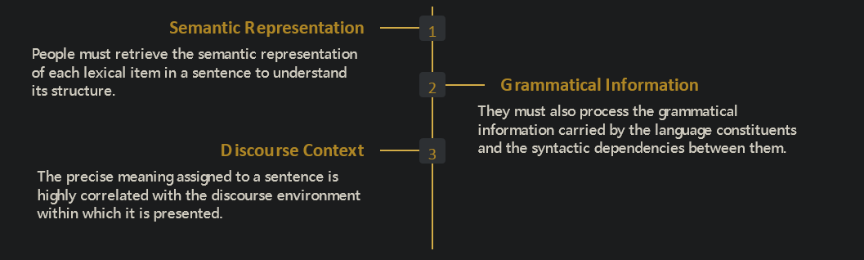

In contrast, figurative meaning comprehension requires individuals to go beyond the literal interpretation of language and understand the intended meaning that may involve metaphorical, idiomatic, or non-literal expressions. Figurative language often conveys meanings that go beyond the literal definitions of words and phrases, requiring listeners or readers to infer the underlying message based on context, pragmatic knowledge, and cognitive processes. This includes the following:

