**II British Geography, Population and Immigration**

1. **Geography**

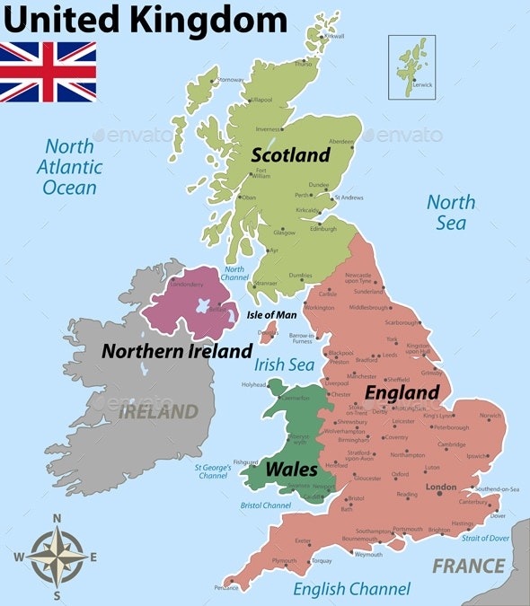 The [United Kingdom](https://en.wikipedia.org/wiki/United_Kingdom) is a  [royal state](https://en.wikipedia.org/wiki/Sovereign_state) located off the north-western coast of [Europe](https://en.wikipedia.org/wiki/Continental_Europe). With a total area of approximately 248, 532 square kilometres, the UK occupies the major part of the [British Isles](https://en.wikipedia.org/wiki/British_Isles)  and includes the island of [Great Britain](https://en.wikipedia.org/wiki/Great_Britain), the north-eastern one-sixth of the island of [Ireland](https://en.wikipedia.org/wiki/Ireland) and many smaller surrounding islands. It is the world's 7th largest [island country](https://en.wikipedia.org/wiki/List_of_island_countries). The mainland areas lie between latitudes 49°N and 59°N (the [Shetland Islands](https://en.wikipedia.org/wiki/Shetland_Islands) reach to nearly 61°N), and longitudes 8°W to 2°E. The [Royal Observatory, Greenwich](https://en.wikipedia.org/wiki/Royal_Observatory,_Greenwich), in south-east London, is the defining point of the [Prime Meridian](https://en.wikipedia.org/wiki/Prime_Meridian). The UK includes England, Scotland, Wales and Northern Ireland.

***England***

**E**ngland (population 49,753,000) consists mainly flat lowland countryside, with highland areas in the north and south-west. Eastern England has the low-lying flat lands of the Norfolk Broads, the Cambridgeshire and Lincolnshire Fens and the Suffolk Marshes. Low hill ranges stretch over much of the country, such as the North Yorkshire Moors, the Cotswolds, the Kent and Sussex Downs and the Chiltern Hills.

**T**he heaviest population concentrations centre on the largest towns and cities, such as London and in south-east England generally; the West Midlands region around Birmingham; the Yorkshire cities of Leeds, Bradford and Sheffield; the north-western industrial area around Liverpool and Manchester; and the north-east region comprising Newcastle and Sunderland.

***Scotland***

**S**cotland (population 5,119,000) may be divided into three main areas. The first is the North-West and Central Highlands, together with a number of islands off the west and north-east coasts. These areas are thinly populated, but comprise half the country’s land mass. The second is the Central Lowlands, which contain one-fifth of the land area but three quarters of the Scottish population, most of the industrial and commercial centres and much of the cultivated land. The third is the Southern Uplands, which cover a number of hill ranges stretching towards the border with England.

**T**he main population concentrations are around the administrative centre and capital of Edinburgh; the commercial and industrial area of Glasgow; and the regional centres of Aberdeen (an oil industry city) and Dundee.

***Wales***

**W**ales (population 2,937,000) is a highland country, with moorland plateau, hills and mountains, which are often broken by deep river valleys. This upland mass contains the Cambrian mountains and descends eastwards into England. The highest mountains are in Snowdonia in the north-west, where the dominant peak is that of Snowdon (3,560 feet, 1,085 metres). The lowland zones are restricted to the narrow coastal belts and to the lower parts of the river valleys in south Wales, where two-thirds of the Welsh population live. The chief urban concentrations of people and industry are around the bigger southern cities, such as the capital Cardiff, Swansea and Newport. In the past, the highland nature of Wales hindered conquest, agriculture and the settlement of people.

***Northern Ireland***

**N**orthern Ireland (population 1,692,000) has a north-east tip which is only 13 miles (21 km) from the Scottish coast, a fact that has encouraged both Irish and Scottish migration. Since 1921–22, Northern Ireland has had a 303-mile (488-km) border in the south and west with the Republic of Ireland. It has a rocky northern coastline, a south-central fertile plain and mountainous areas in the west, north-east and south-east. The southeastern Mourne Mountains include the highest peak, Slieve Donard, which is 2,796 feet high (853 metres). Lough Neagh (153 square miles, 396 sq km) is Britain’s largest freshwater lake and lies at the centre of the country. Most of the large towns, such as the capital Belfast, are situated in valleys which lead from the Lough. Belfast lies at the mouth of the river Lagan and has the biggest population concentration. But Northern Ireland generally has a sparse and scattered population and is a largely rural.

1. **Population**

**T**here is no accurate picture of what the early settlement of the British-Irish Isles was actually like, and there were long periods when the islands were uninhabited. Historians and archaeologists constantly revise traditional theories about the gradual growth of the country as new evidence comes to light. The earliest human bones found (1994) in Britain are 500,000 years old. The first people were probably Palaeolithic (Old Stone Age) nomads from mainland Europe, who were characterized by their use of rudimentary stone implements. They travelled to Britain by land and sea, especially at those times when the country was joined to the European land mass.

**L**ater settlers in the Mesolithic and Neolithic (Middle and New Stone Age) periods between 8300 and 2000 BC had more advanced skills in stone carving. Some came from central Europe and settled in eastern Britain. Others arrived by sea from Iberian (Spanish-Portugese) areas and populated Cornwall, Ireland, Wales, the Isle of Man and western Scotland. Their descendants live today in the same western parts. Neolithic groups built large wood, soil and stone monuments, such as Stonehenge, and later arrivals (the Beaker Folk) introduced a Bronze Age culture.

**B**etween ca 600 BC and AD 43 there was a movement of Celtic tribes into the islands from mainland Europe, bringing an Iron Age civilization with them. But the Celts possessed at least two main languages and were divided into many different tribes with conflicts between them. Celtic civilization dominated the British-Irish Isles until it was overcome by Belgic tribes (also of Celtic origin) around 200 BC.

**T**he Belgic tribes were then subjected to a series of Roman expeditions from 55 BC. The Roman military occupation of the islands (except for Ireland and most of Scotland) lasted from AD 43 until 409. The term ‘Britain’ derives from the Greek and Latin names given to England and Wales by the Romans, although it may stem from Celtic originals. It is argued that the Romans did not mix with the existing population and that their lasting influence was slight. But some Christian practices spread throughout the islands and there is still physical evidence of the Roman presence.

**A**fter Roman withdrawal, Germanic tribes such as Angles (from which ‘England’ is derived), Saxons and Jutes from north-western Europe invaded the country. They either mixed with the existing population or pushed it westwards. The country was divided into separate and often warring Anglo-Saxon kingdoms in England (except for Cornwall), with Celtic areas in Wales, Scotland and Ireland. Many of these regions suffered from Scandinavian (Viking) military invasions in the eighth and ninth centuries, until the Scandinavians were defeated in England, Scotland and Ireland in the tenth and eleventh centuries. The Scandinavian presence, after initial fleeting raids, was reflected in some permanent settlement, assimilation, farming and political institutions.

**E**arly English history was completed when the Anglo-Saxons were defeated by French-Norman invaders at the Battle of Hastings in 1066 and England was subjected to their rule. The Norman Conquest was an important watershed in English history and marked the last successful external military invasion of the country. It influenced the English people and their language (since French was the language of the nobility for the next three hundred years) and initiated many of the social, legal and institutional frameworks, such as a feudal system (hierarchical structure from top to bottom of society), which were to characterize future British society.

Therefore, it will be safe to argue that British people today came from a mixture of different nationalities and ethnic groups such as the Romans, Normans, Anglo-Saxons, Vikings and Danes.

***Early settlement to AD 1066***

|  |  |
| --- | --- |
| **500,000–8300 BC** | Palaeolithic (Old Stone Age) |
| **8300 BC** | Mesolithic (Middle Stone Age) |
| **4000 BC** | Neolithic (New Stone Age) |
| **2000 BC** | Beaker Folk (Bronze Age) |
| **600 BC** | Celts (Iron Age) |
| **200 BC** | Belgic tribes |
| **AD 43** | The Romans |
| **AD 410** | Germanic tribes (Anglo-Saxons) |
| **8th to 11th centuries** | The Scandinavians |
| **AD 1066** | The Norman Conquest |

1. **Immigration**

**I**mmigration from abroad also continued over the centuries owing to factors such as religious and political persecution, trade, business and employment. Immigrants have had a significant impact on British society. They have contributed to financial institutions, commerce, industry and agriculture, and influenced artistic, cultural and political developments. But immigrant activity and success have resulted in jealousy, discrimination and violence from the native population.

**S**ome immigrants stayed only for short periods. Others remained and adapted themselves to British society, while preserving their own cultural and ethnic identities. Newcomers were often encouraged to settle in Britain and the policy of using immigrant expertise continued in later centuries. But foreign workers had no legal rights, and early immigrants, such as Jews and the Hansa merchants, could be summarily expelled.

**O**ther newcomers continued to arrive from overseas, including gypsies, blacks (associated with the slave trade) and a further wave of Jews, who in 1655 created the first permanent Jewish community. In the sixteenth and seventeenth centuries, the country attracted a large number of refugees, such as Dutch Protestants and French Huguenots, who were driven from Europe by warfare, political and religious persecution and employment needs. This talented and urbanized immigration contributed considerably to the national economy and added a new dimension to a largely agricultural population. But, from around 1700, there was to be no more large immigration into the country for the next two hundred years. Britain was exporting more people than it received, mainly to North America and the expanding colonies worldwide.

**I**mmigration and asylum seekers caused public and political concern, which continued through the twentieth century. In the early years of the century, Jews and Poles escaped persecution in Eastern Europe and settled in the East End of London, which has always been an area of immigrant concentration. Demands for immigration control grew and an anti-foreigner feeling spread, fuelled by the nationalism and spy mania caused by the First World War (1914–18). But laws (such as the Aliens Act of 1905), which were designed to curtail foreign entry, proved ineffective. By 1911 the number of people in Britain born outside the empire was 428,000 or 1 per cent of the population. Despite legal controls, and partly as a result of the 1930s world recession and the Second World War, refugees from Nazi-occupied Europe and immigrants entered Britain. After the war, Poles, Latvians, Ukrainians and other nationalities chose to stay in Britain. Later in the twentieth century, political refugees arrived, such as Hungarians, Czechs, Chileans, Libyans, East African Asians, Iranians, Vietnamese and other Eastern Europeans, in addition to Italian, French, German, Irish, Turkish, Cypriot, Chinese and Spanish economic immigrants. These groups today form sizeable ethnic minorities and are found throughout the country. Such newcomers have often suffered from discrimination, some more than others, since racism is not a new phenomenon in Britain.

**B**ut from the late 1940s, people from the non-white New Commonwealth nations of India, Pakistan and the West Indies came to Britain (sometimes at the invitation of government agencies) to fill the vacant manual and lower-paid jobs of an expanding economy. West Indians worked in public transport, catering, the Health Service and manual trades in London, Birmingham and other large cities. Indians and Pakistanis later arrived to work in the textile and iron industries of Leeds, Bradford and Leicester (which may be the first British city to have a non-white majority population). By the 1970s, non-white people became a familiar sight in other British towns such as Glasgow, Sheffield, Bristol, Huddersfield, Manchester, Liverpool, Coventry and Nottingham. There was a considerable dispersal of such immigrants throughout Britain, although many tended to settle in the central areas of industrial cities. These non-white communities have now increased and work in a broad range of occupations. Some, particularly Indian Asians and black Africans, have been successful in economic and professional terms. Others have experienced considerable problems such as low-paid jobs, unemployment, educational disadvantage, decaying housing in the inner cities and racial discrimination. It is argued that Britain possesses a deep-rooted (or institutional) racism based on the legacy of empire and notions of racial superiority, which continues to manifest itself and has hindered the integration of the non-white population into the larger society. Many young non-whites who have been born in Britain feel particularly bitter at their experiences and at their relative lack of educational and employment possibilities and advancement.

**Exercises:**

1. Is it correct to describe contemporary Britain as a ‘multi-cultural’, ‘multi-ethnic’ and ‘multinational’ society? If so, why?
2. Describe in outline the history of settlement and immigration in Britain

***For further reading, please check the following :***

Alibhai-Brown, Y. (2001) Who Do We Think We Are? Imagining the New Britain London: Allen Lane

Donnell, A. (2001) Companion to Contemporary Black British Culture London: Routledge