biophysic course

Dr.Malika MERZOUGUI
Departement Common Trunk of Nature and Life Sciences
University of M'sila
merzougui.malika@univ-m'sila.dz

02-03-2024

1
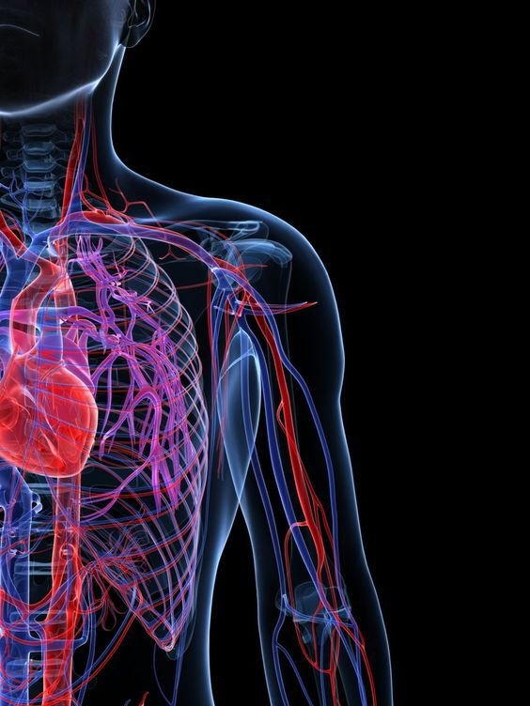

Caption

▪

Glossary entry



Abbreviation

◻

Bibliographical reference



General reference

Table of contents

Objectives 5
Introduction 7
I- Quiz: Prerequisite test 9
II- Chapter I : electrolytic solution 11
A. Introduction 11
B. The solutions 12
1. Definition of solution 12
2. Classification of Solutions 12
C. The Concentrations 13
1. Molar concentration or molarity C 13
2. ponderal concentration Cp 13
3. relation between molar concentration and ponderal concentration 13
4. Molal concentration or molality Cml 14
5. Molar fraction 14
6. Mass or weight fraction 14
D. The solubility 14
E. Conductometry 15
F. Electrolytic solutions 15
1. Coefficient dissociation α 15
2. Coefficient ionization i 15
G. Quantitative characteristics of solutions 16
1. Osmolality concentration W 16
2. Ionic Concentration 16
3. Equivalent Concentration 16
H. Conductivity mechanism in electrolytic solutions 17
1. Electrolytic cell 17
2. Electrolysis 17
3. Conductivity 18
4. Conductance 18
5. Resistance 18
6. Resistivity 18
I. Quiz: Exercises series I 19
J. Interrogation of chapter I 20
III- Examination biophysics 21
A. Examination biophysics 21
Exercises solution 23
Glossary 27
Abbreviations meaning 29
Bibliography 31
Web bibliography 33

Objectives

This course aims to increase students' understanding of how principles of physics can be integrated with biology to better understand biological processes.
• Reminding the student of basic concepts to ensure that he has the necessary requirements in order to complete the course. The basic requirements can also be tested (a series of short-answer exercises)
• The first chapter of biophysics aims to provide definitions of solutions and their types.
• Through this chapter, the student will distinguish between various concepts related to the quantitative characteristics of a solution. Here we give the student various exercises based on what he learned and understood from the lesson.
• The second chapter of biophysics aims to define what diffusion phenomenon.
• Through this chapter, the student knows how passive transport and the diffusion process occur. Here we give the student various exercises based on what he learned and understood from the lesson.
• Verifying the level of understanding and the student's assimilation of the information gained from the lessons. The interrogation mode helps the student evaluate the student's level of understanding and assimilation of the information gained from the lessons.

Introduction

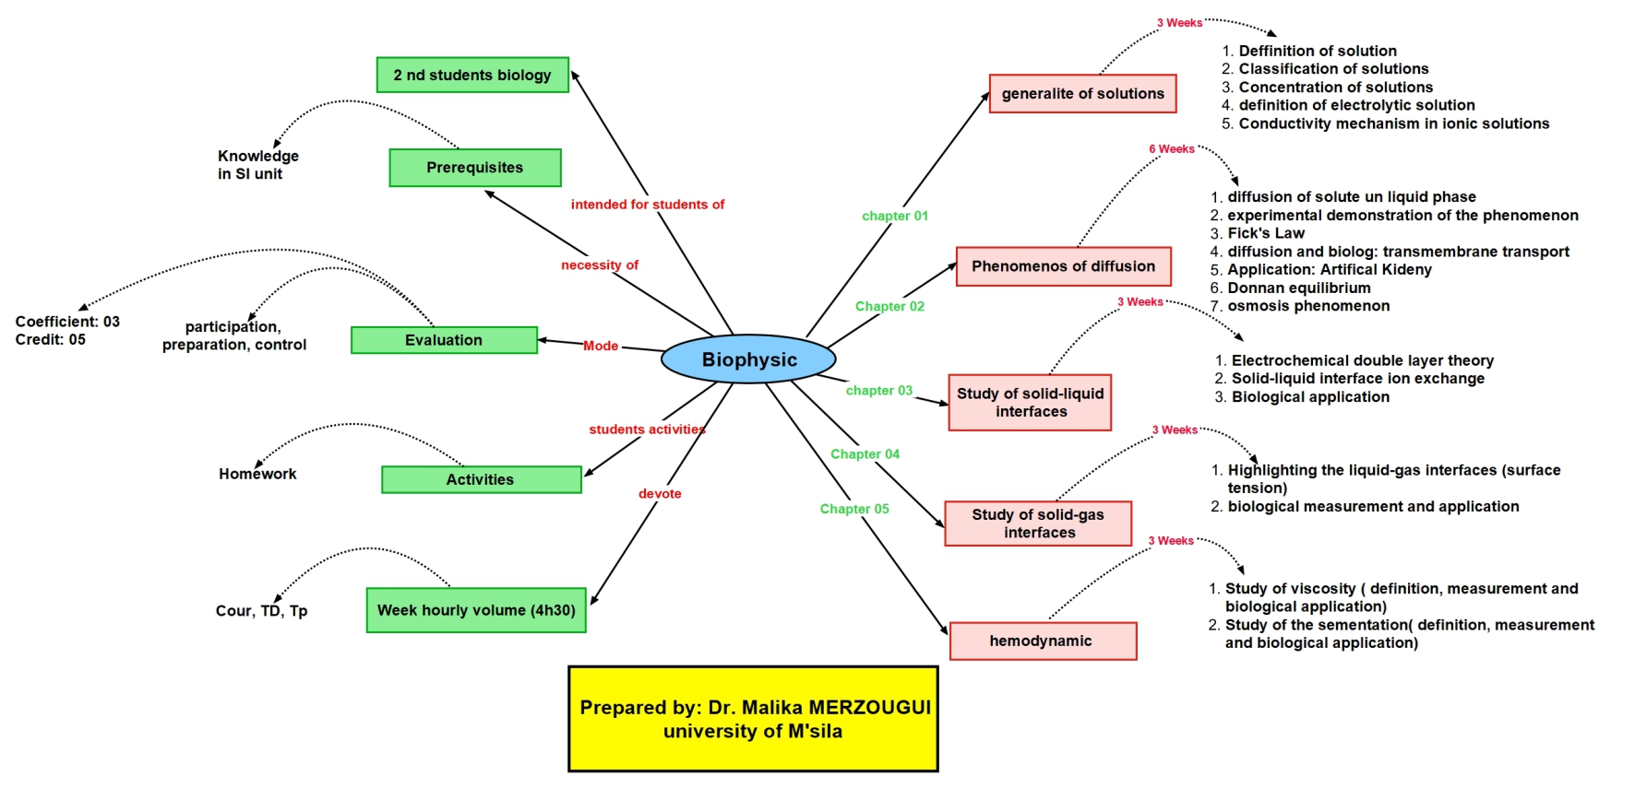
The mental map

In this course, we will explore the exciting interaction of physics and biology, merging physics concepts with the phenomena and processes within living organisms.
Biophysics offers a deep and comprehensive look at applying physics principles to the biological realm, aiding us in better understanding biological processes.
Throughout this course, we'll explore intriguing topics like material transport across cell membranes and biological reactions influenced by surrounding conditions like temperature and pressure.
We'll also learn how to apply physics principles to comprehend complex biological phenomena, such as chemical reactions within cells.
in the end of this course, you'll be able to connect physics concepts with biological processes.

- Quiz: Prerequisite test

I- Quiz: Prerequisite test
I

[Solution n°1 p 23]

Questions
- Define the solutions?
- What is the definition of quantity of matter?
- What is the definition of Concentration?
- Define the filtration process?
- Define the dilution process?

- Chapter I : electrolytic solution

II- Chapter I : electrolytic solution
II

Introduction 11
The solutions 12
The Concentrations 13
The solubility 14
Conductometry 15
Electrolytic solutions 15
Quantitative characteristics of solutions 16
Conductivity mechanism in electrolytic solutions 17
Quiz: Exercises series I 19
Interrogation of chapter I 20

  - Introduction

Solutions are homogeneous mixtures usually classified based on their physical state, including solid solutions, gaseous solutions, and liquid solutions.
Solid Solutions: Composed of at least one substance, which is the solvent, mixed with a specific quantity of another substance, identified as the solute.
Gaseous Solutions: Homogeneous mixtures of gases that do not react with each other.
Liquid Solutions: One of the components is a liquid before being mixed with another substance. The liquid component is called the solvent, and the process is known as dissolution.
- The solute can be a liquid, solid, or gas.
The corresponding figure shows the types of solutions according to the physical state of the
solution

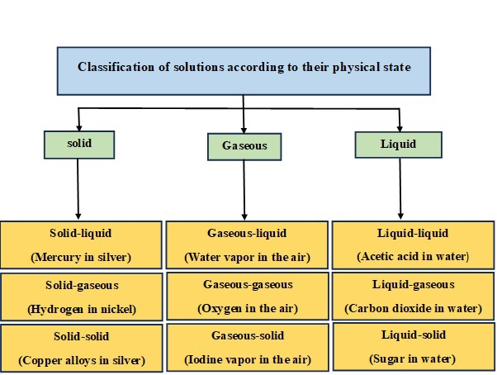
Figure 1 : represents the types of solutions according to their physical state

objectif
Through this chapter, the student will distinguish between various concepts related to the quantitative characteristics of a solution. Here we give the student various exercises based on what he learned and understood from the lesson.

  - The solutions

    - Definition of solution

- A solution is a homogeneous mixture consisting of two or more substances (molecules, atoms, or ions).
- A solution contains substances in small quantities called a solute and another in a large quantity called a solvent.
- In a solution, the solute is dispersed uniformly throughout the solvent.
    - Classification of Solutions

The terms dilute and concentrate are used when referring to the concentration of solutions.
      - Concentrated solutions

Dilute solutions are solutions that contain a relatively large amount of dissolved solute.
      - Dilute solutions

Dilute solutions are solutions that contain a relatively small amount of dissolved solute.
      - Ideal Solution

Ideal solutions are expressed when the interaction energies are equal between solvent-solvent, solvent-solute, and solute-solute. solution (A-B) is ideal if the intermolecular forces in the solution are exactly equal to the intermolecular forces in the two pure substances A and B). Dilute solutions are called ideal solutions.
      - Non-ideal Solution

Non-ideal solutions are expressed when the interaction energies are unequal between solvent-solvent, solvent-solute, and solute-solute. solution (A-B) is non-ideal if the intermolecular forces in the solution are exactly unequal to the intermolecular forces in the two pure substances A and B).

  - The Concentrations

The concentration of a solution measures the amount of solute that has been dissolved in a given amount of solvent or solution. There are several ways to express the amount of solute present in a solution, including:
    - Molar concentration or molarity C

The molar concentration expresses the number of moles of the solute per the volume of the solution. This concentration is measured in mol/m3, in mol/L, or subunits such as mmol/L.

    - ponderal concentration Cp

The ponderal concentration expresses the mass of the solute per the volume of the solution. it is expressed in g/m3, in g/L, or in subunits such as mg/L.

    - relation between molar concentration and ponderal concentration

Mass concentration can be calculated using molar concentration, by replacing m=n×M in the mass
concentration relation. So, the relation becomes as follows: Cp=C×M
    - Molal concentration or molality Cml

The molal concentration is deﬁned as the ratio of the number of moles of the solute to the mass of the solvent contained in the sample. it is expressed in mol/kg.

    - Molar fraction

The molar fraction expression is used to determine the mole ratio of every constituent of the solution. It is defined as the ratio between the number of moles of the constituent ni (solute) on the total number of moles present in the solution ∑ni (solvent + solute).

    - Mass or weight fraction

The mass fraction expression is used to determine the mass ratio of every constituent of the solution. It is defined as the ratio between the mass of the constituent m_i (solute) on the total mass ∑mi (solvent + solute).

Note :
- The sum mole fraction equals 1
- The sum of the weight fraction equals 1

  - The solubility

- Solubility is the ability of a substance (solute) to dissolve in another substance (solvent) to form a solution.
- In general, the solubility degree is expressed in grams of solute per liter of solvent.
- Solubility of one fluid (liquid or gas) in another may be complete (totally miscible, for example: methanol and water) or partial (oil and water dissolve only slightly).
- The solubility of a substance is influenced by several factors including the temperature, pressure, and the nature of the solute and solvent.

  - Conductometry

Conductometry is a method of electrolysis that permits measuring the conductive properties of electrolytes.

  - Electrolytic solutions

Electrolyte solution is a solution that generally contains ions, atoms or molecules that have lost or gained electrons, and is electrically conductive, there are two types of electrolytes:
- Strong electrolytes: solutes that dissociate completely in the solvent giving solutions of high electrical conductivity (such as strong acids and bases).
- Weak electrolytes: solutes that partially dissociate in the solvent resulting in solutions of low electrical conductivity (such as weak acids and bases).
Electrolytic solution can be obtained by dissolving in water:
- an ionic solid NaCl(s) → Na+(aq) + Cl-(aq)
- a polar liquid HNO3(l) → H+(aq) + NO3-(aq)
- a polar gas HCl(g) → H+(aq) + Cl-(aq)
Polar liquids and gases are composed of polar molecules that will dissociate as ions in water. https://youtu.be/D1CfxNvrGkA?si=-p2MC48jYdmjZbNP
    - Coefficient dissociation α

The dissociation coefficient measures the degree to which a substance dissociates into its constituent ions when in solution, and is expressed as

Noting that α is a dimensionless value that varies between 0 and 1. According to the dissociation coefficient α, electrolytes are divided into two categories: weak electrolytes and strong electrolytes.
- When α=1, dissociation is total. In this case, the electrolyte is considered strong. This is the case for salts such as NaCl, KCl, CaCl2, strong acids HCl, H2SO4, and strong bases KOH.
- When 0<α<1 , dissociation is partial, and the solution contains both ions and molecules of the solute. In this case, the electrolyte is considered weak. This is the case for weak acids CH3-COOH and weak bases NH4.
- When α=0 , there is no dissociation and the solution is non-electrolytic. This is the case for solutions of urea, glucose, and sucrose.
    - Coefficient ionization i

The ionization coefficient i of a solution is defined as the ratio between the number of particles and the total initial number of molecules introduced into the solvent. In general, the ionization cefficient is expressed as follows:

- υ is the total number of particles resulting from the dissociation.
- α is the dissociation coefficient.
- The ionization coefficient i equals υ for complete dissociation, and it equals 1 for no dissociation.

  - Quantitative characteristics of solutions

    - Osmolality concentration W

- In a liquid medium, the molecules of the solvent and solutes, or their ions when they are capable of dissociation, move over each other. Each one constitutes a "kinetic unit."
- Osmole is representing a number of kinetic units.
- The number of osmoles (kinetic units) per unit volume of the solution.
- it is expressed in Osm/m3 or mOsm/L.

C: molar concentration, i : ionization coefficient
    - Ionic Concentration

The ionic concentration is the quantity or number of ions present in a solution. It is symbolized by C_i. It is expressed in g ions/m3 or grams ions/L.

- Ci: The ionic concentration of the Mole solution
- 𝐶𝑖+ : The ionic concentration of Mole cations
- 𝐶𝑖− : The ionic concentration of Mole anions
- n+: Number of moles of cations
- n-: Number of moles of anions
- α : Degree of ionic dissociation of the solute
- C: The molar concentration of the solution
    - Equivalent Concentration

Equivalent concentration measures the amount of electrical charge (expressed in equations) present in an electrolyte, it is expressed in equivalent /m3 or equivalent /L.

- Ceq: equivalent concentration of the Mole solution
- 𝐶𝑖 +: ionic concentration of Mole cations
- 𝐶𝑖 − : ionic concentration of Mole anions
- z+: Number of valence of cations
- z-: Number of valence of anions

  - Conductivity mechanism in electrolytic solutions

    - Electrolytic cell

It is an electrochemical cell where electrical energy is converted into chemical energy as a result of passing an electric current an external source, leading to a chemical reaction.
    - Electrolysis

It is a chemical reaction that occurs as a result of passing an electric current through an electrolytic cell. In this process, oxidation reactions of negative ions occur at the anode, while reduction reactions of positive ions occur at the cathode, resulting in the liberation or deposition of substances.
The conductivity mechanism in ionic solutions is primarily based on the movement of charged ions within the solution, these ions can conduct electricity in solutions because they can to move. The more ions present in a solution, the higher the conductivity measurement will be.
- In a solution such as water, conductivity comes from the passing of electricity between ions. For example, when sodium (Na+) and chlorine (Cl-) form sodium chloride in saltwater, more electricity is carried, and therefore the conductivity increases. As salinity increases, conductivity also increases.
- To measure the conductivity of an ionic solution, we use a conductivity cell, which consists of two metallic plates indicated to as the electrodes. The area of the cell immersed in the solution is S in square meters (m²) and a distance L in meters (m) between the electrodes. As shown in Figure 2

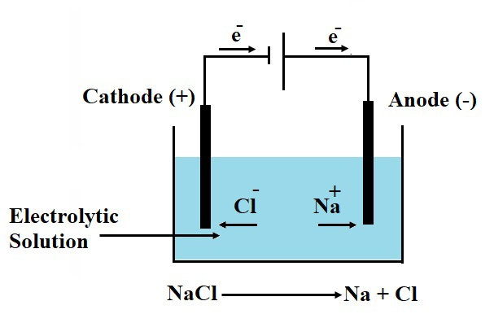
Figure 2: Shows conductivity mechanism in electrolytic solutions

    - Conductivity

- The electrical conductivity σ is a measure of a material's ability to conduct or transmit electricity.
- The conductivity has a direct relation with the molar concentration of the solution and the molar specific conductivity λ, it is expressed in Siemens per meter S/m.

• It is also known as the reciprocal of resistivity

- σ: Electrical conductivity (S/m).
- λ-: Specific molar conductivity of the anion ion S.m2/mol.
- λ+: Specific molar conductivity of the anion ion S.m2/mol.
- [X- ]: Molar concentration of the anion ion mol.
- [X+ ]: Molar concentration of the cation ion mol.
- ρ: The resistivity of the solution Ohm. meter (Ω.m).
    - Conductance

- It is a physical quantity that expresses the conductance of an electric current. Its symbol is G, and it is expressed in Siemens (S).
- It is also known as the reciprocal of resistance.

    - Resistance

Resistance is the capability of a conducting material to permit the passage of electric current, it depends on its geometric shape (material's composition, length, cross-sectional area), and it is expressed in Ohm (Ω).

- R: The resistance of the material Ohm (Ω).
- U: Tension difference between the terminals of the material Volt (V).
- I: Intensity of electric current Ampere (A).
    - Resistivity

Based on resistivity, we can compare different materials based on their ability to conduct electrical currents, and it is expressed in Ohm. meter (Ω.m).

- ρ: The resistivity of the solution Ohm. meter (Ω.m)
- R: The resistance of the material Ohm (Ω).
- K: Cell constant meter (m).

  - Quiz: Exercises series I

[Solution n°2 p 23]

Exercise 1
One litre of an aqueous solution contains:
5.85 g NaCl, 3.28 g PO4Na 3,9 g glucose, 0.6 g urea. It is supposed that NaCl and PO4Na3 are completely dissociated.
Calculate the molarity, osmolarity, ionic, and equivalent concentration of the solution.
The molar masses of NaCl=58.5, PO4Na3=164, glucose=180, and urea=60 g/mol.
Exercise 02
One liter of an aqueous solution contains 60 g of sucrose, 1.8 g of urea, 17.6 g of NaCl, and 2.98 g of Na2SO4. 100 ml of this solution is taken and 1 L of pure water is added.
1. Calculate the osmolarity, ionic, and equivalent concentration.
2. Determine the total ionization coefficient (i) of the solution.
The molar masses of Na2SO4=142, sucrose=342, urea=60 g/mol.
Exercise 03
To measure the resistance of an electrolytic solution, a voltage of U=1 V is applied between the two electrodes of the conductometric cell, and a current intensity of 12 mA is measured. The immersed surface of the cell electrodes is S=1 cm² and the distance between these two electrodes is L=1 cm.
- Calculate the resistance (R) of the solution between the two electrodes
- conductance (G) of the solution between the two electrodes
- conductivity (σ) of the solution between the two electrodes
Exercise 04
Mix 200 ml of a 5 mol/l sodium chloride solution (KCL) with 800 ml of a 1.25 mol/l sodium chloride NaCl solution.
Calculate the conductivity σ_1 and σ_(2 )of each solution.
Calculate the conductivity σ of the mixture.
The ionic molar conductivities λ (Na⁺) =5.01×10-3, λ (Cl⁻) =7.63×10-3 and λ (K⁺) =7.35×10-3 S.m²/mol.

  - Interrogation of chapter I

Document 1
Intr I.pdf

- Examination biophysics

III- Examination biophysics
III

Examination biophysics 21

  - Examination biophysics

Document 2
Exam.pdf

- Exercises solution

Exercises solution

> Solution n°1 (exercise p. 9)

Questions
- Define the solutions?
- What is the definition of quantity of matter?
- What is the definition of Concentration?
- Define the filtration process?
- Define the dilution process?
- Solutions are homogeneous mixtures usually classified based on their physical state, including solid solutions.
- Quantity of matter refers to the quantity or mass present in a given object. It represents the total amount of atoms or molecules that make up a substance. it is exprissed in mol/l.
- Concentration is the measure of the amount of solute dissolved in a given quantity of solvent or solution.
- Filtration is a separation process used to separate solid particles from a liquid or gas by passing the mixture through a filter medium. The filter medium allows the liquid or gas to pass through while retaining the solid particles.
- Dilution is the process of reducing the concentration of a solution by adding a solvent to it. This is typically done by adding more of the solvent (usually water) to a concentrated solution.

> Solution n°2 (exercise p. 19)

Exercise 1
Table : Calculate the molarity, osmolarity, ionic, and equivalent concentration of the solution.

Exercise 02
Calculate the osmolarity, ionic, and equivalent concentration. 2. Determine the total ionization coefficient (i) of the solution.
1. Calculate the molar concentration,
The number of moles of each solute in 100 ml

The molar concentration of solutes after adding 900 ml of water
The total volume of the daughter solution is equal to 100+900=1000 ml= 1l

2. osmolarity concentration of solution

3. The ionic concentration of the solution

4. The equivalent concentration of the solution

Exercise 03
Calculate the resistance R, conductance (G) and conductivity (σ)
- Calculate the resistance R : 83.33 Ω
- Calculate conductance (G) : 0.012 S
- Calculate the conductivity (σ) :120 S/cm
Exercise 04
Calculate of conductivity
1. Calculate of conductivity σ1:

2. Calculate of conductivity σ2:

3. Calculate of conductivity σ of the mixture

- Glossary

Glossary

active transport

active transport the method of transporting material
that requires energy

concentration gradient

an area of high concentration across from an area of low concentration

diffusion

diffusion a passive process of transport of lowmolecular
weight material down its concentration
gradient

osmolarity

osmolarity the total amount of substances dissolved
in a specific amount of solution

passive transport

passive transport a method of transporting material
that does not require energy

- Abbreviations meaning

Abbreviations meaning

- C molar concentration

- Ceq Equivalent Concentration

- Cml Molal concentration or molality Cml

- Cp ponderal concentration Cp

- Dm mass debit

- Dn molar debit

- Bibliography

Bibliography

[1] Aurengo, A. y Petitclerc, T. (2015). Biofísica: (3 ed.). Madrid, Spain: McGraw-Hill España.

[2] Smedley, S. I. (2012). The interpretation of ionic conductivity in liquids. Springer Science & Business Media.

[9] Meglali Omar, Cours de B iophysique, Université Mohamed Boudiaf- M'Sila, 2018/2019

- Web bibliography

Web bibliography

[3] Jove Science Education Database. <em>General Chemistry. </em> Solutions and Concentrations. Jove, Cambridge, MA, (2024).

[4] https://uen.pressbooks.pub/introductorychemistry/chapter/precipitation-reactions/

[5] https://www.britannica.com/science/solubility-chemistry

[6] https://openstax.org/books/chemistry-2e/pages/11-4-colligative properties?query=vapor%20pressure&target=%7B%22index%22%3A0%2C%22type%22%3A%22search%22%7D#fs-idp32351520

[7] https://www.nagwa.com/fr/videos/785127317203/

[8] OpenStax. (2019). University Physics Vol. 2. [Web version], Pg 396–398. Retrieved from https://openstax.org/books/university-physics-volume-2/pages/9-3-resistivity-and-resistanc

https://youtu.be/D1CfxNvrGkA?si=-p2MC48jYdmjZbNP

